**Analysis of SAP Implementation in Accounting Division Using Information System Success Model in Banking Sector (Case Study: PT. Bank Mandiri)**

**Dahlia Raitana1, R. Wahjoe Witjaksono2, Muhardi Saputra3, and Anik Hanifatul Azizah4**

1234School of Industrial Engineering, Telkom University, Bandung (Indonesia)

1[draitana7@gmail.com](mailto:draitana7@gmail.com), 2[witjaksonowahjoe@gmail.com](mailto:witjaksonowahjoe@gmail.com), 3[muhardi@telkomuniversity.ac.id](mailto:muhardi@telkomuniversity.ac.id), 4[anikhanifazizah@gmail.com](mailto:anikhanifazizah@gmail.com)

**Abstract.** PT Bank Mandiri is one of the first companies in Indonesia that implements SAP. The Accounting Division conducts the main activities, such as making of policy and accounting standards, compiling financial statements for both management and regulators, posting journals from the headquarters, monitoring wide open posts and GNC, and manage the taxation in the company. SAP helps company to organize and manage all information that supports the activities and helping employees work. The information contained in it runs in real-time, so it is necessary to research to improve SAP to measure the performance of the SAP system in the accounting division using the system of information systems. The information System success Model has 6 variables, such as system quality, information quality, service quality, usage, customer satisfaction, and net benefit. Collection of data using questionnaires distributed in the accounting division at the headquarters of PT. Bank Mandiri and obtaining respondents to the gathering of 40 people. There were 9 hypotheses tested using Structural Equation Modeling, 7 hypotheses are accepted, whereas 2 hypotheses are rejected.

1. **Introduction**

T. Bank Mandiri, Tbk, was one of the first companies to implement an SAP application, for around 10 years the company using SAP. The main reason the company decided to adopt the SAP software over an equivalent software is the support provided by consultants and guaranteed data protection in the system database, so company does not need to be afraid of losing existing data, because if something happens that causes data loss, the consultant will be fully responsible for restoring the lost data and restoring the existing data structure to the SAP application. At present, Bank Mandiri implement several major SAP modules, namely SAP Human Resource (HR), SAP Financial and Controlling (FICO), and SAP Customer Relationship Management (CRM).

In the accounting division at the headquarters of PT Bank Mandiri conducts the main activities, such as making policy and accounting standards, compiling financial statements for both management and regulators, posting journals from the headquarters, monitoring wide open posts and GNC, and manage the taxation in the company. SAP software helps PT. Bank Mandiri organizes and manages all information that supports these activities. The SAP system integrates modules inside and integrates with other divisions within the company. The information contained therein runs in real-time to reduce human errors, such as data duplication and inaccuracy.

Bank Mandiri continues to conduct a routine evaluation of SAP that is implemented, but PT Bank Mandiri TBK does not have a valuation standard or indicator which can state that implementation SAP at PT Bank Mandiri has succeeded especially the one that used by the division accounting.

Success in implementing the SAP system in the accounting division was tested using the Information Systems Success model by Delone and Mclean that has 6 variables, namely system quality, information quality, service quality, usage, customer satisfaction, and net benefit[3]. The research aims to evaluate SAP software and knowing the factors that needed by the company to optimize the successful implementation of SAP. The result of this research is to provide recommendations and guidance in improving or optimizing the functioning of the SAP system in the accounting division.

1. **Basic Theory**

*2.1 Systems Application and Programs in Data Processing (SAP)*

SAP stands for Systems Applications and Programs in Data Processing, SAP is one of the ERP software that is widely used. SAP is software to manage the organization's resources, management, and operational control. SAP consists of various modules that integrate and SAP help integrate all functionalities in each department from product planning, parts purchasing, inventory control, product sales, and distribution, plant maintenance, quality control, human resources as well as finance and controlling and many other functions in the company [5].

SAP used by around 500 companies around the world as a solution for processing operational data and making real-time reports so that it can help management levels to make good decisions appropriately and enable them to manage company business processes effectively and efficiently [7].

There are several advantages for companies from implementing SAP as follow: (1) Reducing paper usage, (2) Expenses in printing and printing by 33%, decreasing the need for human resources by 2.5%, making it easier to manage data, (3) Accelerating data transfer,(4) Improving work output and improving work procedures, (5) Increase the speed of the transaction process, (6) Increase in the level of customer satisfaction, (7) Facilitate employees in getting information between different sectors because it uses a single database [6]

*2.2 Information System Model by Delone and Mclean*

In 1992, Delone and Mclean developed a research model, namely information systems success model and then, in 2003, Delone and Mclean released "The DeLone and McLean Model of Information Systems Success: A Ten-Year Update" in which there was an updated Information System Success model [2,3] The revised Information System Success Model has added service quality variables, intention to use as alternative uses and combined individual and organizational impact into net benefits.

The variable of the revision model of information systems success is system quality, information quality, service quality, use, user satisfaction, and net benefit. According to [4] the variables in the model are as follows:

1. System Quality refers to the desired characteristics of system performance, such as user convenience, system flexibility, ease of use of the system, and ease of learning, as well as system features such as intuitive, sophistication, flexibility, and response time.
2. Information Quality refers to the characteristics of the desired system expenditure, such as reporting management and web pages.
3. Service Quality refers to services received by users. According to DeLone and McLean, there were three components that affect the quality of service, namely the quality assurance provided by the system, empathy or concern for the system to the user, and the quality of the system's response to user actions.
4. Use refers to how often the user uses the system, examples of measurement are the amount of usage, frequency of use, nature of usage, the suitability of usage, level of usage, and intend to use.
5. User Satisfaction refers to the response from the user to the system, such as a support system, website and many more.
6. Net Benefit refers to the extent to which the existing system contributes to the success of individuals, groups, organizations, industries, and nations.

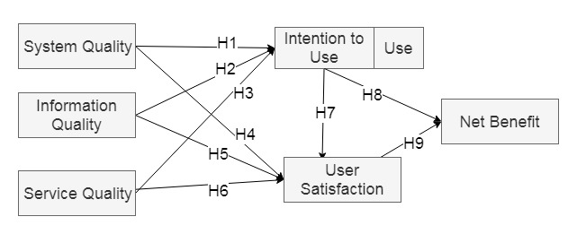

**Figure 1.** Information System Model [3].

|  |  |  |
| --- | --- | --- |
| H1 | : | System Quality has positive impact on Use |
| H2 | : | Information Quality has positive impact on Use |
| H3 | : | Service Quality has positive impact on Use |
| H4 | : | System Quality has positive impact on User Satisfaction |
| H5 | : | Information Quality has positive impact on User Satisfaction |
| H6 | : | Service Quality has positive impact on User Satisfaction |
| H7 | : | Use has positive impact on User Satisfaction |
| H8 | : | Use has positive impact on Net Benefit |
| H9 | : | User Satisfaction has positive impact on Net Benefit |

Based on DeLone and Mclean's information system success model in Figure 1, the researcher developed the research hypothesis as follows:

1. **Data Analysis**

The data analysis stage in this research uses SmartPLS software, and IBM SPSS (Statistical Product and Service Solution) to manage the data obtained using a questionnaire. The questionnaire was distributed to 40 employees who were SAP users in the accounting division at the headquarters of PT. Bank Mandiri.

The data were tested by SEM (Structural Equation Model), SEM is an approach to explain the relationship between variables by manifesting at the same time the relationship between variables tested based on the model used [1]. In this research, SEM analysis was carried out with several steps, namely the determinant coefficient test, path coefficients test, and partial test.

    Path coefficients test to see the strength of the relationship between the dependent variable to the dependent variable, the relationship between variables said to be strong if the value of the path coefficient (β)> 0.1 [8].

The coefficient determination test to measure how much influence the independent variable in explaining the dependent variable, in this research uses the value of adjusted R2 [9].

Partial test to see whether the independent variable has an influence on the dependent variable or does not have an influence on the dependent variable. The partial test is done by comparing the value of T Count with T Table with a degree of error of 5% (a = 0.05), T Count must be greater than T Table [9]. Figure 2 shows the structure of the model of information system success structural models that have been tested for Path Coefficients using SmartPLS prgram.

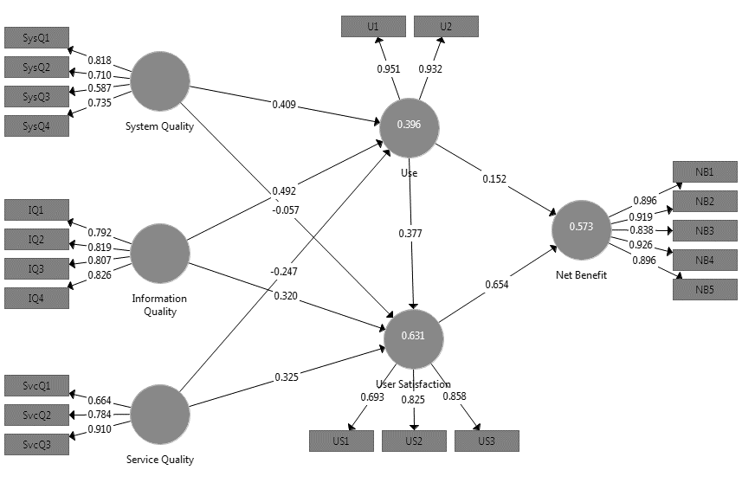

**Figure 2.** The Result of Path Coefficient Test.

Based on the results of SEM analysis conducted with the path coefficient test, coefficient determinant test and partial test that have been done can obtain the significance of the relationship between the variables to assess whether the hypothesis made is accepted or rejected.

**Table 1.** The Result of SEM Test.

|  |  |  |  |  |  |
| --- | --- | --- | --- | --- | --- |
| Hypothesis | Path | β | T Count | R2 | Accepted |
| H1 | System Quality 🡪 Use | 0.409 | 4.698 | 0.346 | Yes |
| H2 | Information Quality 🡪 Use | 0.492 | 1.512 | Yes |
| H3 | Service Quality 🡪 Use | -0.247 | 2.615 | No |
| H4 | System Quality 🡪 User Satisfaction | -0.057 | 2.098 | 0.589 | No |
| H5 | Information Quality 🡪 User Satisfaction | 0.320 | 0.98 | Yes |
| H6 | Service Quality 🡪 User Satisfaction | 0.325 | 0.399 | Yes |
| H7 | Use 🡪 User Satisfaction | 0.377 | 2.363 | Yes |
| H8 | Use 🡪 Net Benefit | 0.152 | 1.267 | 0.550 | Yes |
| H9 | User Satisfaction 🡪 Net Benefit | 0.654 | 2.85 | Yes |

Based on the test results listed in Table 1, the following describes the results of the hypothesis test:

1. H1: System Quality has a positive impact on Use

Variable system quality system to use has a path coefficient of 0.409 and the value of T Count 4,698, where T Count’s value more than T Table with value 2.024. Therefore, system quality has a positive impact on use and significantly connected. This means that the quality of the SAP system that suits the needs increased the frequency of using the SAP system in the accounting division.

1. H2: Information Quality has positive impact on Use

Variable information quality to use has a path coefficient of 0.492 and the value of T Count 1.512, where T Count’s value less than T Table with value 2.024. Therefore, information quality has a positive impact on use but the variables are not significantly connected. This means that the quality of the information displayed and generated by SAP increase the frequency of using the SAP system in the accounting division.

1. H3: Service Quality has positive impact on Use

Variable service quality to use has a path coefficient of -0.246 and the value of T Count 2.615, where T Count’s value more than T Table with value 2.024. Therefore, service quality does not have a positive impact on use and significantly connected.

This is because there are services provided by the SAP system that is implemented not in accordance with the business processes contained in the accounting division so the company must use other applications, as a result, user satisfaction with the quality of service is not good.

1. H4: System Quality has a positive impact on User Satisfaction

Variable system quality to user satisfaction has a path coefficient of -0.057 and the value of T Count 2,098, where T Count’s value more than T Table with value 2.024. Therefore, service quality does not have a positive impact on user satisfaction and significantly connected.

This is because of the complexity of SAP software that makes it difficult for users in the accounting division to operate SAP applications in their daily work, so they experience difficulties and find errors when using it.

1. H5: Information Quality has a positive impact on User Satisfaction

Variable information quality to user satisfaction has a path coefficient of 0.320 and the value of T Count 0.98, where T Count’s value less than T Table with value 2.024. Therefore, information quality has a positive impact on user satisfaction but the variables are not significantly connected. This means that the quality of the information displayed and generated by SAP makes accounting division employees increase the good responses regarding the implementation of the SAP system.

1. H6: Service Quality has a positive impact on User Satisfaction

Variable service quality to user satisfaction has a path coefficient of 0.325 and the value of T Count 0.399, where T Count’s value less than T Table with value 2.024. Therefore, service quality has a positive impact on user satisfaction but the variables are not significantly connected. This means the services provided by the SAP system increase the good responses from accounting division employees.

1. H7: Use has a positive impact on User Satisfaction

Variable use to user satisfaction has a path coefficient of 0.325 and the value of T Count 2.363, where T Count’s value more than T Table with value 2.024. Therefore, use has a positive impact on user satisfaction and significantly connected. This means the frequency of using the SAP system in the accounting division increases the good responses from accounting division employees.

1. H8: Use has a positive impact on Net Benefit

Variable use to net benefit has a path coefficient of 0,152 and the value of T Count 1,267, where T Count’s value less than T Table with value 2.024. Therefore, use has a positive impact on user satisfaction but the variables are not significantly connected. This means the frequency of using the SAP system in the accounting division increases the expected net benefits received from implementing SAP in the accounting division.

1. H9: User Satisfaction has a positive impact on Net Benefit

Variable user satisfaction to net benefit has a path coefficient of 0,654 and the value of T Count 2,85, where T Count’s value less than T Table with value 2.024. Therefore, user satisfaction has a positive impact on user satisfaction and significantly connected. This means the good responses from accounting division employees increase the expected net benefits received from implementing SAP in the accounting division.

1. **Conclusion**

Based on the results of research for analysis of SAP implementation in the accounting division at PT. Bank Mandiri, Tbk, using the Information System Success model that has been done, it was proven that from the 9 hypotheses tested using the Structural Equation Modelling (SEM) model, 7 hypotheses proved to be accepted and 2 hypotheses proved to be rejected.

With this, can be concluded that the variables that increase the Net Benefit of SAP implementation, namely increasing the use and user satisfaction felt by users in using the system can increase the net benefit felt by the company, accounting division, and employees, but the frequency of using the SAP by user does not have a significant effect.

The next one is increasing the user satisfaction that is felt by the user is using the system can increase the use, system quality, and information system, but information quality and service quality do not have a significant effect.

Finally, to increase the use by users can be done by increasing service quality and information quality on SAP, but the information quality obtained from the SAP has no significant effect with user satisfaction.

**5**. **References**

|  |  |
| --- | --- |
| [1] | Abdillah 2017 *Metode Penelitian Terpadu Sistem Informasi* (Yogyakarta: Andi Publisher). |
| [2] | DeLone and McLean 1992 *Information Systems Success: The Quest for the Dependent Variable* (Inf. Syst. Res) vol. 3 p 60-95. |
| [3] | DeLone and McLean 2003 *The DeLone and McLean Model of Information Systems Success: A Ten-Year Update* (J. Manag. Inf. Syst') Vol.19 p 9-30. |
| [4] | Iivari 2005 *An Empirical Test of the Model of Information System Success* (The DATA BASE for Advances in Information Systems) Vol. 36 p 8–27. |
| [5] | Junnarkarm, Atul and Verma 2017 *Study on System Application Product (SAP)- An Important Enterprise Resource Planning Tool For Achievement of Organizational Vision, Mission and Operational Performance* (International Research Journal of Engineering and Technology) Vol. 4 p 2064. |
| [6] | Khoualdi, K and Basahel 2014 *The Impact of Implementing SAP System on Human Resource Management: Application to Saudi Electricity Company* (International Journal of Business and Management) Vol. 9 p 28-32. |
| [7] | Okungbowa 2015 *SAP ERP Financial Accounting and Controlling – Configuration and Use Management* (New York : Appress). |
| [8] | Riduwan and Kuncoro 2014 *Analisis Jalur* (Bandung: Alfabeta). |
| [9] | Sugiyono. 2017 *Metode Penelitian Kuantitatif, Kualitatif, dan R&D* (Bandung: Alfabeta) |