5TH INTERNATIONAL CONFERENCE ON TECHNOLOGY AND VOCATIONAL TEACHERS

Theme:

"ENHANCING TECHNOLOGY AND VOCATIONAL COMPETENCY FOR SMART INDUSTRY"

Title:
INDUSTRIES TRAINING FOR TEACHERS COMPETENCY
Under wide range topics of :
9. Vocational Education
And sub topic of Industry-Driven Training Program

Author:
DODY BUDHIWASKITO, MSC

Affiliation:
LABTECH INTERNATIONAL, LTD
PT. LABTECH PENTA INTERNATIONAL

Keywords:
Industries Training Teachers Competency

Organized by:
UNIVERSITAS NASIONAL YOGYAKARTA (UNY)

Venue
EASTPARC HOTEL YOGYAKARTA
14-15 September 2019

INTRODUCTION

Total vocational K-12 in Indonesia is around 13,710 schools scattered all over in Indonesia. This is huge number of schools and teachers population that should be maintained their skills and knowledge in accordance with the technology applied in SMEs and big industries.

The national education system law number 20 of 2003 article 11 paragraph 1 mandates the government and regional governments to guarantee the implementation of quality (quality) education for every citizen. One parameter of quality education is the qualifications of teachers who need to master the skills, knowledge and work attitudes so that teachers are able to carry out teaching according to standards in the industries.

Smart industries trend towards industry 4.0

Smart technical K-12 school towards TVET 4.0

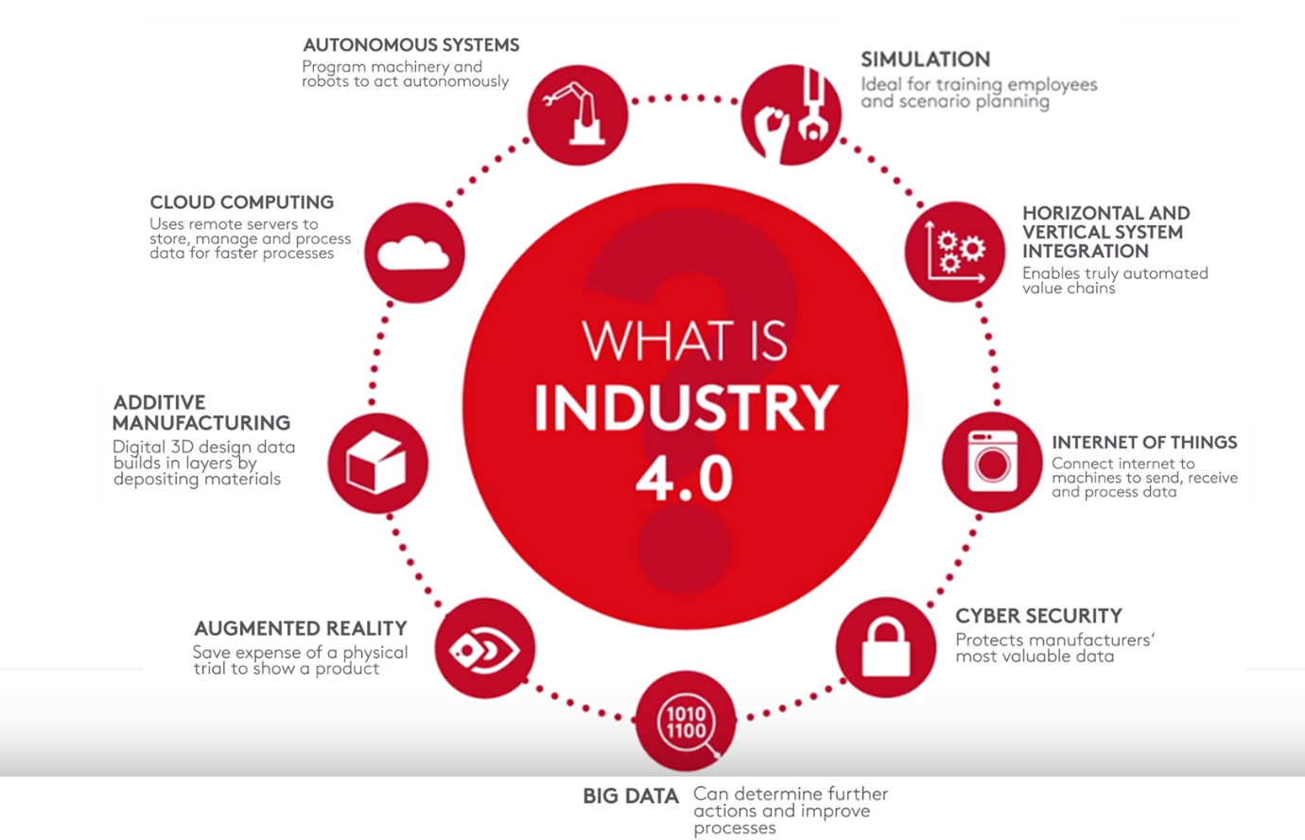

Figure 1: Manufacturing (Smart) Industry 4.0 Components

METHOD
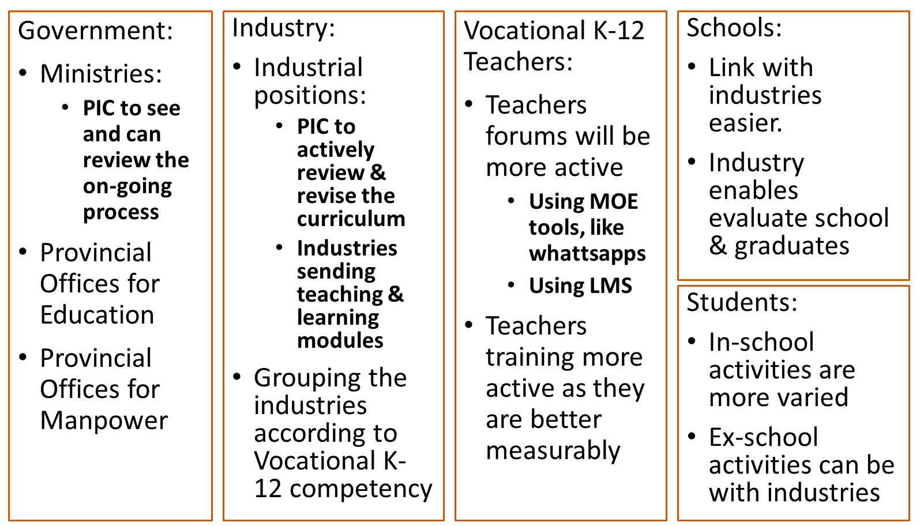

RESULTS

Massive training programs

NO | TARGETS | PROBLEMS | SOLUTIONS
1 | Training topics | The way training topics are determined. | - Curriculum of vocational schools shall be reviewed by industrial experts.  - The gap of skills and knowledge between the taught curriculum and the actual industrial practices shall be the training topics
2 | Trainings certificates | Most of training topics in the field of technology and engineering have not yet been registered with BNSP certification | - Trainings will be implemented based on the way the works have been executed in the industry.  - For some industries, trainings can be implemented as part of “magang” program in the industries
3 | Training instructors’ certificates | The type of assessors’ expertise certificates does not cover the skills and knowledge training topics | - Flexibility of BNSP to work with other Ministries, Ministry of Higher Education and Ministry of Industry  - Let Ministry of Industry set up RPL Recognition Learning specific for the instructors from industries  - Instructors who get the RPL shall be officially acknowledged by the Ministry of Higher Education
4 | Trainings equipment and demo | - Equipment is expensive  - In many cases the equipment are manufactured in overseas | - Cooperation with technical education equipment manufacturer shall be developed.  - Incentives can be initiated by the Ministry of Finance for those who support this program (taxes incentive program).

DISCUSSION

1. Setting up digital platform for the program

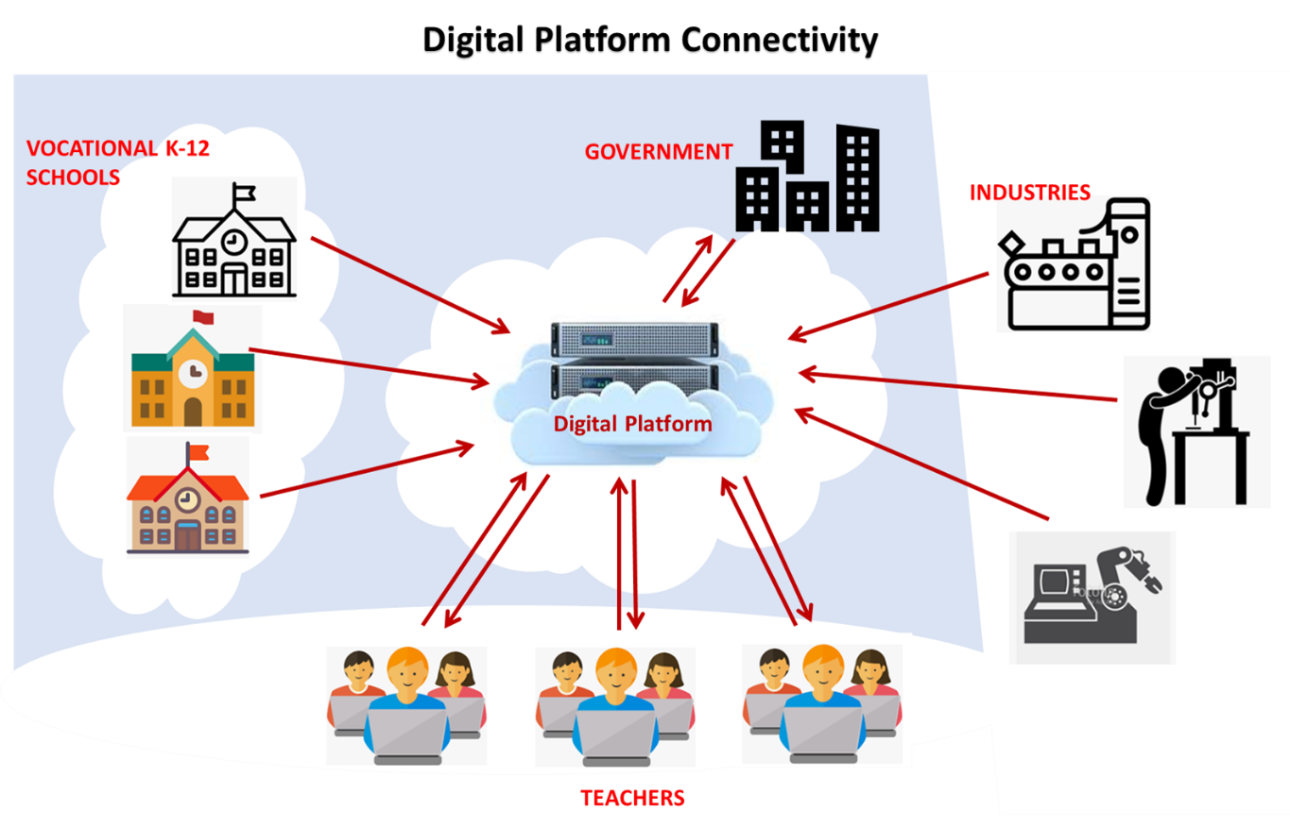

Figure 2: Digital Platform Connectivity

2. Innovative efforts to develop affordable practical or hands-on equipment

For massive trainings and training topics, innovative practical and hands-on equipment is important to do efficiency.
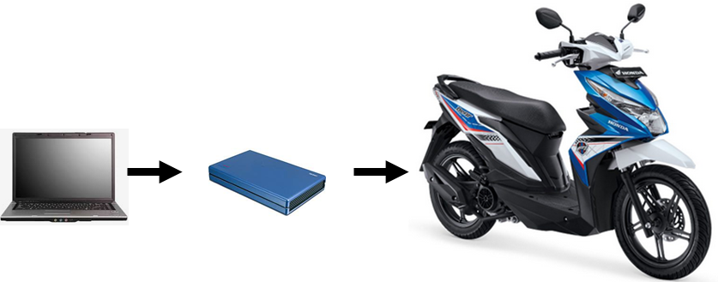

Figure 3: ECU applied for latest technology motorcycle

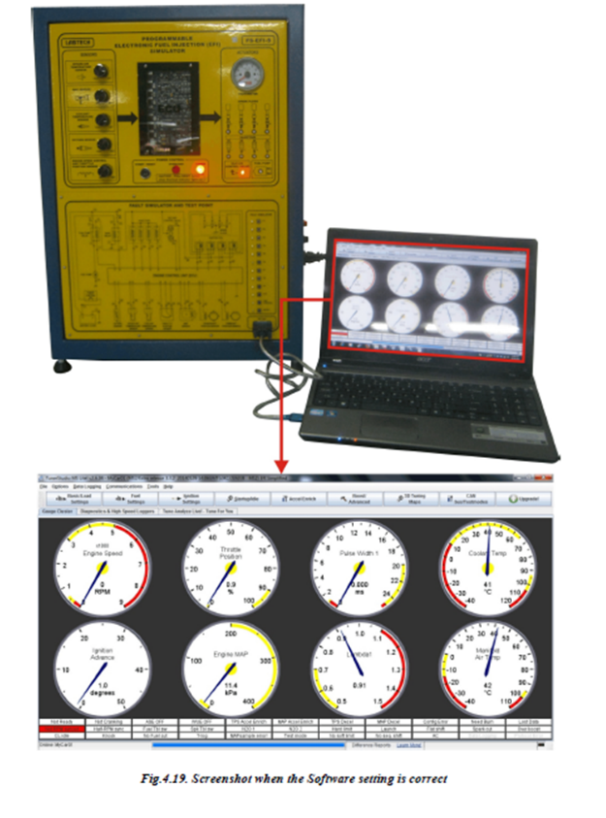
Programmable EFI engineering practice tools Labtech simulators are unique tools because they are used to simulate engine management systems as well as engine management systems running on vehicles. Thus training participants are required not only to become familiar with the operating characteristics of the EFI system but also to be able to service and test the diagnostic according to the procedures specified by the vehicle manufacturer's manual.

The training participants' expertise in simulation practice was trained with the ability to control operating parameters and requirements through various sensor simulations. Each main sensor is related to an electrical measuring device that continuously monitors the signal. This condition allows trainees to explore the operational conditions of the vehicle - signals related to the performance system.

This training combines all electricity to control the engine into the ECU. The engine monitor (sensor) combines engine condition data and the ECU micro-processor using these inputs to control the multipoint electronic injection system and ignition system. A skill that is complicated but very useful for vocational education at the vocational level. At the end of the training the trainees were able to service, diagnose and troubleshoot the EFI simulator

Figure 4: EFI applied for latest technology automobile

3. Massive trainings as a support to develop diploma education

For massive trainings implementation, it can help to develop lectures in the system of diploma education.
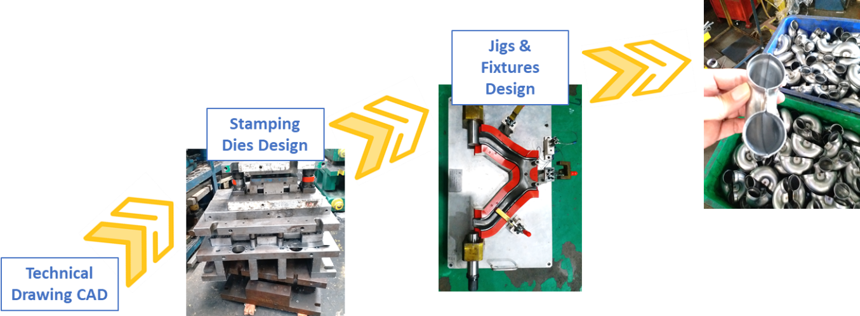

4. Determination of what level the training instructor from Industry

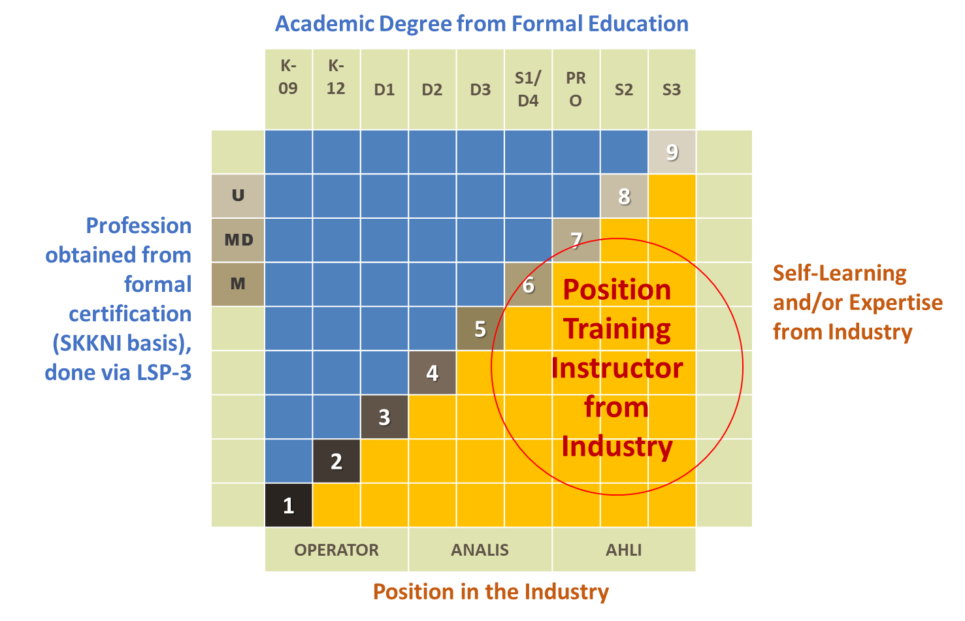

END OF PRESENTATION

Kementerian Pendidikan dan Kebudayaan, Sekretariat Jenderal, Pusat Data dan Statistik Pendidikan dan Kebudayaan, “Statistik SMK 2017/18”, Jakarta 20187, page 10. Link http://publikasi.data.kemdikbud.go.id/uploadDir/isi_B5497FED-88A5-47CD-9492-78B703B41D28_.pdf
SME is Small Medium Enterprises
What is industry 4.0? link https://www.youtube.com/watch?v=zlgDkbhDIwo
BNSP is Badan Nasional Sertifikasi Profesi, National Board for Professions Certification. Link https://bnsp.go.id/
Digital platform connectivity is a base platform for discussion topic
ECU is Electronic Control Unit. Terminology of ECU is different between motorcycle brand
EFI is Electronic Fuel Injection

