The Growth of Critical Thinking Ability of Vocational High School (SMK) Students in Computer Engineering Expertise Program Through the Use of Teaching Material that Contains of Examples Non-Examples Model
Galuh Lumaksono¹, Muladi² dan Muhammad Ashar³

¹Faculty of Engineering, State University of Malang, Jl. Semarang no.5, Malang, Indonesia, 65145
² Faculty of Engineering, State University of Malang, Jl. Semarang no.5, Malang, Indonesia, 65145
³ Faculty of Engineering, State University of Malang, Jl. Semarang no.5, Malang, Indonesia, 65145

E-mail: galuhlx@gmail.com
Abstract. This research aimed at arising the critical thinking ability of Vocational High School (SMK) students in Computer Engineering Expertise Program through the development of teaching material. The teaching material developed was in the form of website, in which the material delivered used Examples non-Examples learning model. The use of website teaching material was expected to be able to increase the students’ interests so that it increased the students’ understanding about the material delivered. It was assisted with the material delivery based on Examples Non-Examples model, of which model could build up the students’ mindset; thus, it was expected that after using the teaching material, the students could think critically in solving the problems. This development was a Research and Development that used development model of ADDIE and the feasibility of teaching material, in which it was determined from the validation that was conducted by material expert, media expert, user, and the influence of the teaching material toward the students’ critical thinking ability.
- Introduction
Critical thinking is one of soft skills that must be owned by someone. According to Dwyer (2014), critical thinking is a metacognitive process through reflective assessment, in which it is purposely done to increase the opportunity to produce logical conclusion about an argument or solution for a problem ^{[1]}. Someone who can think critically is able to make decision in a problem and also could differentiate between incorrect or correct things. Thus, the critical thinking ability will be very needed in the daily life, one of them is in the work environment. The importance of critical thinking in the work environment is proposed by Hodge (2016) who states that critical thinking ability is one of soft skills that needed in the work area of 21 century ^{[2]}. Therefore, the critical thinking ability has to be taught earlier so that someone is able to have this Soft Skill before going to the work environment.
One of institutions that specified to bring up graduates who are ready to go on the work environment is Vocational High School (SMK)^{[3]}. In 2013, Vocational High School (SMK) has already implemented new curriculum where the purpose of the curriculum is that the students can be a human who think critically.
The aim of teaching critical thinking ability to Indonesian students has not been fully successful. The PISA (Programme for International Student Assessment) survey in 2015 shows that Indonesia ranks 62 out of 70 participating countries^{[4]}. Based on Stacy (2011), it shows that only 0,1 percent of students are able to solve High Order Thinking items or questions of level 5 and 6^{[5]}. This indicates that the High Order Thinking ability of Indonesian students is still low, in other words the critical thinking ability is also still low. This proves that special efforts are needed to improve the students' critical thinking ability especially in Indonesia.
One of efforts that can be used to arise the critical thinking ability is by using the teaching material. Raiyn (2016) clarifies that one way to improve the students' critical thinking ability is by using a media that is able to display information in visual forms such as images, diagrams, and interactive simulations ^{[6]}. The students must also be taught how to respond to the information presented properly. This is in line with the opinion of Rahmawati (2016) who states that the students who are prepared with critical thinking ability can observe the opinions of others whether it is wrong or correct based on the scientific truths and knowledge so that the students without hesitation can decide and judge which opinions are wrong and correct ^{[7]}. Along with the development of technology and internet, the forms of teaching material and media displayed are increasingly diverse. One of the uses of technology in teaching material is website-based teaching material. The making of website as teaching material that is able to display various media such as images, files, and videos and how to deliver material interactively can increase the students’ interest; thus, the students are able to understand the content of the material delivered well.
The material submission in teaching material cannot be separated from the stages to deliver the material. The stages to deliver the material are called as learning models. The use of correct learning model will improve the students' critical thinking. One of learning models that is able to arise the critical thinking is a learning model of Examples non-Examples. Kurnianingsih and Sani (2015) assert that the Examples non-Examples model aims to encourage the students to learn using critical thinking by solving the problems, of which problems are contained in the example images that have been prepared beforehand ^{[8]}.
Departing from the description above, it is necessary to develop website-based teaching material that contain of the Examples non-Examples model. The existence of this teaching material is expected to be able to increase the students' attention and understanding about the material presented so that it can increase the level of students’ critical thinking.
The objectives to be achieved in this research are as follows: (1) Designing the website-based teaching material that contains of Examples non-Examples model to arise the students' critical thinking ability; (2) Constructing up a website-based teaching material that contains of Examples non-Examples model to arise the students' critical thinking ability; and (3) Finding out the results of the assessment of material expert, media expert, and students on the feasibility of website-based teaching material that contains of Examples non-Examples model and also the influence of teaching material on the students' critical thinking ability.

- Method
This research was a research and development (R & D). According to Sugiyono (2011), the method of research and development was a research method that used to produce certain products, and examined the effectiveness of these products ^{[9]}. The development model used in this research was ADDIE. According to Thim (2015), this development model was a system design framework that had five working phases namely analysis, design, development, implementation, and evaluation ^{[10]}.
- Analysis
The analysis phase contained of information gathering activities for the development of teaching material. The main information as the basis for developing the teaching material was to identify the field conditions in Vocational High School (SMK), in which it started from the condition levels and the students’ character, facilities which were provided by school to work on the teaching material and the materials that will be displayed in the teaching material.
- Design
The design stage was the stage of designing the teaching material based on the results of the analysis that had been done. The design phase consisted of two stages, namely the design of teaching material, and the instruments design.
The design of teaching material was a stage for designing the form of teaching material. The design comprised up the display of teaching material, flow, material loaded, and media to be displayed.
The instrument design was a stage for designing the assessment instruments. The instruments designed were questionnaire and observation. The questionnaire instrument would be used to assess the feasibility of teaching material while the observation was used to assess the influence of teaching material on the students' critical thinking ability Both of the instruments were designed to have two types of questions, namely closed questions and open questions. The closed questions had the answers provided, the answers followed the Guttman's scale which had 2 choices of answers namely "Yes" and "No". The closed questions would produce quantitative data, of which results would determine the feasibility of the teaching material. While the open questions were filled with responses, suggestions or criticism from the respondents so that the open questions would produce qualitative data that would determine what needs to be revised from the teaching material.
- Results and Discussion
This stage discussed the results and discussion of the research that had been conducted. The information displayed included of: (1) Production Results of the teaching material; (2) The results of validation test, user test, and the test of the influence of teaching material on the students' critical thinking ability.
  - The Production Results
The product that produced in this research was website-based teaching material that contained of Examples non-Examples model. In accordance with the Examples non-Examples learning model, the flow of delivery in the teaching material began with displaying the images that were relevant to the material to be discussed. The students were then directed to look for explanations or answers from the teacher's direction regarding to the image displayed. The students' answers and arguments were written below the picture that was displayed, then several arguments of student were compared to find out an agreement between the students. The process of finding information, delivering arguments, and discussion was expected to be able to arise the students' critical thinking ability. The display of teaching material in this process was revealed in the Figure 1.

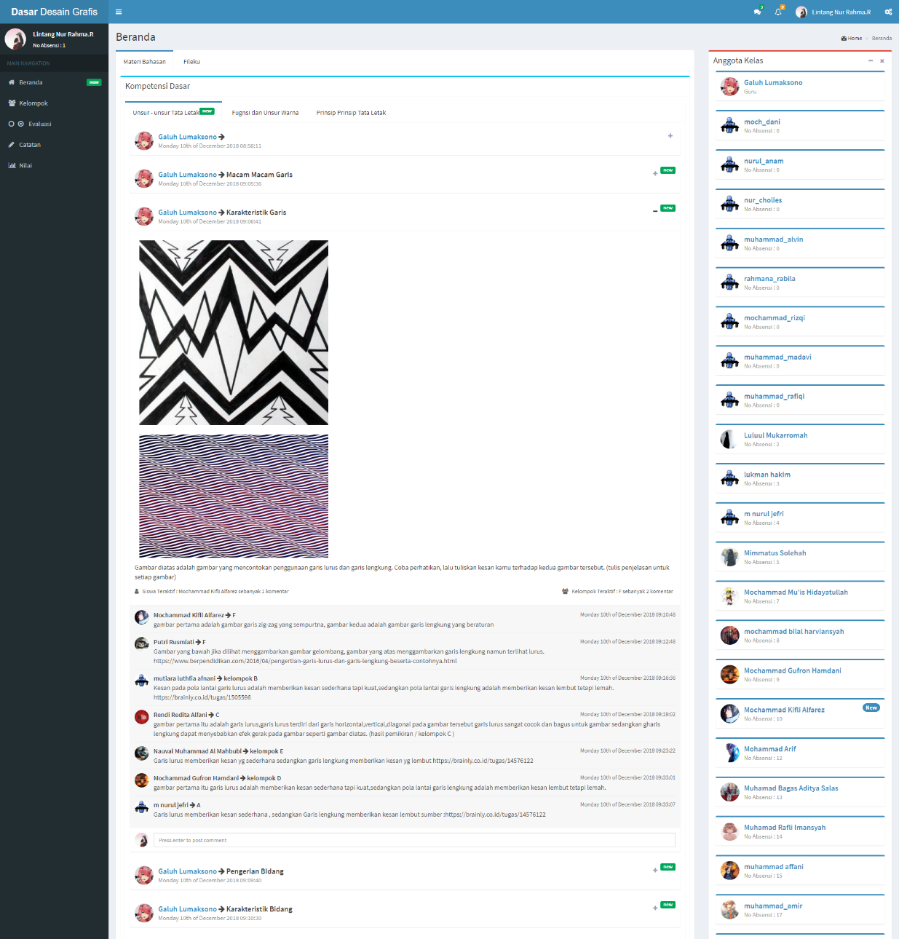
The Students’ Discussion via Chat
The Students’ Discussion Process
The Image Discussion Command
The Examples non-Examples Process
The Display of Material Images
Figure 1. The Display of Material Menu
  - The Result of Teaching Material Test
The teaching material tests that conducted were validation test, user test, and the test of the influence of teaching material on the students' critical thinking ability. The validation test was carried out by material expert and media expert. The respondents of material expert and media expert were taken from the University lecturers and the teachers from school, the user test was carried out by retrieving the data from questionnaire that was given to 36 students who had used the teaching material, while the test of the influence of teaching material on the students' critical thinking ability was conducted by school and the students through an observation.
The data shown in Table 1 were the results of validation carried out by material expert and media expert. The data produced a final score of 92.2% which proved that the teaching material met the high criteria or it was very feasible to be used. Less than maximal result was obtained in the aspect of quality of evaluation. This was because the form of evaluation on teaching material was not in accordance with the condition of the school; therefore, the efforts were needed to adjust the evaluation in each school that would use this teaching material.
Table 1. The Validation Data of Material and Media Experts.
No. | Assessment Aspects | Assessment |  | $${\%X}_{in}$$ | Criteria
No. | Assessment Aspects | ∑S | $$S_{maxs}$$ | $${\%X}_{in}$$ | Criteria
1. | Material Relevance | 26 | 26 | 100 | Very High
2. | Adequacy in Terms of Benefits | 12 | 12 | 100 | Very High
3. | Quality of Language | 8 | 8 | 100 | Very High
4. | Quality of Evaluation | 5 | 8 | 62,5 | High
5. | Software Engineering | 20 | 22 | 90,9 | Very High
6. | Visual Communication | 24 | 24 | 100 | Very High
 | ∑S | 95
 | $$S_{maxs}$$ |  | 100
 | $${\%X}_{in}$$ |  |  | 92,2 | Very High
The data shown in Table 2 were the results of user test conducted by 36 students after using the teaching material. The data produced a final score of 97.2% which proved that the teaching material met a very high criteria or it was very feasible to be used.
Table 2. The User Validation Data.
No. | Assessment Aspects | Assessment |  | $${\%X}_{in}$$ | Criteria
No. | Assessment Aspects | ∑S | $$S_{maxs}$$ | $${\%X}_{in}$$ | Criteria
1. | Software Engineering | 252 | 252 | 100 | Very High
2. | Learning | 383 | 396 | 96,71 | Very High
3. | Visual Communication | 410 | 432 | 94,9 | Very High
 | ∑S | 1045
 | $$S_{maxs}$$ |  | 1080
 | $${\%X}_{in}$$ |  |  | 97,2 | Very High
The data shown in Table 3 were the result of observation made by two teachers in school and the students. The observed aspect was the students' critical thinking ability during the use of teaching material. The data produced a final score of 93.3% which proved that the teaching material was able to arise the students' critical thinking ability.
Table 3. The Data of Critical Thinking Ability Test.
No. | Assessment Aspects | Assessment |  | $${\%X}_{in}$$ | Criteria
No. | Assessment Aspects | ∑S | $$S_{maxs}$$ | $${\%X}_{in}$$ | Criteria
1. | Giving Simple Explanation | 12 | 12 | 100 | Very High
2. | Constructing Basic Ability | 5 | 6 | 83,3 | Very High
3. | Concluding | 10 | 12 | 83,3 | Very High
4. | Giving Further Explanation | 9 | 9 | 100 | Very High
5. | Organizing Strategies and Tactics | 9 | 9 | 100 | Very High
 | ∑S | 45
 | $$S_{maxs}$$ |  | 48
 | $${\%X}_{in}$$ |  |  | 93,3 | Very High

- Conclusion and Suggestion
The product produced in this research and development is the teaching material that contains of Examples non-Examples model, in which it is web-based for the Vocational High School (SMK) students in the Computer Engineering expertise program. The development of teaching material is carried out with the stages of ADDIE development model, of which model consists of 5 stages, namely: (1) Analyze, (2) Design, (3) Development, (4) Implementation, and (5) Evaluation.
The teaching material developed in the form of websites uses the framework of CodeIgniter 3.1.9 for back-end and framework of Bootstrap for front-end. The teaching material contains of basic lessons in graphic design with the delivery of material using Examples non-Examples learning method to increase the influence of teaching material in improving the students' critical thinking ability.
The validation of teaching material obtains a score which indicates that the teaching material is involved in the very high criteria or it is feasible to be used. This score is obtained from the validity test by expert 1 and expert 2 with a score of 92.2%, and the user test obtains a score of 97.2%.
The results of observation from the three observers show a score of 93.3% which indicates that the students are able to think critically during the use of teaching material or the teaching material developed is able to arise the students' critical thinking ability.
In order to use the basic teaching material for graphic design more optimally in one device, it is better to have more than one browser because one browser can only be used for one active account, and the device has a minimum screen resolution of 800x600 pixels.
Further development of teaching material can be carried out on several aspects including of: (1) Improving the chat feature by using a real-time system so that it can load the messages directly; (2) Adding questions in the form of essays along with automatic assessment of critical thinking ability; and (3) Adding online object drawing features because the teaching material is intended for basic subjects of graphic design.

- References
[1] Dwyer, Christopher P., Michael J. Hogan, and Ian Stewart. 2014. “An Integrated Critical Thinking Framework for the 21st Century.” Thinking Skills and Creativity 12 (June): 43–52. https://doi.org/10.1016/j.tsc.2013.12.004.
[2] Hodge, Kay A., and Janet L. Lear. 2016. “Employment Skills for 21st Century Workplace: The Gap Between Faculty and Student Perceptions.” Journal of Career and Technical Education 26 (2). https://doi.org/10.21061/jcte.v26i2.523.
[3] Depdiknas. 2003. Undang-undang RI No.20 tahun 2003.tentang sistem pendidikan nasional
[4] Organisation for Economic Cooperation and Development (OECD). 2015. OECD Database. OECD. Online: http://www.oecd.org/pisa/PISA-2015-Indonesia.pdf
[5] Stacey. 2011. The PISA of Mathematical Literacy in Indonesia. Australia: University of Melbourne
[6] Raiyn, Jamal. 2016. “The Role of Visual Learning in Improving Students’ High-Order Thinking Skills.” Journal of Education and Practice 7 (24): 115–21. http://files.eric.ed.gov/fulltext/EJ1112894.pdf.
[7] Rahmawati, Ika. Dkk. 2016. Analisis Keterampilan Berfikir Kritis Siswa SMP Pada Materi Gaya dan Penerapanya. Malang: Universetas Negeri Malang
[8] Kurniasih dan Sani. 2015. Model Pembelajaran. Yogyakarta: Kata Pena
[9] Sugiyono. 2010. Metode Penelitian Pendidikan; Pendekatan Kuantitatif, Kualitatif dan R&D. Bandung: Alfabeta
[10] Thim-Mabrey, Christiane. 2015. “ADDIE Model.” ADDIE Model 107 (3): 361–73. https://doi.org/10.13140/2.1.4687.6169.

