**Implementation of the Simple Additive Weighting Method in Determining Policy Recommendations for Higher Education Study Programs Based on Alumni Perceptions**

**HWW Iswara1 and H Jati2**

1,2Graduate School, Universitas Negeri Yogyakarta, Yogyakarta, Indonesia

E-mail: [hilariosecond@gmail.com](mailto:hilariosecond@gmail.com) and [handaru@uny.ac.id](mailto:handaru@uny.ac.id)

**Abstract.** This study aims to develop a quality web-based Alumni Information System and make a reference for higher education study programs in the form of policy recommendation features with the Simple Additive Weighting method in the Information System. The feature is made so that the policies taken can be in accordance with the priority scale of their main problems. The result of this research and development is a product in the form of a quality web-based Alumni Information System and features policy recommendations for study programs.. This is proven by fulfilling the eligibility assessment criteria of the software version of the ISO 25010 model, which includes 5 aspects, namely functional suitability, reliability, performance efficiency, maintainability, and usability in this system. The policy recommendation features produced also have a high degree of accuracy, because the results bear a 96% similarity with the actual accreditation score.

1. **Introduction**

Alumni are important components or stakeholders in improving the quality of higher education. The campus must manage alumni data for tracer study for accreditation, find out the outcome of education outcomes, monitor the distribution of graduates, evaluation materials for tertiary institutions, and build relationships with alumni. Currently there are 2 systems that provide data or information about alumni at Universitas Negeri Yogyakarta (UNY). To assess the quality of a software, testing is needed based on the assessment criteria of the feasibility of the version of the ISO 25010 model, which includes 5 aspects, namely functional suitability, reliability, performance efficiency, maintainability, and usability [1]. Indicator of feasibility in testing aspects of functional suitability according to ISO standards is the achievement of the success score of functionality approaching number 1. The indicator of eligibility in testing aspects of reliability is the achievement of a minimum success rate of 95%. Indicator of feasibility in testing aspects of performance efficiency is the achievement of an average response time of less than 9 seconds. Indicator of the feasibility of testing the aspects of maintainability is the achievement of a Maintainability Index (MI) of at least 65. The feasibility indicator of testing the usability aspect is the achievement of a minimum score of 61%.

Information Systems relating to alumni owned by UNY are not yet of sufficient quality. This is evidenced by the lack of information displayed, the low level of efficiency in web performance, the many alumni and students who are not satisfied with the existing system, and too complex administration. We know that alumni are very useful for improving the quality of higher education. This is because alumni can provide advice on several aspects on campus that need to be addressed. Several study programs at Universitas Negeri Yogyakarta are also currently not Accredited A. One of the study programs that has not been Accredited A is the Informatics Engineering Study Program which is still Accredited B with a score of 346. This is because so far there has not been a reference for study programs so that the policy what is taken can be in accordance with the priority scale of their problem. Therefore, it will also be very useful for the campus if in the developed system it can also be used to analyze data and produce information in the form of policy recommendations for tertiary study programs that need to be taken based on evaluations conducted by alumni and guidelines for accreditation of tertiary institutions.

Data processing automatically becomes information policy recommendations in the field of informatics can be overcome with the name Decision Support System (DSS). This system is used to assist decision making in semi-structured and unstructured situations, where no one knows for sure how decisions should be made [3]. One type of method in DSS is Simple Additive Weighting (SAW). SAW method is a method used to find optimal alternatives from a number of alternatives with certain criteria. The advantage of the SAW method compared to other methods lies in its ability to conduct assessments more precisely because it is based on the value of criteria and weighted preferences that have been determined [3].

The criteria along with their preference weights are based on existing standards, namely guidelines for assessing undergraduate study program accreditation according to the National Accreditation Board for Higher Education (BAN-PT) [4]. Based on these problems, it is necessary for researchers to overcome them by implementing the Simple Additive Weighting method in determining policy recommendations for tertiary study programs based on alumni perceptions obtained from the web-based Alumni Information System to be developed.

1. **Method**

This research and development is carried out using the waterfall model according to Pressman (2015) which is indeed used for software development [1]. The first step is communication. Before starting a technical job, communication with clients is needed, 100 alumni and 1 campus administrator to understand their needs. Needs data is obtained by giving questionnaires to alumni and conducting interviews with campus administrators. The result of this communication is project initialization, such as analyzing problems encountered and collecting necessary data, and helping define software features and functions. The second step is planning which includes estimation, risk analysis, scheduling, and monitoring. The third step is modelling which includes analysis and design. Analysis of the client's needs is done to select features that will be developed on the system. The features to be developed are features that are needed by more than 50% of the respondents. The fourth step is construction which includes code and tests. The product was tested with the appropriateness evaluation criteria of the ISO 25010 Model version of the software which included functional suitability, reliability, performance efficiency, maintainability, and usability testing. The final step is deployment.

1. **Results and Discussion**

This research and development produces a product in the form of a quality web-based Alumni Information System. The Alumni Information System is able to provide information about alumni and is able to produce information on policy recommendations that need to be taken by higher education study programs based on priorities and existing alumni perception data.

This information system has features including a homepage, list, entry, profile, personal data, study program evaluation questionnaire, alumni data, alumni statistics, alumni distribution map, policy recommendations, application, and exit. The following is a display of the resulting Information System (Figure 1 & Figure 2).

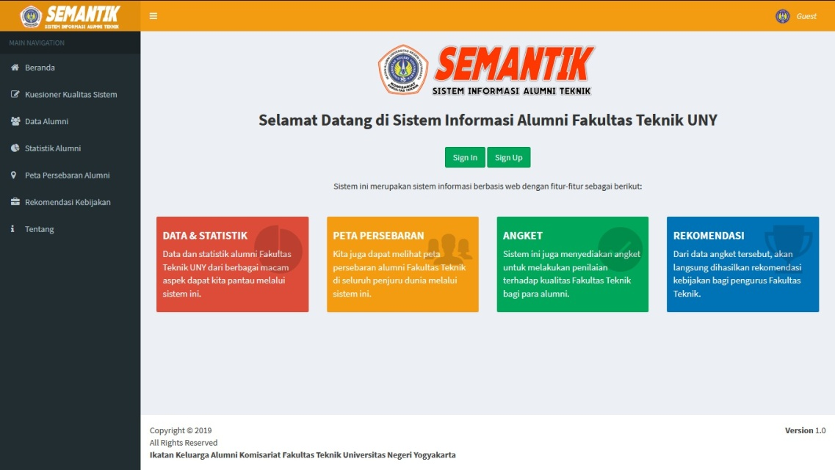

**Figure 1.** The Front Interface of Alumni Information Systems.

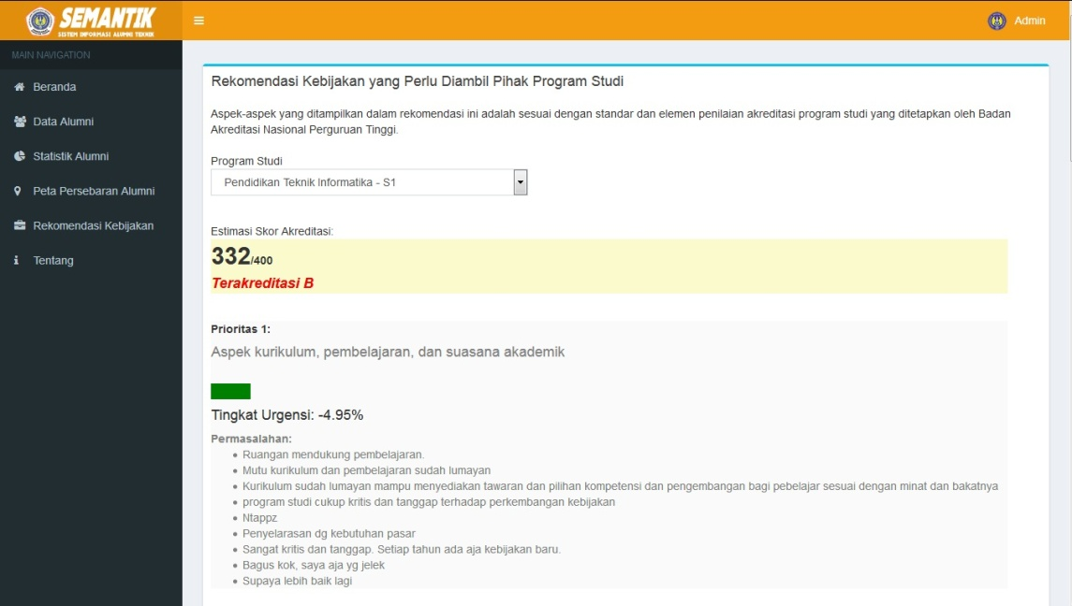

**Figure 2.** Policy Recommendations Menu Interface on Alumni Information Systems.

From the calculation of the functional suitability level of the developed information system, it shows the value of functionality (X) of 1, so that this system has met the functional suitability aspects. From the reliability testing using the WAPT 9 device the results obtained were 455 successful sessions, 0 failed sessions, 930 successful pages, 0 failed pages, 20969 successful hits, and 0. 0 failed hits. These results if expressed as a percentage are obtained a figure of 100%. Thus, this information system meets the reliability aspect. From the performance efficiency testing using the GTMetrix device the results of performance scores which include a page speed score of A (91%) and Yslow score of B (80%) and page details which include a fully load time of 0.8 seconds, a total page size of 648 kb, and request equal to 31. Because the response time of this system is 0.8 seconds, this information system has fulfilled the aspect of performance efficiency. From maintainability testing using the PhpMetrics tool, an MI score of 87.24 was obtained. Thus, this information system has fulfilled aspects of maintainability. From the results of the calculation of the usability level of the information system developed, it shows usability value of 84.06%, so that this system has met the usability aspect. The following table 1 presents the results of the feasibility testing of the software version of the ISO 25010 Model on the developed Information System.

|  |  |  |  |
| --- | --- | --- | --- |
| **Table 1.** Software Feasibility Test Results for Model Version ISO 25010 | | | |
| Aspect | Standard Score | Testing Score | Result |
| Functional Suitability | 1 | 1 | Pass |
| Reliability | ≥ 95% | 100% | Pass |
| Performance Efficiency | < 9 seconds | 0,8 seconds | Pass |
| Maintainability | ≥ 65 MI | 87,24 MI | Pass |
| Usability | ≥ 61% | 84,06% | Pass |

This system is also able to produce policy recommendations and calculate estimates of study program accreditation scores. To produce policy recommendations, the first step is to take the weight of each aspect of the questionnaire from the database and make it an array. Next is adding all the weights to the total value. Next is to take the average value of each questionnaire score from the database. The next step is to multiply the average of each aspect score by the aspect weight value and -100 and divide it by the total weight value. Next save the value with the name score percentage in the importance level of the aspect in the array. After that, sort the array of urgency aspects of those aspects from the largest value. Next is to take the name of the aspects and problems of each aspect from the database, so that the importance score of these aspects becomes more informative and meaningful. The final step is to display all the aspect names, problems, and importance scores of the aspects in order in the array so that the priority information on policy recommendations can be understood by the user.

To find accreditation score estimates based on available data, it is done by accumulating the total score on all aspects of accreditation assessment. To calculate the estimated accreditation score for each aspect by adding the average of each score to the number 3 (to convert from the negative Likert scale format to the positive Likert scale format), then multiplying the number by aspect weight and multiplying again by 400 (maximum score accreditation) and divided by 21 (total weight) multiplied by 5 (maximum score for each aspect). The following is the formula.

$$Estimated accreditation score= \sum_{i=1}^{7}{\frac{\left({\overline{aspect score}}_{i}+3\right) ×{aspect weight}_{i} ×400}{5 ×21} }$$

To find out how accurate the determination of policy recommendations in the developed system, a comparison is made between the estimated accreditation scores in the system with the actual study program accreditation scores. For the trial sample used as a comparison is the S1 Informatics Engineering Education study program with 25 alumni respondents. Obtained accreditation score data obtained from the system of 332, while the fact is the accreditation score of the S1 Informatics Engineering Education study program is 346. Thus the similarity of the score is 96%, so that the level of accuracy of determining policy recommendations is very high.

1. **Conclusion**

This research and development has produced a product in the form of a quality web-based Alumni Information System, as evidenced by the fulfilment of the eligibility assessment criteria of the software version of the ISO 25010 Model, which includes 5 aspects namely functional suitability, reliability, performance efficiency, maintainability, and usability in this system. The policy making carried out by the university study program can be in accordance with the scale of the priority of their problems because there is already a reference in the form of a Decision Support System for Study Program Policy Recommendations using the Simple Additive Weighting method. The Decision Support System has proven its accuracy level of 96%.

1. **References**

[1] Pressman R 2012 *Software Engineering: A Practitioner's Approach* (New York: McGraw-Hill)

[2] Turban, E 2001 *Decision Support Systems and Intelligent Systems* (New Jersey: Prentice Hall)

[3] Kusumadewi S and Hartati S 2006 *Fuzzy Multi-Attribute Decision Making (FUZZY MADM)* (Yogyakarta: Penerbit Graha Ilmu)

[4] BAN-PT 2008 *Pedoman Penilaian Akreditasi Program Studi Sarjana* (Jakarta: Badan Akreditasi Nasional Perguruan Tinggi)