Measurement of Magnetic Fields on Electric Train

Hutomo Wahyu Nugroho
Research Center for Testing Technology
Indonesian Institute of Sciences
South Tangerang, Indonesia
huto001@lipi.go.id
Yudhistira
Research Center for Testing Technology
Indonesian Institute of Sciences
South Tangerang, Indonesia
yudh002@lipi.go.id
M. Imam Sudrajat
Research Center for Testing Technology
Indonesian Institute of Sciences
South Tangerang, Indonesia
muha091@lipi.go.id
R. Harry Arjadi
Research Center for Testing Technology
Indonesian Institute of Sciences
South Tangerang, Indonesia
harry_arjadi@yahoo.com
Aditia Nur Bakti
Research Center for Testing Technology
Indonesian Institute of Sciences
South Tangerang, Indonesia
adit004@lipi.go.id

Abstract—Electric train is one of the most widely used transportation modes in Indonesia especially Jakarta. The magnetic field on the train generally occurs in areas close to the source. In this paper, already measured the magnetic field (near field) in the electric train in the frequency range 0.015 kHz up to 1 kHz. The measurement results show that the highest magnetic field is obtained when the train starts up at 333.76 nT. The magnetic field level is small when away from the electrical inverters. The average level of the magnetic field when the train is at its highest is 223.26 nT and during braking there is an increase of 323.93 nT.
Keywords—Electric train, electromagnetic, magnetic field, inverter

Introduction
Today, traveling by train is the easiest, fastest way to explore another city. In Indonesia, especially in Jakarta, many people are better to use electric train than they go by private cars because more efficient and avoid traffic. People using electric train is increasing year by year and become one of alternative public transportation that likely choose by peoples and society around Jakarta. Based on data from PT. Kereta Commuter Indonesia (KCI), the number of passengers throughout 2017 reached 315.8 million passengers, up 12.55% from previous year [1]. The amount is around 868 thousand/day.
In general, all electrical and electronic based equipment when operated will produce electromagnetic fields. At present, because of the large amount of electronic equipment used in everyday life, the equipment emits and receives electromagnetic field exposure. This electromagnetic field has the characteristics to interfere with each other (can be mutually reinforcing or weakening) which results in the malfunctioning of electronic equipment that is exposed to the electromagnetic field exposure optimally according to its specifications.
At present, the railway system uses electric power, both as to its driving force, as well as a supporting part (light system, air conditioner, etc.), and instead uses very large electric power. So surely the train system produces an electromagnetic field. In general, train infrastructure operates in a complex and non-homogeneous environment, where low-power electronic equipment must function in an environment with large voltages and currents such as on electric rail trains [2]. In addition, according to research conducted by the International Commission on Non-Ionizing Radiation Protection (ICNIRP), the electromagnetic field can also affect human health, which means here are train passengers themselves [3]. In 1998, ICNRP issued a guideline to limit radiation emitted by trains [4].
Electromagnetic fields are present everywhere in our environment but are invisible to the human eye [5]. Electromagnetic fields are a combination of invisible electric and magnetic fields of force. They are generated by natural phenomena, but also by human activities, mainly through the use of electricity. The magnetic field on the train generally occurs in areas close to the source. In 2011, Wuwus et al conducted a research of the measurement of the electromagnetic field in the electric train [6]. In this paper, the magnetic field (near field) measurements have been carried out in the electric train in the frequency range 0015 kHz to 1 kHz

Basic Theory

Magnetic Field
Magnetic fields and electric fields are interrelated and are both components of the electromagnetic force, one of the four fundamental forces of nature [7]. Magnetic fields are widely used throughout modern technology, particularly in electrical engineering and electromechanics. A magnetic field is an area which is under the influence of a magnetic charge. A magnetic field, like an electric field, is due to the polar nature of electric or magnetic charges. Poles are oriented in north and south directions, and a magnetic field's strength depends on the strength of the magnet that is creating it. Magnetic fields are a basic principle behind countless appliances and modern-day gadgets.
A magnetic field can be generated in two ways: either around a magnet or in the vicinity of a moving electric field (when electric charge carriers such as electrons move through space or within an electrical conductor). Magnetic and electric fields interact differently depending on the environment into which they are placed. An object placed in a magnetic field experiences a force which depends on its orientation within the field. Properties of a magnetic field are rendered in electromagnetism, which is the basis of technological advancements such as bullet trains, elevators, escalators, and cathode-ray tube televisions [8].
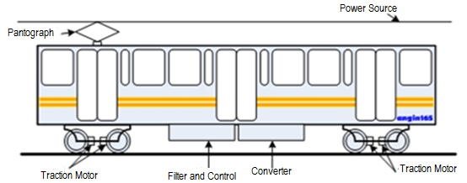

Fig. 1. The main parts of the electric train

Electric Train
In an electric railway system, the train is provided by sliding contact from a supply line that is placed over the railway tracks. The electric train uses two types of electricity sources, namely a DC source of 600 V, 750 V, 1500 V, and 3000 V, while for an AC source of 15 kV with a frequency of 16.7 Hz and 25 kV with a frequency of 50 Hz. A pantograph use to deliver the AC/DC sources to the trains. There are 2 types of pantographs commonly used on an electric train, namely diamond-shaped and single-arm, both types have the same function to supply electricity from the source above to the converter then forward to the motor (Fig. 1) so that the train runs. The pantograph must always contact continuously with the source conductor, besides that the pantograph must be aerodynamic because it is used at relatively high speed continuously [9].
The current generally return to the substation via the rails, a separate return conductor, or via the earth. The large electrical plants in the network are constituted of sub-plants, which are essentially independent. Every single sub-plant consists essentially of overhead lines, buried cables, and rails. Two different substations that are equipped with static AC–DC conversion groups supply the sub-network.
The return path of the current is constituted by the rails that are connected by means of cables to the negative pole of the supply. DC electrical motors controlled by choppers are employed for traction. In order to compensate for the voltage drop along the lines, several substations are used as line subway feeders. The power delivered by the substation is transmitted to the traction vehicle via a system of ﬂexible suspension contact lines (overhead or centenary) with which a locomotive mounted articulated device (pantograph) is brought into contact. On the traction vehicle, the power is regulated using choppers and then supplied to electric motors to control the movement. Auxiliary power that is lower than that which is supplied to the electric traction motors is also conditioned and regulated using static converters, inverters, and rectiﬁers. The rails ensure that the current return and the sources of magnetic fields on the train are often under the floors. [10].
1st train
Control
room
2nd train
3
2
1
3th train
4th train
Control room
4
5
Motor inverter
Electrical inverter
Fig. 2. Measurement point

METHODOLOGY
In this measurement, the motor located below the train is a source suspected of producing a high electromagnetic field. Ideally, the measurement is at the distance as close as possible to the source so that get the maximum measurement results. However, because the condition of the train is moving and the position of the motor is under the carriage, it is not possible to take the ideal near field measurement. The possible approach is to take measurements on the train floor area exactly where the motor is installed.
Magnetic field measurements are carried out in the frequency range of 0.015 kHz-1 kHz. The antenna is placed 10 cm above the surface of the train floor. Setup measurements can be seen in Fig.3.
The measurement conditions are as follows (Fig.2) :
- When the electric inverter starts at point 1
- When after the electric inverter starts up at point 2
- When after the electric inverter starts up at point 4
- When after the electric inverter starts up at point 5
- When the first acceleration starts at point 5
- When the train is running at point 5
- When braking starts at point 5

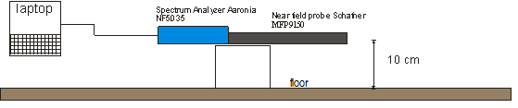
Fig. 3. Measurement setup

Results And Discussion
The results of near field magnetic field measurements are shown in the following graphs :
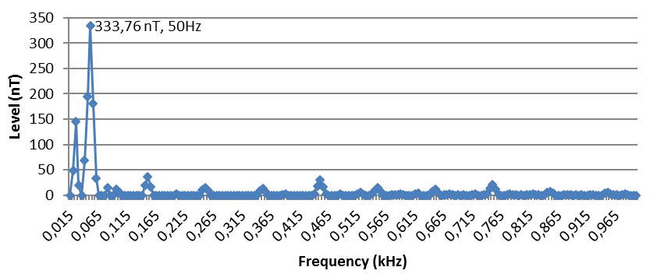
Fig. 4. Measurements graph when the electric inverter starts at point 1 (0,015 kHz-1 kHz)
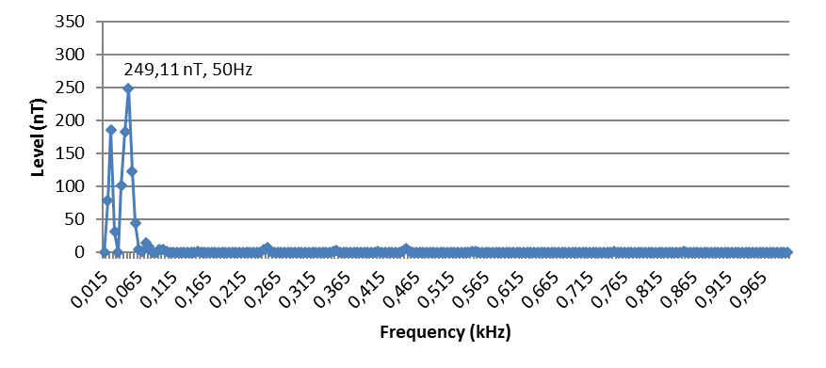
Fig. 5. Measurements graph after the electric inverter starts at point 2 (0,015 kHz-1 kHz)

From the picture above it can be seen at the measurement point 1 when the electric inverter starts to turn on the highest value of the magnetic field reaching 333.76 nT which is at the frequency of 50 Hz. A few moments after the inverter startup is seen in point 2 there is a decrease in the magnetic field value to 249.11 nT at the same frequency. At this point, it should be the maximum magnetic field due to the electricity inverter. But because of the limited measurement time so that the initial data when the inverter starts to be completely turned on cannot be done at this point.

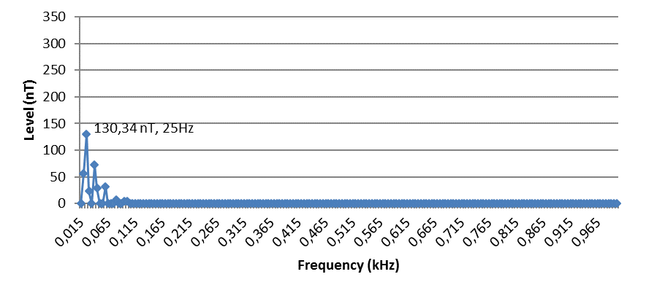
Fig 6. Measurements graph after the electric inverter starts up at point 4 (0,015 kHz-1 kHz)

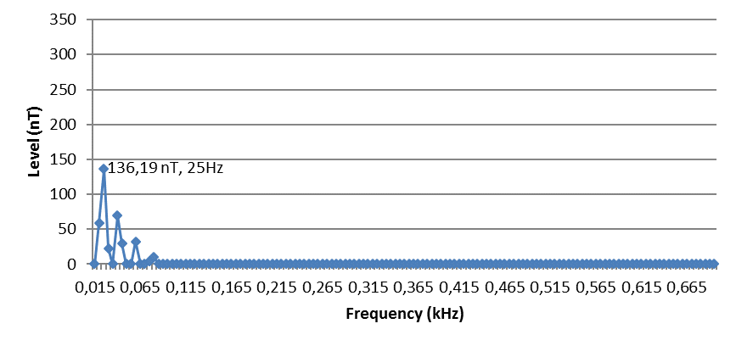
Fig. 7. Measurements graph after the electric inverter starts up at point 5 (0,015 kHz-1 kHz)

Fig. 6 and 7 are the results of measurements on the third train where it is located far from the electricity inverter and from the measurement results, it is seen that the magnetic field level is almost the same at both points which are around 130 nT. This value is relatively much lower than at the start of the starts up.
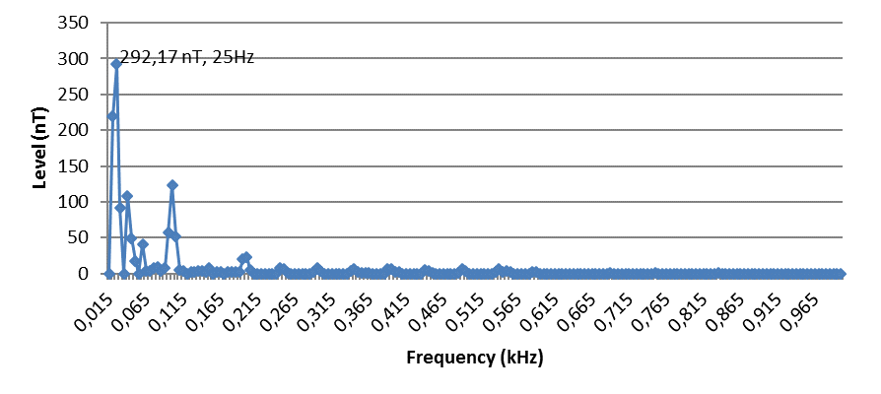
Fig. 8. Measurements graph when the first acceleration starts at point 5 (0.015 kHz-1 kHz)

In Fig. 8 shows an increase in the magnetic field level at point 5 (above the inverter motor) when the first acceleration occurs or the train starts moving from a stationary position. The peak value occurs at a frequency of 25 Hz which is equal to 292.17 nT.
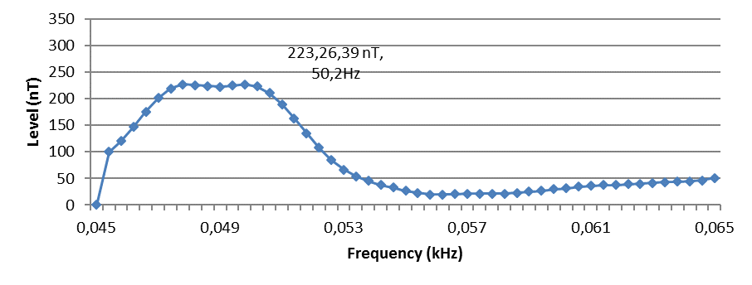
Fig. 10. Measurements graph at point 5 when the train is running (0.045 kHz-0.065 kHz)

Fig. 10 is a graph of the average magnetic field measurement results measured at a point just above the motor inverter when the train runs with a narrower measurement range, starting from a frequency of 45 Hz to 65 Hz. The graph shows that the largest magnetic field level at a frequency of 50 Hz with a magnetic field strength of 223.26 nT.

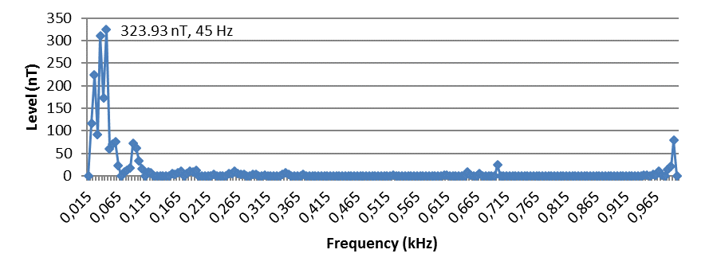
Figure 11. Measurements graph at point 5 when braking begins (0,015 kHz-1 kHz)

From Fig. 11, it can be seen when the train is braking, there is an increase in magnetic field level, which is at a frequency of 45 Hz with a field strength of 323.93 nT.
If all measurement results are compared with the limit recommended by the ICNIRP which is only 100µT for passengers (general public) then the magnetic field level of the train is relatively low.
For further application, the units in µT can be converted into units of dBµA/m using the following equation:

dBµA/m = 20 log ($\frac{μT}{1.25}$) + 120 (1)

So that the results are as follows :

TABLE 1. Magnetic Field (dBµA/m)
Condition | Measurement point | Frequency  (Hz) | Magnetic field  (µT ) | Magnetic field  (dBµA/m)
Electric inverter starts | 1 | 50 | 333,76 | 168,53
After electric inverter starts up | 2 | 50 | 249,11 | 165,98
After electric inverter starts up | 4&5 | 25 | 130 | 160,34
First acceleration | 5 | 25 | 292,17 | 167,37
When driving | 5 | 50 | 223,26 | 165,03
When breaking | 5 | 45 | 323,93 | 168,27

Conclusion
In this study, magnetic field measurements have been carried out on electric trains. The measurement results show the magnetic field level when measured near the electricity inverter is higher than when measured far from the electricity inverter. The highest level of the magnetic field is obtained when the train starts, which is equal to 333.76 nT. The average level of the magnetic field when the train driving is 223. 26 nT and during braking an increase of 323.93 nT. The value of the magnetic field strength at the two farthest points from the electricity inverter looks almost the same which is around 130 nT. This value is relatively much lower than at the start of the starts up.

Acknowledgment
The authors would like to thank Research Centre for Testing Technology, Indonesian Institute of Sciences for the equipment provided, PT. INKA for the EUT provided, and to the EMC Laboratory staff for the support.

References
- https://databoks.katadata.co.id/datapublish/2018/07/24/berapa-penumpang-krl-jabodetabek
- Niska, Stefan. “Measurements and Analysis of Electromagnetic Interferences in the Swedish Railway Systems.” Sweden. Lulea University of Technology, 2008.
- ICNRP Guidelines for limiting exposure to time-varying Electric, magnetic, and electromagnetic fields (up to 300 ghz). Published in: Health Physics 74 (4):494-522; 1998
- L. Hardell, T. Koppel, M. Carlberg. M. Ahonen, and L. Hedendahl, “Radiofrequency radiation at Stockholm Central Railway Station in Sweden and some medical aspects on public exposure to RF fields,” Int J Oncol. 2016 Oct; 49(4): 1315–1324.
- WHO. “Electromagnetic Field.” http://www.who.int/peh-emf/about/WhatisEMF/en/index3.html. 2009
- W. Ardiatna, D. Mandaris, D. Andiani, and R. H. Arjadi, “Pengukuran Tingkat Emisi Radiasi Elektromagnetik Kereta Rel Listrik Terhadap Lingkungannya.”. Jurnal Teknologi Indonesia Vol 33 No 2. 2010
- https://en.wikipedia.org/wiki/Magnetic_field
- https://www.techopedia.com/definition/8211/magnetic-field
- https://konversi.wordpress.com/2010/04/23/kereta-rel-listrik/
- M. N. Halgamuge, C.D. Abeyrathne, and P. Mendis, “Measurement and Analysis of Electromagnetic Fields From Trams, Trains And Hybrid Cars.” Radiation Protection Dosimetry. 2010, Vol. 141, No. 3, pp. 255–268

