Research of the Deep Cultivation and Cultural Design Activities of Kabuasua Tribe
Li-Hsun PENG ¹ and Min-Qiao WU ² and Indarti ³

¹ Department of Creative Design, National Yunlin University of Science and Technology. University Road, Section 3, Douliou, Yunlin 64002. Taiwan.
² Department of Creative Design, National Yunlin University of Science and Technology. University Road, Section 3, Douliou, Yunlin 64002. Taiwan
³ Department of Home Economic, Faculty of Engineering, Universitas Negeri Yogyakarta. & Doctoral Program, Graduate School of Design, National Yunlin University of Science and Technology. University Road, Section 3, Douliou, Yunlin 64002. Taiwan.

E-mail: penglh@gemail.yuntech.edu.tw, m10736013@gemail.yuntech.edu.tw, indarti@uny.ac.id
Abstract. The history of the development of Taiwan’s aborigines is an endless tragic song. Regarding the aboriginal group that is not rectifying the name by the government. Researchers are deeply aware that they face cultural and survival crises.
Mr. Duan, Hong-kun, a cultural and historical worker of the Kabuasua tribe, He and several colleagues set up the Kabuasua tribe school, hoping to cooperate with the education unit to hold the tribe's tour and cultural creative design courses, trying to collide with the new sparks and the students' interaction in various event design or tribal visits. In the process, and to stimulate and create the possibility of multi-directional development of the tribe, not only can promote the culture of the Siraya, but also make more people understand the efforts and processes of the Siraya name rectification movement.
Chen,Yi-jun, a CEO of the Kabuasua tribal school, says: "In fact, everyone can become a cultural seed of the aboriginal tribe." Therefore, by actively working across the school cooperation to deep plowing of campus, and with the local residents to promote the tribal cultural and creative industries. For example, the actual practice is to extract the characteristics of Kabuasua cross-stitch culture, and then to reproduce and produce the characteristic cultural goods with YunTech’s advanced electric embroidery process.
In addition, we can also promote the "Zelan Rice" culture of Kabuasua in the form of event design. From the activities, people can experience the production methods of rice and the process of making cultural products. If we develop the above cultural elements in tandem, we can not only achieve the purpose of cultural inheritance, but also hope to be able to integrate into the activities of small trips to find more innovative and very down to earth approach. This will promote the promotion of the original culture, no longer just the unilateral contribution and efforts of the local people. It is the all team who work together to create a partnership. In this way, the seeds of culture can be distributed, and more fruits with the rich cultural connotations of the Siraya can be born.
Keyword－Siraya, Kabuasua tribe, Cultural design, Cultural Inheritance, Activity Design
- Introduction
  - Research background and motivation
"We are always alive, culture is passed down, where is it going to disappear? The stigma of social ignorance, the Siraya seems to be floating in the land of Taiwan" [1]. "Culture" is the most representative of the representativeness and core soul of the nation. At present, Taiwan’s lazy mentality in ethnic education often refers to the indigenous peoples in the western plains as “Pingpu people”. Many cultural historians and aboriginal ethnic groups have begun to criticize and oppose such events. They believe that this is an early misconception of misconceptions and ideas under the ethnic identity; the Kabuasua tribe in Dongshan District, Tainan City is the victim of this historical error. After nearly 20 years of recognition campaign, they gradually recovered their sense of self-identity. The Siraya people of Kabuasua tribe who have their own cultural history, national beliefs and customs.
The researchers conducted field investigations and Participatory Observations in the Kabuasua tribe, and after interviews with the geoscientists and tribal residents, they learned deeply about the actual situation of the Siraya people in the name movement. Actions, and how many challenges and tests they have encountered on the road to cultural rejuvenation, all the effort and spirit are all about retrieving the trajectory of self-culture and trying to pass on to the next generation to reach culture. The purpose of sustainable business.
  - Research purposes
This study explores the Kabuasua tribe of the Siraya ethnic group in Tainan City. Expecting to organize the cultural activities of the tribe, and organize the small travel activities design. Through the cooperation with National Yunlin University of Science and Technology (YunTech), National Tainan Girls Senior High School, Chang Jung Christian University, and Catholic Sheng Kung Girls High School, we will establish cooperation of deep plowing of campus and try to form a consensus with the economically disadvantaged aborigines, create a tribal cultural and creative industry economy, and enhance the positive energy and influence of culture.
  - Research directions
The core issue of this research lies in the deep cultivation of the campus and the creation and inheritance of the tribe. It is hoped that the ethnic groups and the young students will achieve the cooperation and co-creation in the interaction process of the activity design. In addition, the Kabuasua tribe school provides suitable learning and activity space, and human resources can also cooperate with educational institutions and participate in the grand event. Therefore, this research is feasible, and is expected to be integrated into the cultural design of the event. More creative and grounded practices.
In this way, the development of cultural elements in tandem can also enable the participating participants to experience the cultural context of food, clothing, housing, travel, education, music, etc. in the Kabuasua tribe while conducting cultural activities. It could be drive and enhance the cultural development and inheritance of Kabuasua tribe.
  - Research Questions
In recent years, researchers have conducted data collection and analysis on the Shiraza Jibei tribe through field surveys, in-depth interviews, and participatory observations, and then injected design ideas into the local cultural activities. The following research questions are discussed:

(1) What problems and dilemmas have the Siraya people encountered in the implementation of cultural heritage?
(2) What is the necessity of bringing young students into Kabuasua tribe?
(3) What kind of benefits can the tribe bring to the campus?
(4) How to inject the culture, beliefs, clothing, food, housing, travel, education and music of the Siraya into the preparation of cultural activities through design thinking.
- Literature Review
This chapter is mainly exploring the design of children's shoes and metalworking, and introduce the correct concept of transportation to teach children and promote parents' ideas and research related to this research.
  - The Kabuasua tribal School
The tribal school has also fulfilled the responsibility of caring for tribal children. In addition to many children who will come here during school hours, the most important thing is to hold camps or supplementary activities during the cold and summer vacations so that children can have A space where you can live together and learn knowledge. Through long-term persistence and hard work, the tribal school has also been a window to promote the culture of Kabuasua tribe, attracting more people to come here to know the culture, beliefs and customs of the traditional Shiraz, and to taste the tribal meals. Experience the traditional rice food culture DIY, as well as many handicraft activities, such as: mochi production, reins beading, cross stitch crafts, etc.
In view of this, the Kabuasua tribal school has increased the cultural development and inheritance, and has spent a lot of time and effort to be able to have today's appearance. Over the years, from the inside out, the efforts and development have not only condensed the awareness of the identity of the local people, but also let them know that it is very important to protect and continue the self-culture. It also makes the outsiders more familiar and close to Siraya culture.
2.2 Cultural heritage
The term "cultural heritage" has been defined in many documents, and researchers will summarize and analyze the definition of cultural heritage by different scholars, as shown below:

(1) Cavalli-Sforza & Feldman (1981) believe that cultural inheritance is a common behavioral pattern of modern human beings [2]. It is the ancestor's expression of life habits, beliefs and language, and the thoughts accumulated through teaching and inheritance. People pursue the inheritance process. In the middle, the self-mind has also been sublimated, which in turn affects the thoughts and behaviors of future generations.

(2) Banks & Banks (1989) propose that cultural inheritance is an act that can be carried out in order to survive, including sharing knowledge, concepts, and values with each other, and also transmitting symbols and beliefs with other groups. Instead of explaining it [3].

Through the narratives of the two scholars on cultural inheritance, the researchers believe that culture is both a social heritage and a cluster of traditional national behaviors. It is a social element that is derived from material and spiritual life. Such development can enable each generation to continue. Constantly learning and achieving the purpose of delivery.
- Research Methodology
  - Field work
Field work is a way of in-depth interviews, participatory observations and residential experiences. In the natural environment, research and observation of geographical features, social structure, customs, and interviewers, after a long period of data collection and analysis, obtained the first First-hand research data [4].
  - In-depth interview
During the research period, the researchers went to the Kabuasua tribal school to conduct field investigations many times, and also established emotions and consensus with the local cultural and historical workers [5]. The accumulated development and relationship between the tribes and the tribes are aimed at It will enrich the relevant cultural connotations of the people, literature, land, scenery and objects of the Siraya people. After reaching a consensus with the tribal residents, they can implement the plan and promote the cooperation and promote the culture. In particular, after the author has accumulated a long cultural experience, he can find out what the tribe lacks. For example, how to improve the cultural identity of the local people, how to pass the culture to the next generation and continue to spread, and to package the cultural characteristics. And why the promotion of the event design method. Therefore, this research can also be more inspective and unique; as a result, it also enhances the innovation and creativity of research.
- Analysis
  - Overview of Kabuasua 's tribal culture characteristics and industry
The name Kabuasua is from Siraya language as the "Kapok Tribe", formed between the fifty-six to the sixty years of the Qing Emperor Qianlong, and is now located in Dongheli, Dongshan District, Tainan City. The Kabuasua tribe has a multi-faceted cultural identity and characteristics such as tribal school, space art transformation, cultural ritual belief culture, ceremonial activities, characteristic agricultural products and craft activities, and will be organized according to different seasons. Launch cultural events with seasonal features. Therefore, the following will integrate the researchers to analyze the cultural characteristics of the Kabuasua tribe [6].

Kabuasua’s tribal & Cultural Characteristics | Kabuasua’s Tribal View | Kabuasua Tribe
Art transforming the Tribal space | 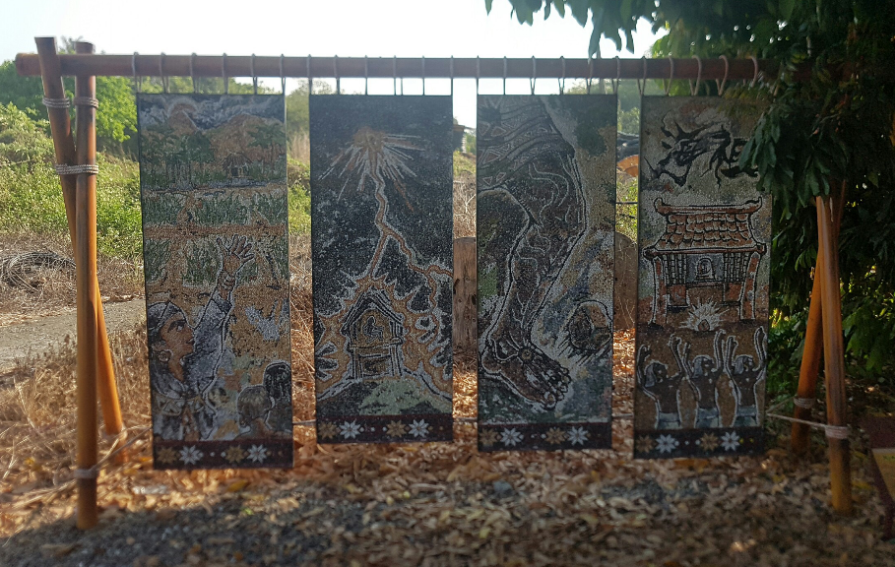 | There are many unique works of art in Kabuasua tribe, and these legendary works made by staining with natural fine stones. In addition, in the southeast, southwest, and northwest, there are three sets of seats, each of which has the drawing style of the three sets of seats, representing the fate of the Siraya and meaningful names commemorates the post-Japanese war.
Cultural Tours | 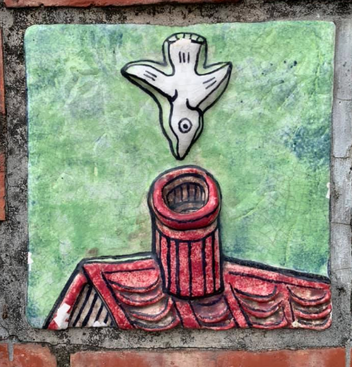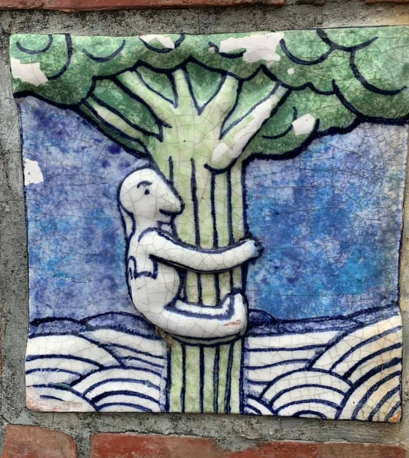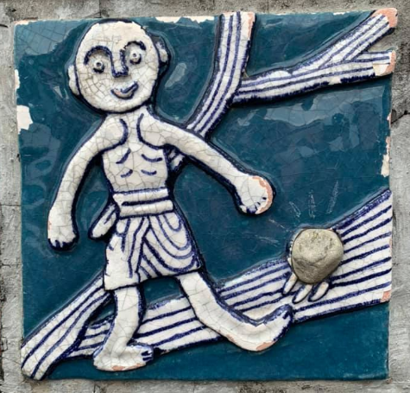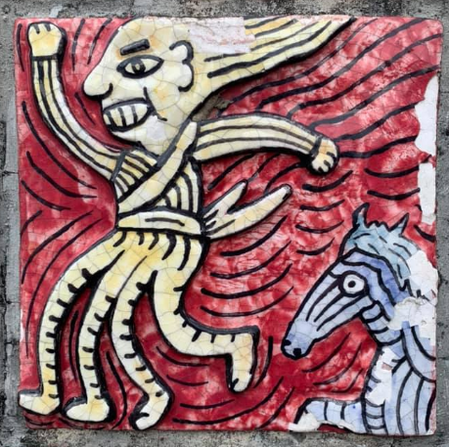 | Discover the stories of pottery plates on the red brick walls of the streets. These stories were told by the local tribal people, and the stories of the tribes of the local tribes are turned into stories on the walls of the tribes. Let the visiting people know the interesting and rich story of the Kabuasua’s tribal culture. There is also a Qr-code device next to each pottery board, which can provide you with the contents of the digital tours.
Ceremony Activities | 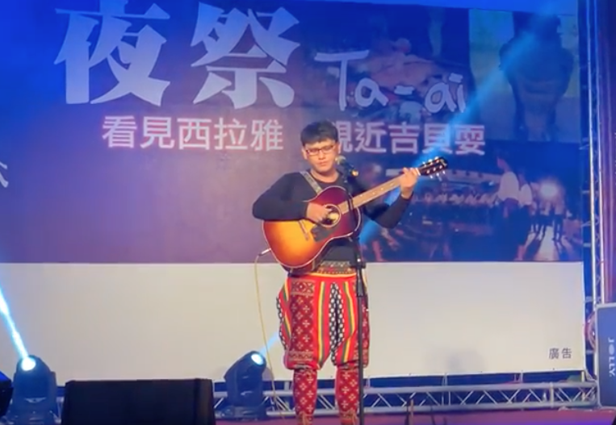 | The most special ceremonial event in Kabuasua tribe, among which are the "Night Festival" and "Xiaohai Festival". Both are most famous, and they are holding in the fourth and fifth days of September in the lunar calendar every year. The holding of the ceremonies will attract people from outside the country to return to their hometown and to worship the Ari Mom, and will attract many people from all over the country [7].

- Conclusion
When the nation’s root-seeking consciousness rises, it also prompts the people of the Kabuasua tribe to explore and understand their status; Siraya, who often considered to have disappeared and “Chineseized” in history, and is now constantly thinking positively. Let the cultural characteristics of the Siraya stand out and want to become the statutory Taiwanese aborigines. This is the goal that Kabuasua tribe in the past few years and revived their traditional culture. Mr. Duan, Hongkun, the Director General of the Kabuasua’s tribal School. In order to inherit the culture of the Siraya, he and several partners in the tribe formed the “Kabuasua’s Tribal and Historical Studio”, and they decided to jointly revive the responsibility of tribal culture rejuvenation, not only will we do our part for our own people, and we hope that more and more people in the tribe will unite and discuss their ethnic consciousness and drive the overall Siraya culture together.
In order to practically implement the purpose of tribal culture inheritance, the writers and historians decided to work together to make substantial efforts for the Jibei tribe. They have long been in contact with many schools, such as: Kabuasua Primary School, Yunlin University of Science and Technology, Tainan Girls High School, Evergreen University, Kaohsiung High School, Chiayi University, Providence University, etc.; even the Hong Kong Polytechnic University participated in tribal cultural activities. The researchers not only recorded the process as an observer, but also participated in many activities. They experienced the various experiences of the Kabuasua tribe. It was really a very special preparation and planning, and it received many enthusiastic responses. In view of this, the model of the Kabuasua tribe through the deep cultivation of campus and cultural activities. In order to makes the benefits of enhancing cultural heritage and cultural revitalization extremely powerful and has very good interactive feedback. Researchers believe that if this model can bring good repercussions, then it can bring its programs to other tribes or communities that are interested in creating a cultural future together, so that more people can find different cultural contexts, understanding and Learn more about the cultural context of Taiwanese people.

- References
[1] Duan H K 2013 Ali Ancestor’s Faith Research. Tainan City: Tainan City Government.
[2] Cavalli-Sforza L L & Feldman M W 1981. Cultural transmission and evolution: a quantitative approach (No. 16). Princeton University Press.
[3] Banks J A & Banks C A M (Eds.) 1989. Multicultural education. Boston: Allyn & Bacon.
[4] Cai J D 2017 Fieldwork ABC, Local Sociology: PiKeBan.
[5] Bi H D 1996 Hermeneutics and qualitative research. In Hu Y H (editor), qualitative research: theory, methods and examples of indigenous women (27-45). Taipei: Giants.
[6] Pan C C, Duan H K 2016 Identity under the Resurgence of Culture--Taking the Siraya’s Kabuasua Tribe as an Example. Taiwan Journal of Aboriginal Ethnic Studies 201603 (6:1).
[7] Duan H K 2013 Al Ancestor’s Faith Research. Tainan City: Tainan City Government.

