Simulation of Acidity Reduction of Hot Spring Bath Water in Lahendong Geothermal Field, North Sulawesi using Runge-Kutta Method
Natalia Intan Kharisma¹, Brenda Claudia Mauren¹, Andang Widi Harto¹ and Pri Utami²
¹ Phycics Engineering, Department of Nuclear and Physics Engineering, Faculty of Engineering, Universitas Gadjah Mada, Indonesia
² Geological Engineering Department and Geothermal Research Center, Faculty of Engineering, Gadjah Mada University, Yogyakarta, Indonesia.

*Coresponding author’s e-mail: natalia.intan.k@mail.ugm.ac.id
Abstract. Numerous acidic hot springs characterize to Lahendong geothermal field. Many of them for example, those occuring in the Pine Forest recreation area are utilized for bathing. This hot springs have a temperature for about 40 degrees of Celcius and pH value of less than 2. Besides being corrosive the acidic fluids also irritate human skin. This paper presents the preliminary results of our research aiming to reduce the acidity of the hot spring bath water in lahendong by utilizing Calcium Carbonate (limestone). The increment of pH of the water is calculated by using Runge-Kutta 4th order method and approached by continuous-stirred tank reaction using cylindrical tank. The trial using simulated trial errors and assumed variables. Simulation could be applied and adjusted to field conditions. First trial produces pH 2.5, it is obtained if the frequency factor value by 0.2. Second trial produces pH 5 with frequency factor value by 1.1. Thus, the greater the value of frequency factor, the faster the reaction will work and produce a larger pH.

- Introduction
The earth has a large energy stored in it, a heat source at a few kilometers depth called magma. Magma heat is transferred to the surface through steam-heated. Geothermal energy is thermal energy that can be utilized to generate the electric power, as known as geothermal power. Geothermal energy is a renewable, suistainable and produces almost no emission of CO₂. Geothermal system uses both gas and liquid part as energy. The geographic structure on the surface could show the geothermal potential, it is called the manifestation. Manifestation has unique structure and it can be utilized as a tourist object. Hutan Pinus Lahendong (Pine Forest Lahendong) is one of the destinations uses its manifestation as the main attraction of tourism.
Lahendong is located in North Sulawesi, South of Manado. Lahendong geothermal field has been operated since 2001 and became the first geothermal field in the eastern of Indonesia. Lahendong is part of the Sangihe volcanic arc, located between volcanic mountains, there are Lokon volcano in Northwest, Tondano volcano in West, and Soputan volcano in Southwest [1]. The first geothermal activity in Lahendong is started after the peak of the voluminous volcanism in the Sangihe arc [1]. Numerous acidic hot springs characterize to Lahendong geothermal field. Many of them for example, those occuring in the Pine Forest recreation area are utilized for bathing. This hot springs have a temperature for about 40 degrees of Celcius and ph values of less than 2.
Hot spring in Pine Forest Lahendong is categorized as acid-sulfate water type. Water with a low pH can be acidic and corrosive. The acidic is mostly caused by sulfuric acid content (in this area). Acidic fluids constitute high risks for the skin health. Besides being corrosive the acidic fluids also irritate human skin. The sulfuric acid water has powerful water bonding therefore makes the skin dry faster [2].
The addition of calcium carbonate in the sulfuric acid can reduce the acidity. Calcium carbonate (as known as limestone) usually used as a treatment to neutralize mining wastewater (acid mine drainage). Limestone has been proven to increase the pH value, moreover it is also decreasing metal and sulfate. For instance, this method has been done by using the limestone to neutralize acid streams during coal mining and processing. As the result, limestone could reduce the acid content from 12000 mg/l to 300 mg/l, sulfate from 15000 to 2600 mg / l, as well as iron from 5000 to 10 mg / l and aluminum from 100 to 5 mg / l. The usage of caco3 in acid content also increased the pH from 2.2 to 7 with a reaction time of 2 to 4.5 hours [3].
Therefore, this paper will explain the change by using the Runge-Kutta 4th order method in order to calculate: amount of the limestone, temperature, and changes in pH values.
- Research Method
This research is assumed theoretically using Runge-Kutta method based on the circumstances in the field. Only first order ordinary differential equations can be solved by using the Runge Kutta 4th order method. The equation of Runge-Kutta 4th order represented as,

$$y\left(x+h\right)=y\left(x\right)+\frac{1}{6}\left(K_{1}+2K_{2}+2K_{3}+K_{4}\right)$$
Where
$$K_{1}=f(x,y)$$
$$K_{2}=f\left(x+\frac{h}{2},y+\frac{K_{1}}{2}\right)$$
$$K_{3}=f\left(x+\frac{h}{2},y+\frac{K_{2}}{2}\right)$$
$$K_{4 }=f\left(x+h,y+K_{3}\right)$$

This equation is gained through the review of its mass balance and energy balance. Runge-Kutta is selected because this method is more effectively and more accurate than Euler’s Method. Euler's Method uses a small interval size to get a reasonably accurate result which is not efficient enough [4].
  - Mass balance
The mass balance is approached by a continuous-stirred tank reactor with the mass transfer from the flow as following
(initial flow) – (outflow) + (generate flow) – (consumed flow) = (accumulation)

It is assumed that the initial flow is equal with outflow and there is no consumed flow. The equation will become as
(flow) + (generate flow) = (accumulation)
The flow is a volumetric flow rate ($Q$) and the generate flow is described as influencing variables, such as porosity ($ϕ$), volume (cylindrical, ${πD^{2}}/4$), and reaction rate constant ($R^{‴}=k∙C$ with $k=A∙exp\left({-E}/{RT}\right)$ [5].
Rearranging and inserting the variables have been mentioned before, thus

$$QC_{H_{2}{SO}_{4}}⃒_{z+∆z}+\frac{πD^{2}∆z}{4}{ϕ∙R}^{‴}=QC_{H_{2}{SO}_{4}}⃒_{z}$$

$$QC_{H_{2}{SO}_{4}}{\overset{⃒}{}}_{z}-QC_{H_{2}{SO}_{4}}{\overset{⃒}{}}_{z+∆z}=\frac{-πD^{2}∆z}{4}{ϕ∙R}^{‴}$$

$$\frac{C_{H_{2}{SO}_{4}}⃒_{z}-C_{H_{2}{SO}_{4}}⃒_{z+∆z}}{∆z}=\frac{-πD^{2}∆z}{4Q}{ϕ∙R}^{‴}$$

$$\frac{dC}{dz}=\frac{-πD^{2}∆z}{4Q}{ϕ∙R}^{‴}$$
  - Energy balance
The energy balance is similar with mass balance, however the influencing variables in generate flow are volume, porosity, reaction flow rate, and enthalpy of reaction (92.2 kJ/gmol).

$$QρCpT⃒_{z}+\frac{πD^{2}∆z}{4}{ϕ∙R}^{‴}∙{∆h}_{R}=QρCpT⃒_{z+∆z}$$

$$QρCpT⃒_{z}-QρCpT⃒_{z+∆z}=\frac{πD^{2}∆z}{4}{ϕ∙R}^{‴}∙{∆h}_{R}$$

$$QρCpT⃒_{z}-QρCpT⃒_{z+∆z}=\frac{πD^{2}∆z}{4}{ϕ∙R}^{‴}∙{∆h}_{R}∙{∆h}_{R}$$

$$\frac{dT}{dz}=\frac{πD^{2}}{4∙Q∙ρ∙Cp}{ϕ∙R}^{‴}∙{∆h}_{R}$$

Value of $ρ∙Cp$ will be approached with equation (14).

$$ρ∙Cp≃ϕ∙ρ_{L}C_{p_{L}}+(1-ϕ)ρ_{s}C_{p_{s}}$$

Therefore, the mass balance can be defined as a function to calculate the concentration of the hot spring (equation (8)) and energy balance as a function to calculate the temperature of the hot spring (equation (9)).The function on each component is
$$\frac{dC}{dz}=f_{1}\left(C,T\right)$$
$$\frac{dT}{dz}=f_{2}\left(C,T\right)$$

Thus, then the Runge-Kutta equations for this research are
$$x_{j+1}=x_{j}+Δx$$
$$C_{j+1}=C_{j}+\frac{Δz}{6}\left[K_{C1}+{2K}_{C2}+{2K}_{C3}+K_{C4}\right]$$
$$T_{j+1}=T_{j}+\frac{Δz}{6}\left[K_{T1}+{2K}_{T2}+{2K}_{T3}+K_{T4}\right]$$
Where,
$$K_{C1}=f_{1}\left(C_{j}, T_{j}\right)$$
$$K_{T1}=f_{2}\left(C_{j},T_{j}\right)$$

$$K_{C2}=f_{1}\left(C_{j}+K_{C1}∙\frac{∆z}{2},T_{j}+K_{T1}∙\frac{∆z}{2}\right)$$

$$K_{T2}=f_{2}\left(C_{j}+K_{C1}∙\frac{∆z}{2},T_{j}+K_{T1}∙\frac{∆z}{2}\right)$$

$$K_{C3}=f_{1}\left(C_{j}+K_{C2}∙\frac{∆z}{2},T_{j}+K_{T2}∙\frac{∆z}{2}\right)$$

$$K_{T3}=f_{2}\left(C_{j}+K_{C2}∙\frac{∆z}{2},T_{j}+K_{T2}∙\frac{∆z}{2}\right)$$

$$K_{C4}=f_{1}\left(C_{j}+K_{C3}∙∆z,T_{j}+K_{T3}∙∆z\right)$$
$$K_{T4}=f_{2}\left(C_{j}+K_{C3}∙∆z,T_{j}+K_{T3}∙∆z\right)$$
The equation above is slightly different with the basic Runge-Kutta’s equation because in this case there are two variables as the focus, concentration ($C$) and temperature ($T$).This calculation is a numerical method where the data should be entered to the equation in order to gain the result. Figure 1 represents the procedure diagram of the research.
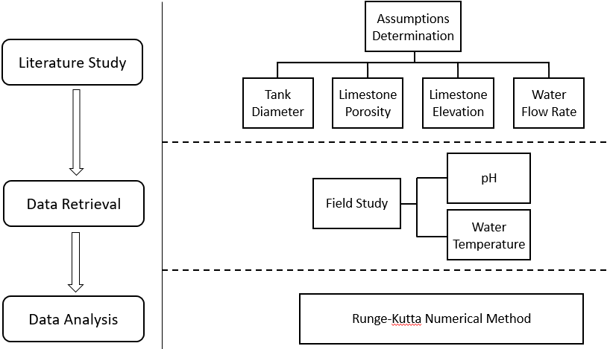
Figure 1. Research Procedure Diagram.

- Result and Discussion
  - Result
The obtained data is divided into two parts, namely field data and assumed data. Table 1 expresses variables based on field data while Table 2 expresses variables based on assumptions.

Table 1. Field Data Variables
Symbol | Variables | Value | Unit
$$D$$ | Diameter | 2 | dm
$$ϕ$$ | Porisity | 0.3
$$Q$$ | Flow rate | 0.15 | dm³/s
$$z$$ | Elevation | 1 | dm
$$∆z$$ | Changes elevation | 0.05 | dm

Table 2. Assumed Variables
Symbol | Variables | Value |  | Unit
$$k$$ | Constant flow rate | 4.679717
$$C$$ | Concentration of sulfate acid based on initial pH | 0.005
$$π$$ | Pi | 3.14 |  | gmol/liter
$$E$$ | Activation Energy | 0.1621 |  | J/gmol
$$R$$ | Reynold's number | 8.314
CaCO₃
$$ρ$$ | Density |  | 2710 |  | g/liter
$$c_{p}$$ | Spesific heat capacity |  | 0.82 |  | J/g.K
H₂SO₄
$$ρ$$ | Density |  | 1840 |  | g/liter
$$c_{p}$$ | Spesific heat capacity |  | 139.93 |  | J/g.K

Calculation and determination of pH value are done by entering the variables in the Runge-Kutta function. This calculation uses trial and error method to obtain the value of frequency factor ($A$) variable. Value of frequency factor is changed and adjusted to reach the required pH values. Calculation and results of data processing a re presented in Table 3 and Table 4.

Table 3. Runge-Kutta Calculation with the target of pH values is 2.5 and produces an A value by 0.2
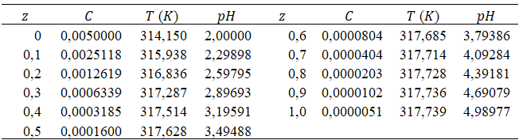

Table 4. Runge-Kutta Calculation with the target of pH values is 5 and produces an A value by 1.1
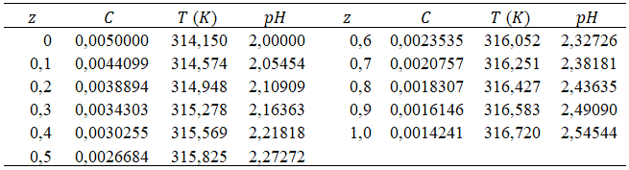

  - Discussion
Assumptions used in this calculation are:
            - The limestone has pure CaCO₃
            - Particle is in sphere form
            - Hot spring is approached by sulfuric acid
            - Using a cylindrical tank (due to neutralization procces)

According to the Table 3, the first trial 10 cm of stone produces pH 2.5. It will be obtained if the frequency factor value is 0.2. After that, Table 4 shows pH 5 with the same size as first trial and the frequency factor value is 1.1. Both of them have the same height, and from the two examples it can be concluded that the greater the value of frequency factor, the faster the reaction will work, eventually it can produce a larger pH value.
The value of the variable can be changed and adjustable to the conditions in the field. At the results stage, the determination of pH values uses the change in the frequency factor value to get the expected results. The frequency factor value is a variable that depends on environmental factorsthus it affects the other variables as well as the occurrence of collisions. Frequency factor is affected by the shape and size of the particles used (in this case is CaCO₃). The shapes and sizes difference of the particles effects the value of frequency factors. In the collision process, particle size plays an important role to speed up and slow down the reaction. Collisions occur faster if the size of the particles is insignificant. The smaller of surface area (size) of a particle, the faster it moves and the impact will be even greater.
The height of the stone pile is also influential in determining the required pH. This height can be adjusted by changing the frequency factor value. In determining pH using the Runge-Kutta method, there are 3 things to be considered in determining pH using the Runge-Kutta method, namely the frequency factor, the expected pH and the height of the stone pile.
At a further stage, it is necessary to have measurements for validation results. Solution of this method is based on approximation and approachment.

- Conclusion
The Runge-Kutta 4th order method can be applied to increase the pH values. This calculation could be used for any type of tank, according to the prescribed assumptions. The frequency factor affects changes in pH values. The greater the value of frequency factor, the faster the reaction works faster and produces a larger pH value.

Acknowledgements
The author is gratefully acknowledge the support of this work by Research Directorate of UGM, the owner of Pine Forest Lahendong for the coorperation with us, and my endless gratitude to my partner and my great supervisor.

References
[1] P. Utami, “Hydrothermal Alteration and the Evolution of the Lahendong Geothermal System, North Sulawesi, Indonesia,” no. April, p. 449, 2011.
[2] K. S. Garvin, “Health Effects of Sulfur in Water | Livestrong.com.” [Online]. Available: https://www.livestrong.com/article/158629-health-effects-of-sulfur-in-water/. [Accessed: 24-May-2019].
[3] J. P. Maree, M. De Beer, W. F. Strydom, and A. M. Christie, “Limestone Neutralisation of Acidic Efluent, Including Metal and Partial Sulphate Removal,” IMWA Proc. 1998, p. 12, 1998.
[4] E. Supriyanto and M. Sc, “Runge-Kutta Orde Empat,” vol. 2006, no. 3, pp. 1–9, 2006.
[5] M. K. Stenstrom and D. Rosso, “Fundamentals of Chemical Reactor Theory,” pp. 1–9, 2003.

