Development Of Accreditation Information System (AIS) for Vocational Higher Education with NAAHE Standard
(Case Study At Astra Manufacturing Polytechnic)

Rida Indah Fariani¹ and Ayudiah Damayanti²

^{1,2}Department of Information System, Astra Manufacturing Polytechnic
Jl. Gaya Motor Raya No. 8 Sunter II Jakarta, Indonesia

E-mail: rida.i.fariani@polman.astra.ac.id
Abstract. Higher Education Accreditation is an activity that must be implemented by every college for every 5 years where this activity becomes a benchmark for college sustainability. This accreditation must be in line with the National Accreditation Agency for Higher Education (NAAHE) standards. Astra Manufacturing Polytechnic (Polman Astra) as one of the vocational higher education also conducts the accreditation. In compiling the accreditation instrument Polman Astra has a problem such as the inaccuracy of accreditation data between one department and another and the difficulty of coordinating among departments in providing data accreditation compilation. This problem may cause the late of accreditation according to a predetermined time. Due to this problem, an information system was built, namely Accreditation Information System (AIS). It is a web-based information system and designed according to NAAHE standard. AIS is built using the .NET framework and SQL Server DBMS with prototyping methodology. After implementation, AIS was able to integrate the needs of data accreditation by providing data requirements that were directly generated from the Polman Astra database. AIS is also able to manage the accreditation data table dynamically and transparently, reduce paper printing costs and prevent delays in the preparation of accreditation instruments so that the accreditation can be completed according to a predetermined time

- Introduction

Higher education plays a fundamental role in preparing human resources to gain global competitiveness and enhance the nation. One of higher education quality is affected by the quality of education. The Indonesia government has set standards that can maintain the quality of education by establishing the National Standard of Higher Education (NSHE) and the standards set by each college [1]. NSHE must be applied by each higher education. Therefore the government conducts accreditation to see whether the higher education has implemented NSHE in its governance. Accreditation is the recognition of educational Institutions given by the competent authority after being assessed that the Institution meets certain criteria requirements [3]. This accreditation is carried out by the National Accreditation Agency for Higher Education (NAAHE) [4] and the result is the recognition that the institution or study program has met the established standards.
Astra Manufacturing Polytechnic (Polman Astra) is a formal educational institution with a Diploma III program that focuses on creating human resources that are ready to use in the industry. Supporting government regulations regarding higher education accreditation, Polman Astra organizes accreditation carried out by NAAHE with established standards. There are 7 standards that must be met, namely: (1) Vision, mission, goals, objectives and strategies for achievement, (2) Governance, leadership, management systems and quality assurance; (3) Students and graduates; (4) Human Resources; (5) Curriculum, learning, and academic atmosphere; (6) Financing, facilities & infrastructure and Information Systems; and (7) Research, community service, and collaboration [4].
In the accreditation process, Polman Astra makes accreditation instruments for both institution and program study in accordance with the NAAHE standards. It is found that when making the accreditation instrument, there are several problems experienced, namely: (1) Data inaccuracies between one department and another, because the existing data between department related to accreditation has not been integrated; (2) Difficulty in coordinating among team accreditation which lead to delaying of accreditation instrument preparation ; and (3) Delay in returning table data by the related department for over fifteen days by average.
To solve these problems, Polman Astra conducts a business process improvement for the accreditation process by developing an information system that can accelerate the process of preparing accreditation instruments. The system is called the Accreditation Information System (AIS). Therefore the purpose of this research is to build AIS which has the ability to: (1) Integrate data and information for the purposes of compiling accreditation instruments; (2) Making data and information on accreditation instruments to be transparent and can be managed easily by all related departments; (3) Reducing operational costs such as paper printing costs for drafting accreditation instruments; and (4) Prevent delays in the preparation of accreditation instruments so that the preparation of accreditation instruments is completed on time.

- Methodology

This research process was carried out with the stages as follows : (1) Problem identification and formulation; (2) Business Process Improvement; (3) Development of AIS, which is using prototyping method. This method consist of several phase : Planning, Analysis, Design and Implementation ; (4) Presentation of research result; and (5) Presentation of research conclusion.
On stage one, problem identification and formulation are obtained by doing an user interview and analyzing the current internal business process. Business process improvement is done by automating or eliminate some inefficient process. A prototyping method perform the analysis, design and implementation phases concurrently, and all three phases are performed repeatedly in a cycle until the system is completed [5]. With this method, the basic of analysis and design are performed and work immediately begins on a system prototype, which is provides a minimal amount of features. This method is shown in Figure 1.

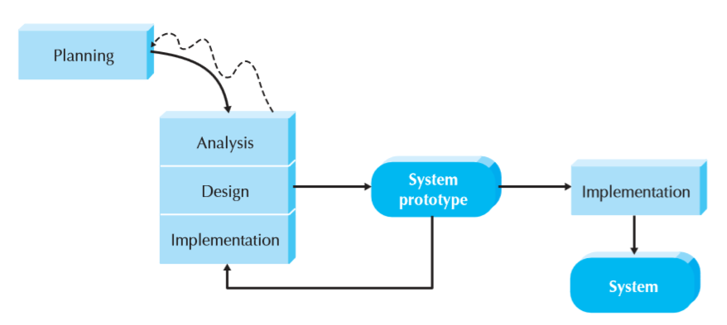
Figure 1. Prototyping Method [5]

- Result And Discussion

  - Existing Business Process and Improvement
Existing business process can be described as follows : (1) Institution or Program study that requires accreditation process apply accreditation request to QA department; (2) QA Department prepare the preliminary data for instrument accreditation; (3) QA Department then distribute the preliminary data to the related departments to be completed ; (4) The related departments complete the data based on NAAHE standard and sending it back to the QA department; (5) QA Department gather, check, and compile data form departments using standard format and sending it to the accreditation team; (6) Accreditation team then make instruments accreditation based on these data and sending it back to the QA Department when finished; (7) QA Department do final check and legalize these instruments and submit it to the NAAHE. These flows can be seen in Figure 2.

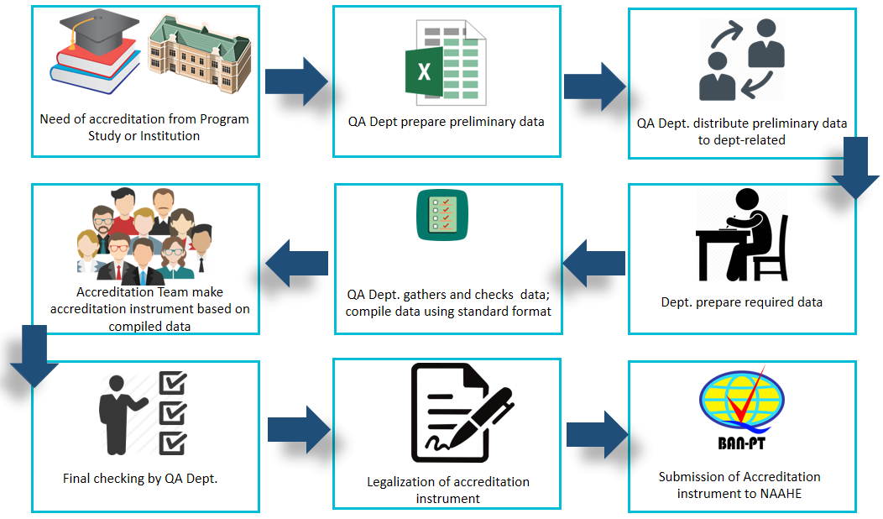
Figure 2. Existing Accreditation Business Process

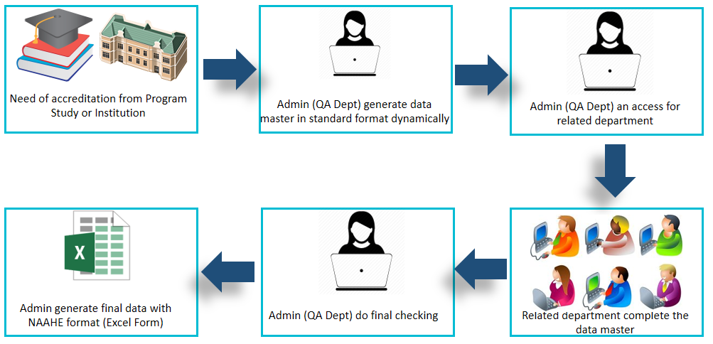
Figure 3. Accreditation Business Process Improvement

From the current business processes, improvements are made in the form of (1) process efficiency; and (2) process changes. Efficiency is carried out in the data preparation process, from originally manual data preparation changed into automatically generated from institutional databases. Process changes were made to the data processing (point 2 to 6 in the existing business process). In the improvement process, the department is given the right of access to data through the system so that the process of completing data is simpler and faster. There is no need for the accreditation team specifically because the data has been produced by the department according to needs. The QA Department only needs to do a final check and generate data in accordance with NAAHE standard by the system. The business process improvement can be seen in Figure 3.

  - Development of AIS
    - Planning. This phase is the fundamental process of understanding why an information system should be built and determining how the project team will go about building it [5]. This phase produces system request, a brief summary of a business need. It explains how a system that support the need will create business value. System request can be seen in Table 1.
Table 1. System Request of AIS
Project Sponsor | Mr. Sasmito Budi Utomo
Business Need | AIS was built to help Polman Astra in compiling accreditation instruments for both institution or study program accreditation
Business Requirement | This project uses web-based applications that can be accessed through the internet and can only be accessed by registered users. The functionalities that should be covered by making this project include: (1) The system can manage departments related to accreditation; (2) The system can manage accreditation standards; (3) The system can manage accreditation questions bank; (4) The system can manage accreditation tables templates; (5) The system can manage tables for accreditation entries; (6) The system can manage the details of the accreditation table ; (7) The system can generate detailed accreditation tables which data can be supported by Polman Astra's database; (8) The system can manage the accreditation table authorization to the related departments; (9) The system can manage the contents of accreditation tables entries; and (10) The system can export tables of accreditation entries into a spreadsheet format.
Business Value | (1) To help the related department of accreditation in obtaining accurate data; (2) To simplify and accelerate the preparation of accreditation instruments so that they can be delivered on time; and (3) to integrate accreditation data and information so that all related departments can see and get accurate data.

    - Analysis. This phase answer the questions of who will use the system, what systems will do, and where and when it will be used [5]. It produces functional requirement document and user category. Functional requirements can be seen on Table 2 and user category on Table 3.
Table 2. Functional Requirement of AIS
Function | Function Detail
Related Department Function | Admin (QA) view, add, update and manage department data
Standardization function | Admin (QA) view, add, update and manage standardization data
Question Bank Function | Admin (QA) view, add, update and manage question bank data
Accreditation tables templates function | Admin (QA) view, add, update and delete accreditation tables template
Accreditation tables function | Admin can : (1) View, add the accreditation data table; (2) Admin view, add, update, delete the accreditation data table detail; (3) Admin view, add, update, delete the accreditation table details authorization; (4)Admin exports accreditation tables entries in spreadsheet format
Entries of Accreditation tables function | The related department view, add and update contents of the accreditation table
Table 3. User Category of AIS
User Category | System Grant
Admin | (1) Manage related departments; (2) Manage standardization; (3) Manage bank questions; (4) Manage accreditation tables templates; (5) Manage the accreditation tables; (6) Manage the accreditation tables details; (7) Manage to generate detailed accreditation tables; (8) Manage authorization the accreditation tables detail to the related department; and (9) Exporting the accreditation table
Related Department | Manage accreditation tables entries

    - System Design. This phase decides how the system will operate, in terms of the hardware, software and network infrastructures, the user interface and database that will be needed [5]. AIS uses ASP.NET programming language version 14.1.11170.0 with the development tool Microsoft Visual Studio 2015 version 14.0.25431.01, SQL Server 2012 version 11.0.2100.60 as database and IIS 8 as web servers. AIS uses client-server-three-tier network architecture. Furthermore the operational environment needs to be considered and analyzed to maximized system performance. The recommended operational environment of AIS are presented in the Table 4, meanwhile user interface example presented in the Figure 4.
Table 4. Hardware and Software Specification for AIS Operational
Specification | Client | Application Server | Database Server
Processor | Intel® Core 2 Duo CPU E8400 3.00 GHz | Intel Xeon 3.3 GHz 8 CPU | Intel Xeon 2.27 GHz 8 CPU
Memory | 2 GB | 8 GB | 4 GB
Storage | 80 GB | 300 GB | 100 GB
Operating System | Windows 7 Pro x64 | Windows Server 2012 | Windows Server 2003
Web Browser / Web Server/ DBMS | Google Chrome | IIS 8 | Microsoft SQL Server 2008 R2 x64
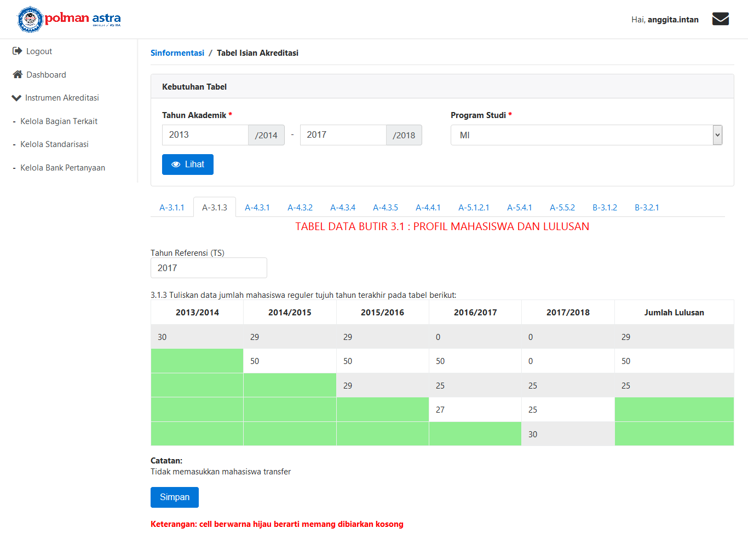
Figure 4. User Interface Example : Generate Detailed Accreditation Table
    - Prototyping History. In its development AIS has gone through three prototypes to become a complete system. The following are the history of the AIS prototype : (1) Prototype 1: produces functions that can manage : related departments, standardization, question banks, accreditation tables, accreditation tables detail, authorization of accreditation tables, accreditation table details entry, exporting accreditation authorization entries; (2) Prototype 2 : adding the functions to manage the accreditation tables template dynamically so that the export function of the table can still be used even though there is a change in the rules of NAAHE; (3) Prototype 3 : Separating the data generate detail table for study programs accreditation and institutions, which previously merged.

  - Test and Implementation

AIS testing is done based on scenarios which in line with its business processes. The following results are obtained from the AIS test : (1) Data and information on the accreditation tables can be integrated and can produce its detail directly from the Polman Astra's database; (2) Data and information on the accreditation table that can be viewed by all related departments and can be managed based on the authorization given; (3) AIS can eliminate the paper printing process when there is an error in filling, because all related departments can view and update the entire contents of the accreditation tables through the system; (4) The risk of delays in the preparation of accreditation instruments can be prevented because there are reminders that will appear at any time when the related departments have not filled the accreditation table. The result is accreditation document can be submitted to NAAHE on time.

- Conclusion

Based on the implementation and results of the AIS testing, it can be concluded as follows : (1) AIS can integrate accreditation data and information for both the institution and study program accreditation; (2) AIS can make data and information on accreditation instruments to be transparent and can be managed easily by all related departments; (3) All data can be corrected directly through AIS so it can reduce paper printing costs due to data errors from the related departments; and (4) AIS can prevent delays in the preparation of accreditation instruments and can be completed on time.

- References

- Regulation Of National Accreditation Agency for Higher Education (NAAHE) No. 2 Year 2107 concerning national accreditation system
- Regulation Of National Accreditation Agency for Higher Education (NAAHE) No. 2 Year 2107 concerning national accreditation system
- “Indonesia Dictionary,” [Online]. Available at : https://www.kbbi.web.id/akreditasi. [Accessed 06 07 2018]
- Academic Script of Study Program Accreditation, Jakarta ; NAAHE , 2019
- Dennis, Allan 2010 Systems Analysis and Design with UML third Edition (John Wiley & Sons)

