SMILE (Self-Monitoring Interactive Learning Evaluation) for Indonesian University Students

Wahyul Amien Syafei
Department of Electrical Engineering
Diponegoro University
Semarang, Indoneisia
https://orcid.org/0000-0002-6058-2693
Jati Ariati
Faculty of Psychology
Diponegoro University
Semarang, Indoneisia
ariati.jati@gmail.com
Anastasia Ediati
Faculty of Psychology
Diponegoro University
Semarang, Indoneisia
aediati@gmail.com
Agung Budi Prasetijo
Department of Computer Engineering
Diponegoro University
Semarang, Indoneisia
agungprasetijo@ce.undip.ac.id
D. V. S. Kaloeti
Faculty of Psychology
Diponegoro University
Semarang, Indoneisia
veronikasakti@gmail.com
Y. E. Windarto & M.A. Virzawan
Department of Computer Engineering
Diponegoro University
Semarang, Indoneisia
yudi@live.undip.ac.id

Abstract— Study in university can be perceived as a positive challenge However, pressure to meet academics standard, life transitions, relation with friends, and time management are potentials to boost depression, anxiety, and stress. Further, students with mental health problems were reported having worse quality of life. Therefore, it is beneficial for students to understand their conditions in order to maintain their mental status. The ability to assess the psychological condition using tools that can be self-operated will provide self-help monitoring and enhancing knowledge about their condition. This research aims to develop a mobile, fast response, and interactive measurement of psychological condition regarding depression, anxiety and stress status application in android based smart phones. The application is called SMILE (Self-Monitoring Interactive Learning Evaluation). The measurement is based on DASS-21 (Depression Anxiety Stress Scale-21) which consists of 21 questions to assess the severity of the core symptoms of depression, anxiety, and stress over the prior week. The Waterfall method which consists of system analysis, design, implementation, and testing is chosen to develop this application software. Black-box testing shows that the developed application software runs as expected. Validation result of the psychological disorder level which was examined by comparing it to the result from the test data demonstrates high accuracy.
Keywords—Psychological disorder; DASS-21; android; mobile; interactive; fast response; waterfall; black-box testing

Introduction
Depression, anxiety, and stress are psychological disorders that recently becomes common in humans. Depression is a human function disorder that is related to natural feelings of sadness and accompanying symptoms, including changes in sleep patterns, appetite, psychomotor, concentration, fatigue, hopelessness and helplessness, and suicide [1]. Stress is a condition caused by interactions between individuals and the environment, stress raises perceptions of demands that come from situations that originate from the biological, psychological and social systems of a person. Anxiety is a manifestation of various emotions that mix between panic, erratic feelings, and unclear fears when someone is experiencing pressure or frustration.
Depression, anxiety, and stress levels can be measured using Depression Anxiety Stress Scale (DASS) made by Lovibond & Lovibond [2]. DASS consists of two types, DASS-42 and DASS-21. DASS-42 has 42 statement questions while DASS-21 has 21 statement questions. The levels of depression, anxiety, and stress in DASS are divided into 5, namely normal, mild, moderate, severe, and very severe [3].
The use of DASS-42 to observe the contribution of depression, anxiety, and stress to obesity in adolescent was conducted by Masdar, at all in Pekanbaru. The data were statistically analyzed using Chi-square and Fisher test. The results showed that depression and stress were big contributors to obesity in adolescence while anxiety contributed to determine the food intake and nutrient substance. [4].
DASS-21 is a short version of DASS-42. It is a questionnaire consists of 3 scales, depression, anxiety, and stress. Each scale has 7 statement questions that can describe the individual's mental condition. Depression scale assesses despair, life devaluation, self-deprecation, lack of interest or involvement, and anhedonia (inability to enjoy an exciting thing). Anxiety scale assesses autonomic arousal, skeletal muscle effects, situational anxiety, and subjective experience of the influence of anxiety. Finally, Stress scale assesses the difficulty of relaxed, aroused nerves, being irritable or anxious, irritable or over-reactive and impatient. [5].
Psychologists may use DASS-21 to measure the level of depression, anxiety, and stress of their patients. The DASS-21 questionnaire is usually done by using questionnaire paper which then will be calculated manually by psychology experts. This type of measurement is not attractive, consumes time, bores, and makes the psychological disorders even worse. Dass-21 can be used as a screener for depression in substance use disorder inpatients: a pilot study. [6].
Recently, to make an interactive and more convenient system, people tend to develop an application under android based smart phone. Subhankar et al. has reviewed some procedures in developing android based application and its security in [7].
Stress meter application under Android based on combination of DASS-42 and Achievement Motivation Scale was developed by Mulawarman et al. The application has a moderate level of acceptability to identify the stress level. Data which were obtained from 30 final year college students showed that the higher the level of stress the lower of achievement motivation. [8]
One innovative way for automatic stress measurements via smartphone technology was proposed by T. Stütz et al. In this work, automatically collected smartphone usage and sensor data were investigated to predict the experienced stress levels of a user using a customized brief version of the Perceived Stress Scale (PSS). A user study has been conducted in which smartphone data and stress (as measured by the PSS seven times a day) were recorded for two weeks. It was found that there were significant correlations between stress scores and smartphone usage as well as sensor data. [9].
The goal of this research is to develop a more convenient way to measure the level of depression, anxiety, and stress. It is an application software under android based smart phone called SMILE.apk, (Self-Monitoring Interactive Learning Evaluation). Waterfall method which consists of system analysis, design, implementation, and testing is chosen to develop this application software. It utilizes the DASS-21 calculation scale to facilitate psychologists in measuring the levels of depression, anxiety, and stress of Indonesian university students.

System Design
The waterfall method is used to achieve the goal. This method uses a systematic and sequential approach in the development of a software.
The first step in the waterfall method is analysis where the designer or system developer analyzes what the system needs to define the specifications. The second stage is system design which is based on the system’s specifications. Third stage is implementation. At this stage, the system is developed in accordance with the design that was made in the previous stage. Fourth stage is testing phase. In this stage, all functions that exist on the system that have been made are tested to make sure they are running as expected. The final stage is the stage of maintenance or system maintenance. It includes repairing errors in the system that may not be found in the previous stage or adding new functions to the system.
Since the target users of this application are Indonesian, the questionnaires are Indonesian translated version of DASS-21 by Damanik [10]. Table I lists the score and level of depression, anxiety, and stress from DAS-21 calculation.
- Score and level of depression, anxiety, and stress.
Level | Depression | Anxiety | Stress
Normal | 0-9 | 0-7 | 0-14
Mild | 10-13 | 8-9 | 15-18
Moderate | 14-20 | 10-14 | 19-25
Severe | 21-27 | 15-19 | 26-33

Activity Diagram
The design of work processes is a fundamental design regarding system behaviour and activities that occur when the system is run. The activities and behaviour of this system are illustrated on the activity diagram. The first activity is when the user wants to take a questionnaire, the user must log in first to access the questionnaire retrieval menu. Figure 2 shows the activity diagram of the questionnaire retrieval.

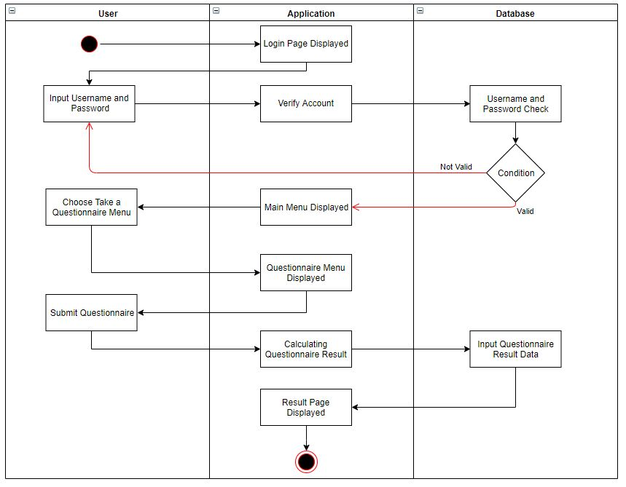
- Activity diagram of the questionnaire retrieval.
The second activity is when the user wants to delete the history of the questionnaire he/she has taken. The user must log into the system, enter the history list menu, and select the option to delete history.
The third activity is designed to allow the admin to change the user account data. The admin must log into the system, enter the user list menu to find the account whose data will be changed, and then select the change option to change the data from the user.
The fourth activity is provided for the admin to delete user data. After logging into the system, the admin must enter the user list menu to search for the user account to be deleted and select the delete option to delete the user.
The fifth activity allows the admin deletes the history data that has been taken by the user. The admin have to log into the system, enter the history list menu to search for history to be deleted, and then select the delete option to delete history data. Figure 6 shows the activity diagram of deleting history.
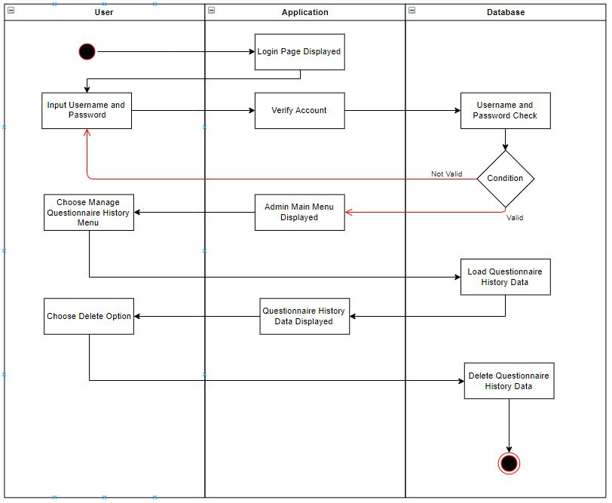
- Activity Diagram of deleting history.
Activity and use case diagrams cannot describe the behavior of the system. Therefore, in the design process, a sequence diagram is used to determine system behavior in executing scenarios.

Sequence Diagram
Sequence diagram describes the behavior of objects in the use case by describing the life time of the object and the message sent and received between objects.
The sequence diagram of the login process contains the interaction of the actor who wants to enter the system. Login will separate the access rights of each actor. The sequence diagram for the login process is shown in Figure 4.
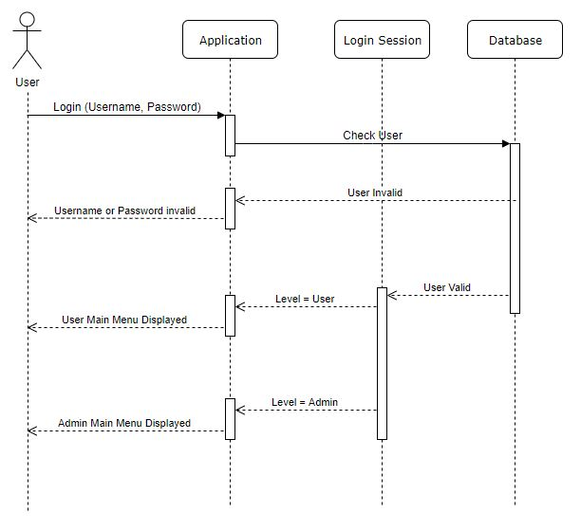
- Sequence diagram of login process.
Taking questionnaires sequence diagram contains interactions when the user takes a questionnaire. The sequence diagram for the questionnaire retrieval process is shown in Figure 8.
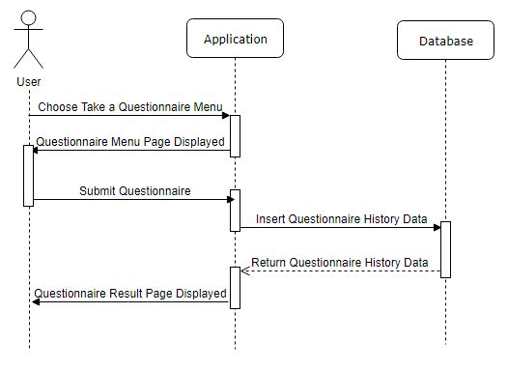
- Sequence diagram of questionaire retreval.
View profiles sequence diagram works when a user wants to see a personal data profile. View the history sequence diagram takes place when the user needs to see and delete the history list. The user can see the history details that has been taken and also delete the history. User manage sequence diagram runs when the admin chooses manage user menu. He can view user's personal data, make data changes to user, and delete user account. Manage history sequence diagram operates when the admin wants to manage history menu. He can view and delete the questionnaire history data of the users.
Demographic data sequence diagrams is executed when the admin selects the demographic data menu. He can see statistical data that informs the number of users based on the parameters of age, sex, ethnicity, education level, parental education, and parents’ income. The demographic data sequence diagram is shown in Figure 6.
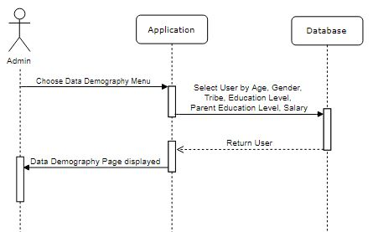
- Sequence Diagram Data Demography.
The DASS-21 data sequence diagram takes place when the admin chooses the DASS-21 data menu. He can see statistical data that displays information about the number of levels of depression, anxiety, and stress that generated by the user. The DASS-21 data sequence diagram is displayed in Figure 7.
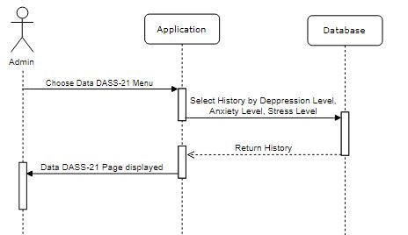
- Sequence Diagram DASS-21 Data.
Deployment diagrams can be used to model additional systems (embedded systems) that describe the design of devices, nodes, hardware, as well as client or server systems. The application deployment diagram can be seen in Figure 15.
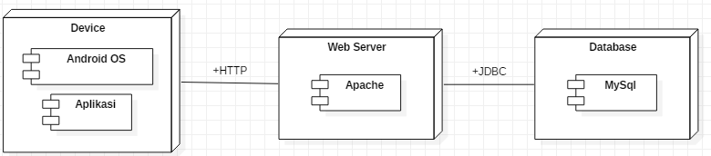
- Deployment Diagram of SMILE.apk.
The design of the database system in this application is done by making a description of the needs and interrelationships between the data using Entity Relationship Diagram (ERD). ERD of this application is depicted in Figure 9.
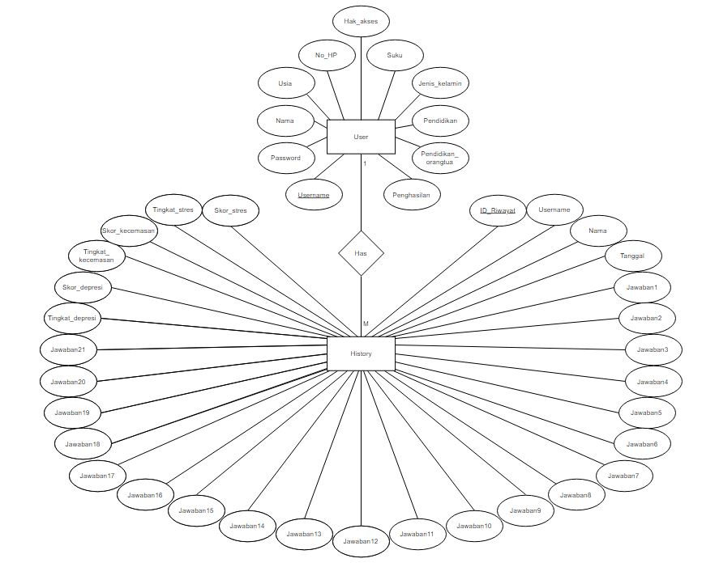
- Entity Relationshp Diagram of SMILE.apk.

Users
The SMILE.apk application is designed to be simple and easy to use. Only two users are involved, i.e. admin and user. Admin has responsibility to manage the user and data base. User is the patient or anyone who wants to measure the level of depression, anxiety, and stress.
The user menu structure is the menus contained on the page that are available to the user. Users are required to log in first before entering the main menu. In the main menu, there are 4 menu choices, namely taking a questionnaire, looking at profiles, view history, and logout. The user menu structure can be seen in Figure 18.
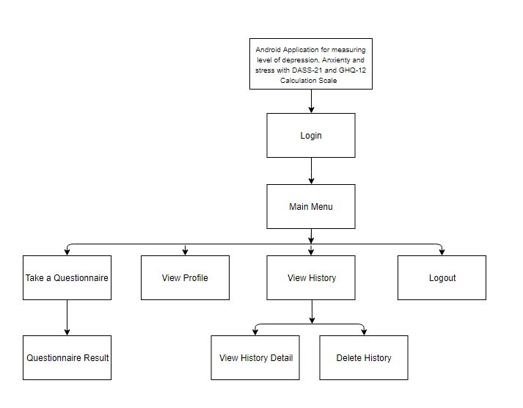
- Structure of User’s Menu.
The admin menu structure is the menus contained on the page that are available for the admin. Admin is required to log in first before entering the main menu. In the main menu, there are five menu choices, namely manage user, manage history, demographic data, DASS-21 data, and logout. The admin menu structure is shown in Figure 19.
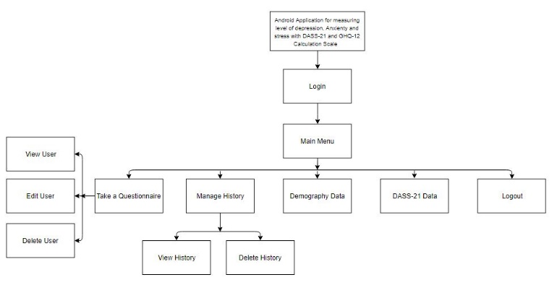
- Structure of Admin’s Menu.

Implementation and testing of the Smile Apk.
This section deals with two things, i.e., the implementation of DASS-21 in digital form and testing the developed system under android based smart phone.

Main Menu
The main menu of the developed SMILE application is used to enter the system. Registered user can directly enter the system after login using user name and password. When the user is not recognized by the system, user must register via registration page.

User Menu
If registration is success, each user will be granted a personal page. Based on the previous explanation of Fig 19, the main menu of user consists of four sub menus, i.e. Take a Questioner, View profile, View history, and Logout. After finish filling the digital form of DASS-21, user can verify his level of depression, anxiety, and stress. Whether they are normal, mild, moderate, or severe. Fig. 12 (a) shows user profile page and (b) shows emotion condition in chart bar of depression, anxiety, and stress level.

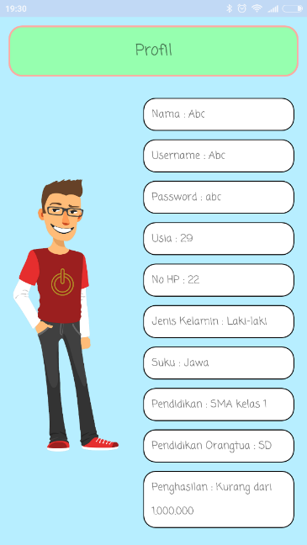  (a) | 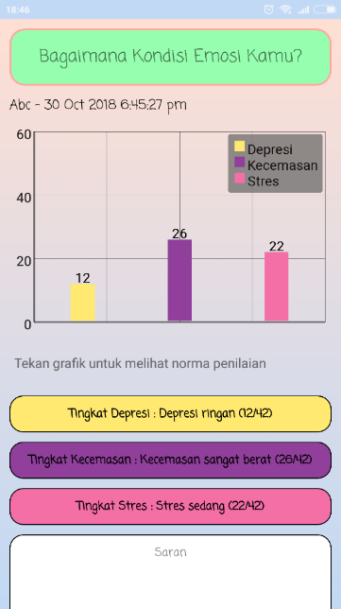  (b)
- (a) User profile’s page and (b). User ‘s emotion condition page represents the level of depression, anxiety, and stress.

Admin Menu
Admin has responsibility to manage the user and data base. After login to the system, Admin enters the main menu, which has five submenus, i.e. Manage User, Manage History, Demographic Data, DASS-21 Data, and Logout.
Admin also be able to view the Demographic data which presents the profile of all users who deals with this application. Fig. 13. (a) shows demographic data of total seven users who takes benefits form this application. Admin also can view the DASS-21 data of all users, as shown in Fig. 13. (b). This page represents the level of depression, anxiety, and stress of the community. From this demographic and DASS-21 data, admin can give information to the upper manager to take next action.

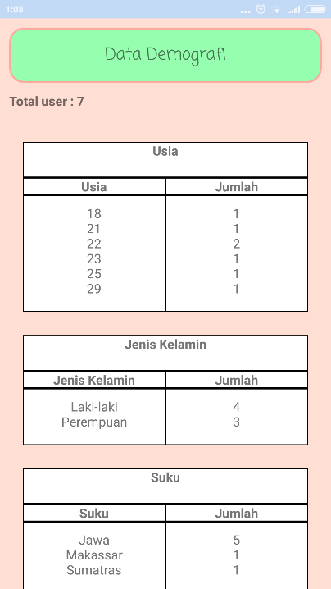  (a) | 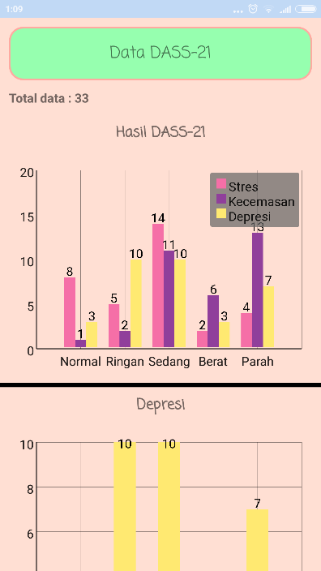  (b)
- (a). Demography data and (b). DASS-21 data.

Conclusion
The mobile, fast response, and interactive measurement of depression, anxiety, and stress based on DASS-21 calculation scale has been developed as an application in android based smart phone called SMILE.apk. This application provides a tool for Indonesian University students to measure their level of depression, anxiety, and stress by taking questionnaires of DASS-21 digital form. The students can obtain the results, view personal profile data, and delete the history of measurement that has been taken. This application also provides the admin to manage user's personal profile data, change user data, delete user, view user history, delete user history, view demographic data, and view DASS-21 data. Validation result of the psychological disorder level which was examined by comparing it to the result from the test data demonstrates high accuracy. Further work will be developing this application by adding another calculation scale, such as GHQ-12 and implementing the application on other platforms such as Windows Mobile 10 and iOS.

Acknowledgment
This work was supported by DRPM, Ministry of Research, Technology, and Higher Education of the Republic of Indonesia through the LPPM UNDIP under the Applied Research schema (Grant Number 101-172/UN7.P4.3/PP/2018).

References

- Kaplan H.I, Sadock B.J, Grebb J.A., Sinopsis Psikiatri, Binarupa Aksara, Jakarta, 2010.
- Sary, Y.N.E., Buku ajar psikologi pendidikan. Parama Publishing, Yogyakarta, 2015.
- Lovibond, S.H. & Lovibond, P.F., Manual for the Depression Anxiety Stress Scales. (2nd. Ed.), Psychology Foundation, Sydney, 1995.
- H. Masdar, P.A. Saputri, D. Rosdiana, F. Chandra, Darmawi, Relationship Of Depression, Anxiety And Stress With Obesity In Adolescent, Jurnal Gizi Klinik Indonesia (2016), Vol. 12 No. 4 – April 2016, pp.138 – 143, ISSN 1693-900X (P), ISSN 2502-4140 (OL). https://jurnal.ugm.ac.id/jgki.
- Le MTH, Tran TD, Holton S, Nguyen HT, Wolfe R, et al. “Reliability, convergent validity and factor structure of the DASS-21 in a sample of Vietnamese adolescents”. PLOS ONE 12(7): e0180557. June 2017.
- Beaufort, et. all. “The Depression, Anxiety and Stress Scale (DASS-21) as a Screener for Depression in Substance Use Disorder Inpatients: A Pilot Stud” European Addiction Research Vol. 24, pp. 260-268. Deecember 2017.
- Shubhankar Mukherjee et al., Android Application Development & Its Security, International Journal of Computer Science and Mobile Computing (2015), Vol.4 Issue.3, March – 2015, pp. 714-719.
- M. Mulawarman, I. Ariffudin, A.I.N Rahmawati, M.E. Wibowo, E. Purwanto, A. Munandar, Application of Android-Based Stress Meter as Stress Academic Indicator on College Student with Low Achievement Motivation. International Conference on Science and Education and Technology (ISET) 2018, pp. 301 – 313. DOI: 10.2991/iset-18.2018.64.
- T, Stütz, et al., Smartphone Based Stress Prediction. Springer International Publishing Switzerland (2015). UMAP 2015, LNCS 9146, pp. 240 – 251. DOI: 10.1007/978-3-319-20267-9_20.
- Psychology Foundation of Australia. Depression anxiety stress scales. [series online] 2014 [cited October 2015]. Available from: URL: http://www2. psy.unsw.edu.au/dass/Indonesian/Damanik.htm.

