EEG dataset classification using CNN method
Wei-Lung Mao¹ ,Haris Imam KF¹, Yingying Lee², and Teng Wen Chang³
¹Department of Electrical Engineering, Graduate School of Engineering Science and Technology, National Yunlin University of Science and Technology, Douliu 64002, Taiwan
²Bachelor Program in Interdisciplinary Studies, College of Future, National Yunlin University of Science and Technology
³Department of Digital Media Design, National Yunlin University of Science and Technology

E-mail: wlmao123@yahoo.com.tw, harisimamkf@gmail.com, iilee@yuntech.edu.tw, tengwen@yuntech.edu.tw
Abstract. This paper proposes a simple Convolutional Neural Network (CNN) program to classify epileptic seizure. The diagnosis of epileptic seizure involves the identification and different characteristic of the Electroencephalography (EEG) signal. As such, it needs a method for identifying and classifying epileptic seizure. Deep learning is part of a neural network that has the ability and pattern to identify and classify epileptic seizure. CNN has been demonstrated high performance on image classification and pattern detection. In this paper, we combine the continuous wavelet transform (CWT) and CNN to classify epileptic seizure. This experiment uses the wavelet transform to convert signal data of EEG to time-frequency domain images. The output of the wavelet transform is an image that will classify into five attributes. In this experiment, we develop a simple program that will compare with other CNN approach (AlexNet and GoogleNet). The results of this experiment are two kinds of data, accuracy, and loss. The resulting accuracy is 72.49%, and the loss is 0.576. This result has a better learning time than GoogleNet and smaller loss result than AlexNet.
Index Terms Electroencephalography signal, Convolutional Neural Network, Continuous Wavelet Transform
- Introduction
EEG or Electroencephalography is one of the medic methods. EEG is the most popular tool for the investigation of brain function [1]. EEG is used for problem detection of the brain. The output of the EEG signal is time-series data. Therefore, comparing output data with standard EEG signal can know the disease or problem that occurs. The neural network has a vital role in technology development in recent years. The neural network has been used in many industrial sector and classification system. One of neural network implementation is Deep Learning. Deep learning has a very complicated layer than a conventional neural network. Many application systems have used deep learning for the platform. The implementations of Deep Learning is used for images classification. Image classification plays an essential role in many aspects. In recent years, deep learning is developed. The development of deep learning starts on hand-written image classification [13], AlexNet [10], and GoogleNet [5]. In this paper, we develop a new approach of CNN to identify epileptic seizure. We develop the pre-processing step that converts the EEG dataset became the input wavelet transform. The resulting image of the wavelet transform is used in CNN for the input image. In this experiment, we compared the result accuracy and loss from the previous method of CNN (AlexNet and GoogleNet)
- Signal Model
The detection and diagnosis of epileptic seizures often require long-duration monitoring of the patient’s electroencephalogram (EEG) signals [3]. Electroencephalography (EEG) is one of the most common techniques used for monitoring brain activities. Generally, expert neurologists analyze the records visually, which is time-consuming and inefficient. In particular, the noise characteristics of the EEG recording make it challenging to separate seizures from artifacts with similar time-frequency patterns. Machine learning algorithms have been widely used for automatic detection or prediction of epileptic seizures in raw EEG signals [11]. The data set used in this paper was downloaded on UCI (Machine Learning Repository) and was published on [2] The data consist of 11500 samples of EEG that have 5 Attributes. The attributes are EC for Eyes Closed, EL for Epileptic Seizure, EOP for Eyes Opened, HB for Healthy Brain, and TMR for Tumor Identification. The signal visualization of each attribute is shown in Figure 1(a)-(e).
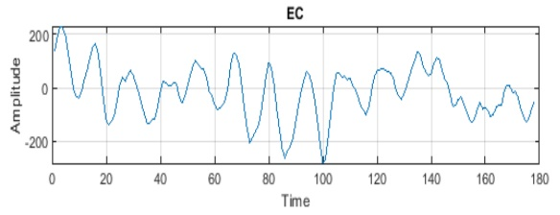 |  | 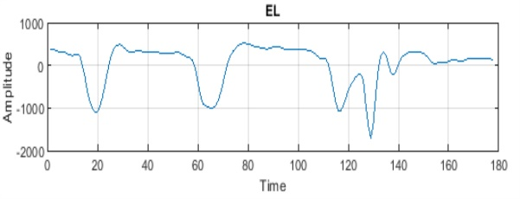
Fig. 1a. Eyes Closed |  | Fig. 1b. Epileptic
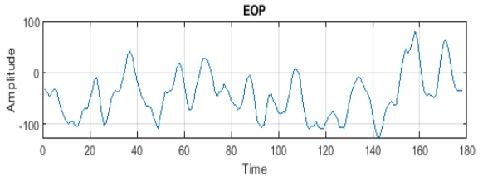 |  | 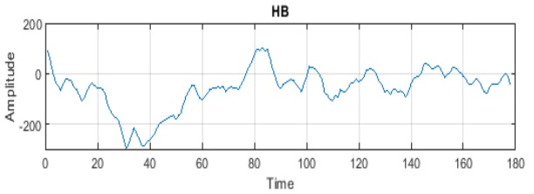
Fig. 1c. Eyes Opened |  | Fig. 1d. Health Brain
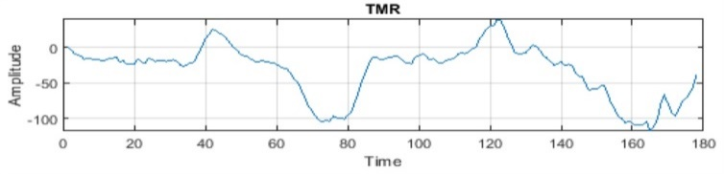
Fig. 1e. Tumor Area

- Continuous Wavelet Transform (CWT)
The Fourier Transform is a useful tool to analyze the frequency component of the signal. Short-time Fourier Transform (STFT) uses a sliding window to find spectrogram, which gives the information of both time and frequency. In conclusion, STFT might be suitable for time-frequency domain analysis of harmonic-related disturbances [14]. However, the problem is that the limit of the window depends on frequency. Wavelet transform could be the best solution for this problem. The wavelet transform is based on small wavelet with limited duration. The wavelet transform has been shown to have significant advantages for temporal signals analysis to Fourier’s classical techniques [7]. The CWT transform has the additional advantage of providing the visualization of the magnitude of wavelet coefficients, which allows us to observe when and which frequencies are stimulated, their duration, time evolution and their density [4]. Mother of Wavelet shown on Eqs. (1)-(2).
(1)
$\int_{-∞}^{∞}{φ\left(t\right)dt=0}$
(2)
$$||φ\left(t\right)||^{2}=\int_{-∞}^{∞}{φ\left(t\right)φ*\left(t\right)dt=1}$$
As the dilation and translation property states, the mother wavelet can form a basis set denoted by Eq. (3),
(3)
$\{{ φ}_{s,u}(t)= \frac{1}{\sqrt{s}}φ\left(\frac{t-u}{s}\right) \}$ $|_{υ∈R,s∈R^{+}}$
u is the translating parameter, indicating which region we concern and s is the scaling parameter greater than zero because negative scaling is undefined. The multiresolution property ensures the obtained set $\{{ φ}_{s,u}\left(t\right) \}$ is orthonormal. Conceptually, the continuous wavelet transform is the coefficient of the basis ${ φ}_{s,u}(t)$. It can be shown Eqs. (4)-(6).
(4)
(5)
(6)
$$Wf\left(s,u\right)= < f\left(t\right), { φ}_{s,u}>$$
$$=\int_{-∞}^{∞}{f(t)φ_{s,u}^{*}(t)dt}$$
$$=\int_{-∞}^{∞}{f\left(t\right) \frac{1}{\sqrt{s}}φ^{*}(\frac{t-u}{s})dt}$$
Via this transform, one can map a one-dimensional signal $f(t)$ to a two-dimensional $Wf\left(s,u\right)$. The two variables can perform the time-frequency analysis. We can tell locate a particular frequency (parameter s) at a certain time instant (parameter u).
- Convolutional Neural Network (CNN)
Convolutional Neural Network or CNN have been used in recent years and become a popular method in the deep neural network. CNN has four main features layer, Convolutional layer, Relu layer, Pooling layer, and fully connected layer.
4.1. Convolutional layer
The convolutional layer is the core of CNN operation. The convolutional layer consists of several feature maps. Each neuron of the same feature map is used to extract local characteristics of different positions in the former. However, to obtain a new feature, the input firstly convolved with the activation function. Explain in [8] to describe the creation of convolutional features write the output of the ($l-1$)st layer as $x_{l-1}$ := [$x_{l-1 }^{1}$ …………. $x_{l-1 }^{F_{l-1}}$]. This decomposes the $M_{l-1}$-dimensional output of the ($l-1$)st layer as a stacking $F_{l-1}$ features of dimension $N_{l-1}$. This collection of features is the input to the $l$th layer. Likewise, the intermediate output $u_{l}$ can be written as a collection of $F_{l}$ features as $u_{l}$ := [$u_{l }^{1}$ …………. $u_{l }^{F_{l}}$] where $u_{l }^{F}$is a length of $N_{l-1}$ and is obtained through convolution and linear aggregation of features $x_{l-1}^{g}$of the previous layer, g = 1, …………. $F_{l-1}$. Specifically, let $h_{l}^{fg}$ := [[${h_{l}^{fg}]}_{0}$, …………. [${h_{l}^{fg}]}_{K_{l-1}}$] be the coefficient of $K_{l}$- tap linear time-invariant filter that is used to process the $gth$ feature of the ($l-1$)st layer to produce the intermediate feature $u_{l }^{fg}$At layer $l$. Since the filter is defined by convolution, the components of $u_{l }^{fg}$are explicitly given by Eq. (7).
(7)
${{[u}_{l }^{fg}]}_{n}$ := ${[h_{l}^{fg}* x_{l-1 }^{g}]}_{n}$ = $\sum_{k=0}^{K_{l-1}}{ {[h_{l}^{fg}]}_{n} {[ x_{l-1 }^{g}]}_{n-k}},$
However, after evaluating the convolutions in the previous equation, the $l$-th layer features $u_{l }^{f}$are computed by aggregating the intermediate features $u_{l }^{fg}$associated with each of the previous layer features $x_{l-1}^{g}$using simple summation on Eq. (8).
(8)
$u_{l }^{fg}$:= $\sum_{g=1}^{F_{l-1}}{ u_{l}^{fg}}$ = $\sum_{g=0}^{F_{l-1}}{ h_{l}^{fg}* x_{l-1 }^{g}}$
4.2. Relu layer
The standard way to model a neuron’s output f as a function of its input x is with f(x) = tanh(x) or f(x)= (1-$e^{-x}$). Deep Convolutional neural network with RELU trains several times faster than their equivalent with tanh unit [11]. Relu layer changes all negative activation values to zero of the given input by applying the following function: f(x) = max(x,0) [6].
4.3. Pooling layer
Pooling layer is used to reduce the dimension of the feature maps and increase the robustness of feature extraction. There is two types of pooling layer, mean and max-pooling layer. The equation of pooling depends on [8] are in Eq. (9). The mean and max-pooling layer equation shown on Eqs. (10)-(11).
(9)
$[{v_{l}^{f}]}_{n}$ = $pl\left([{u_{l }^{f}]}_{n_{l}}\right)$
For mean pooling,
(10)
$pl\left([{u_{l }^{f}]}_{n_{l}}\right)$ = $1^{T}{{[u}_{l }^{f}]}_{n_{l}}$/|$n_{l}$|
And max pooling,
(11)
$pl\left([{u_{l }^{f}]}_{n_{l}}\right)$ = max ${{[u}_{l }^{f}]}_{n_{l}}$
4.4. Fully connected layer with a softmax output
After all of the features generated by our neural network, they are passed to the fully connected softmax layer. The output of this layer is probabilities distribution of all classes [9]. The fully connected layer is the final result of classification. They take all the neuron from the previous layer and combine them into one layer. The calculation of accuracy and loss results based on Eqs. (12)-(13) where N is the number of observations and K is the number of classes.
(13)
(12)
$$Accuracy=\frac{Images Validation}{Number of Images Validation}$$
$$Loss= \frac{1}{N}\sum_{n=1}^{N}{\sum_{i=1}^{K}{\left.{\left(Images Train-Images Validation\right)}^{2}\right.}}$$
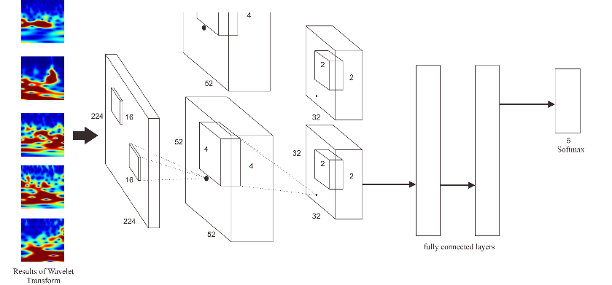
Fig. 2. Our CNN Architecture.

- Method and Simulation Results
In this research, we use EEG dataset for the data source. The method of this experiment used to compare between different CNN approach. The entire experiment uses Matlab 2018b and Intel i5 processor. We split the data source into 2, first is to training data for 70%, second is to test validation around 30%. In this research, we develop a new approach to CNN. We use three convolutional layer, three Relu, and three pooling layers. The first convolutional layer filters the 224 x 224 x 3 input image with 104 kernels of size 16 x 16 x 16 with a stride of 2. The second convolutional layer layers take the output of the first convolutional layer and filter with 128 kernels of size 4 x 4 x 52. The last convolutional layer takes the output of the second convolutional layer and filter with 64 kernels of size 2 x 2 x 64. Our design of CNN architecture is shown in Figure 2.
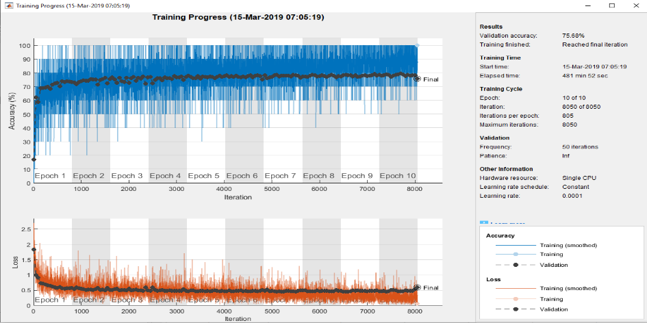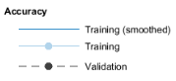 | 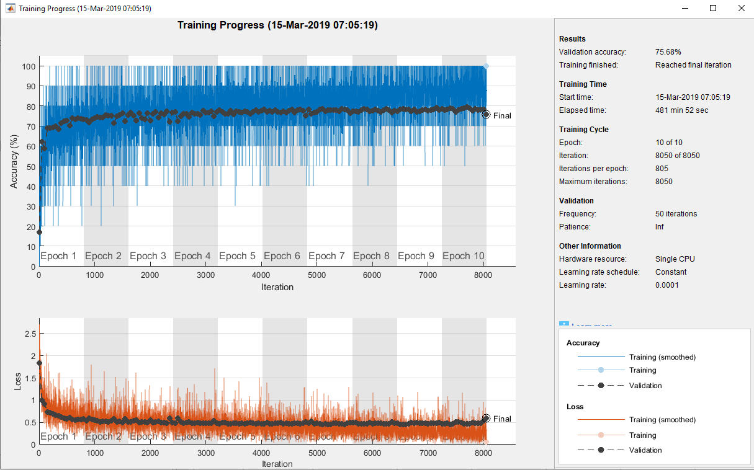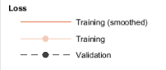
Figure 3a. Accuracy results in AlexNet | Figure 3b. A Loss results in AlexNet.
AlexNet contains 5 Convolutional Layer for learning [11]. It gives a benefit to the learning process and uses a short time to finish the learning. This experiment uses AlexNet and Epileptic Dataset to classify the epileptic seizure. However, this CNN needs 481 minutes to finish ten epoch. The resulting accuracy and loss are shown in Figure 3(a)-(b). The result of accuracy is 75.68% and 0.600 for the loss.
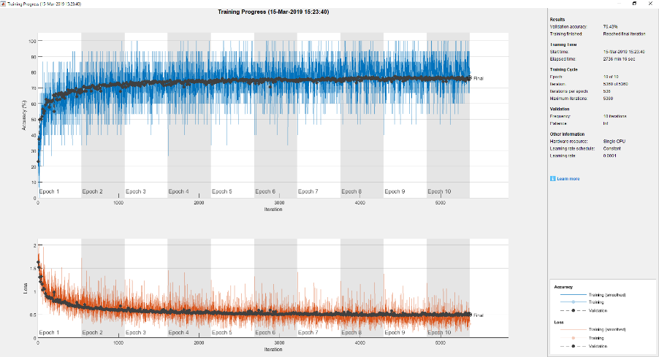 | 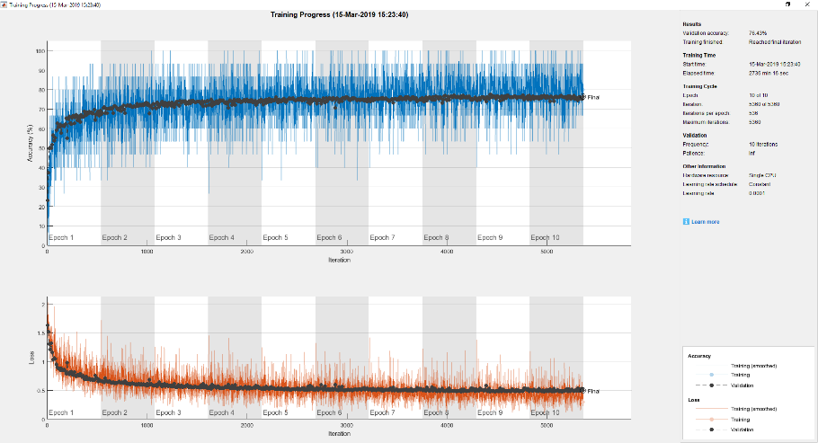
Figure 4a. Accuracy results in GoogleNet | Figure 4b. A Loss results GoogleNet
GoogleNet uses inception method that more complicated than conventional method [5]. It gives a benefit to the learning process. The advantage is high accuracy for learning result. The disadvantage is more time for the learning process. The experiment result for GoogleNet and EEG dataset for ten epochs are need 2736 minute. The resulting accuracy and loss are shown in Figure 4(a)-(b). The accuracy and loss results are 76.43% and 0.496.
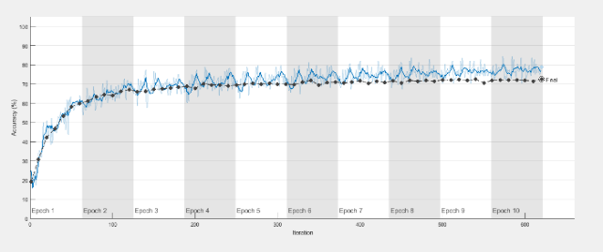 | 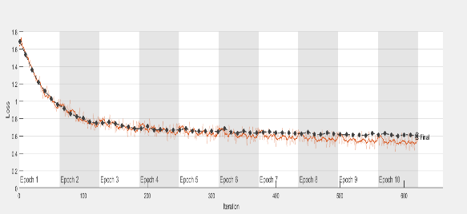
Figure 5a. Accuracy results in Our Program | Figure 5b. A loss results in Our Program
This program is developed three Convolutional layers with three max pooling and relu activation. The architecture program has a similarity with AlexNet, but it has a better loss result. The result of this program is 72.49% for the accuracy and 0.596 for the loss. The resulting accuracy and loss are shown in Figure 5(a)-(b). However, it takes 820 minutes to finish the learning batch.
- Conclusion
In this work, we propose the accuracy and the loss result of three different CNN approach. Compared with the previous existing CNN approach, our program achieved a better loss result than AlexNet. Our program produced a better time learning than GoogleNet. We hope that this program can be modified more complicated and achieved better performance.

Acknowledgments
The authors would like to thank the National Yunlin University and Science and Technology for providing a personal laboratory to perform the experiment. This work was supported by the Ministry of Science and Technology, Taiwan, under Contract MOST 107-2221-E-224-040.

- References
- A. Antoniades et al., "Detection of Interictal Discharges With Convolutional Neural Networks Using Discrete Ordered Multichannel Intracranial EEG," in IEEE Transactions on Neural Systems and Rehabilitation Engineering, vol. 25, no. 12, pp. 2285-2294, Dec. 2017.doi: 10.1109/TNSRE.2017.2755770
- Andrzejak RG, Lehnertz K, Rieke C, Mormann F, David P, Elger CE (2001) Indications of nonlinear deterministic and finite dimensional structures in time series of brain electrical activity: Dependence on recording region and brain state, Phys. Rev. E, 64, 061907
- Bhattacharyya and R. B. Pachori, "A Multivariate Approach for Patient-Specific EEG Seizure Detection Using Empirical Wavelet Transform," in IEEE Transactions on Biomedical Engineering, vol. 64, no. 9, pp. 2003-2015, Sept. 2017. doi: 10.1109/TBME.2017.2650259
- Briassouli, D. Matsiki, and I. Kompatsiaris, "Continuous wavelet transform for time-varying motion extraction," in IET Image Processing, vol. 4, no. 4, pp. 271-282, August 2010. doi: 10.1049/iet-ipr.2008.0253
- C. Szegedy,W. Liu, Y. Jia, P. Sermanet, S. Reed, D. Anguelov, D. Erhan,V. Vanhoucke, and A. Rabinovich, “Going deeper with convolutions,” in Proceedings of the IEEE Conference on Computer Vision and Pattern Recognition, 2015, pp. 1–9.
- D. Bardou, K. Zhang and S. M. Ahmad, "Classification of Breast Cancer Based on Histology Images Using Convolutional Neural Networks," in IEEE Access, vol. 6, pp. 24680-24693, 2018. doi: 10.1109/ACCESS.2018.2831280
- E. Gomez-Luna, D. Silva, G. Aponte, J. G. Pleite and D. Hinestroza, "Obtaining the Electrical Impedance Using Wavelet Transform From the Time Response," in IEEE Transactions on Power Delivery, vol. 28, no. 2, pp. 1242-1244, April 2013. doi: 10.1109/TPWRD.2012.2234942
- F. Gama, A. G. Marques, G. Leus and A. Ribeiro, "Convolutional Neural Network Architectures for Signals Supported on Graphs," in IEEE Transactions on Signal Processing, vol. 67, no. 4, pp. 1034-1049, 15 Feb.15, 2019. doi: 10.1109/TSP.2018.2887403
- G. Liang, H. Hong, W. Xie, and L. Zheng, "Combining Convolutional Neural Network With Recursive Neural Network for Blood Cell Image Classification," in IEEE Access, vol. 6, pp. 36188-36197, 2018. doi: 10.1109/ACCESS.2018.2846685
- Krizhevsky A, Sutskever I, Hinton G E. ImageNet Classification with Deep Convolutional Neural Networks[J]. Advances in Neural Information Processing Systems, 2012, 25(2):2012.
- K. Samiee, P. Kovács, and M. Gabbouj, "Epileptic Seizure Classification of EEG Time-Series Using Rational Discrete Short-Time Fourier Transform," in IEEE Transactions on Biomedical Engineering, vol. 62, no. 2, pp. 541-552, Feb. 2015. doi: 10.1109/TBME.2014.2360101
- T. Guo, J. Dong, H. Li, and Y. Gao, "Simple convolutional neural network on image classification," 2017 IEEE 2nd International Conference on Big Data Analysis (ICBDA)(, Beijing, 2017, pp. 721-724. doi: 10.1109/ICBDA.2017.8078730
- Y. Lecun, L. Bottou, Y. Bengio and P. Haffner, "Gradient-based learning applied to document recognition," in Proceedings of the IEEE, vol. 86, no. 11, pp. 2278-2324, Nov. 1998. doi: 10.1109/5.726791
- Z. Wang and R. S. Balog, "Arc Fault and Flash Signal Analysis in DC Distribution Systems Using Wavelet Transformation," in IEEE Transactions on Smart Grid, vol. 6, no. 4, pp. 1955-1963, July 2015. doi: 10.1109/TSG.2015.2407868

