Kaxabu Niumian Community’s Tribal Design and Cultural Empowerment Actions
Li-Hsun PENG¹ and Yuan-Hao LIU² and Ibnu Siswanto³

¹Department of Creative Design, National Yunlin University of Science and Technology. University Road, Section 3, Douliou, Yunlin 64002. Taiwan.
² Department of Creative Design, National Yunlin University of Science and Technology. University Road, Section 3, Douliou, Yunlin 64002. Taiwan.
³ Automotive Engineering Education Department, Faculty of Engineering, Universitas Negeri Yogyakarta.
E-mail: penglh@gemail.yuntech.edu.tw, stu90409@gmail.com, ibnusiswanto@uny.ac.id
Abstract. The language of the aborigines is the core of the spirit of the ethnic culture. When it gradually disappears, it means the decline of the culture, and the inheritance of the unique cultural characteristics will also be stagnant. The Kaxabu Niumian Community is located in Puli Township, Nantou County, Taiwan, has a total population of only 8000 people. Due to the aging of the population and the outflow of younger generation, the faults of the ethnic culture and design inheritance, so that Kaxabu language has been recognized as an endangered language by the UNESCO. Therefore, it is imperative for the revitalization of the cultural preservation and Design Empowerment of the Kaxabu people and culture.
In recent years, many studies have conducted research and records on Kaxabu, but the records of ethnic languages are mainly literature, textbooks, and documentaries. The forms of other media preservation are few The most urgent need of the Niumian community is the issue of the Pass on the torch. The Fundamental solution is to start from the senior students of the primary school in a step-by-step manner, cultivate local consciousness, start from the ethnic language, culture, nature observation, integration design, and creation. Integrate the elements of cultural heritage into the campus curriculum.
The research uses cultural action to revitalize the development of the Kaxabu tribe, and through the multicultural design camp activities, introduces young people from the community to experience the design culture and creativity together with the local people and students. By using the Participatory Design and involve with young design teams, researchers, and tribal people to increase the experience of cultural exchanges in tribal communities. So that the community have the opportunity to design and enhance creativity ideas for the tribal culture. Through the process and experience of experiencing cultural innovation, it is transformed into the foundation of the next generation to understand the traditional culture and history of the tribes and hopes to gradually form a tribal consensus.

- Introduction
1.1. Research background and motivation
Although Taiwan has a small land area, it is a cultural gathering place with diverse ethnic groups. It contains the traditional language, rituals, craft culture and aesthetic features of various ethnic groups. These are important assets of Taiwanese culture. However, the dilemma facing Taiwan’s aboriginal people is due to the rapid changes of generations, which makes the difference in resources between urban and rural areas, causing many indigenous people to leave their homes to the city in order to get rid of the hardships, and the problem of the aging of the tribal population. Make the local cultural heritage a fault.
The Kaxabu Niumian Community of Puli Township is located in the central Taiwan, Nantou County. It has a population of approximately 8,000 people, and its language is also listed by UNESCO as an extremely endangered language. Their language is gradually lost, it means the decline of the culture, and the inheritance of the unique cultural characteristics will also be stagnant. Therefore, it is imperative for the cultural preservation and resurgence of the Kaxabu culture.
As mentioned above, how to effectively preserve the Kaxabu culture is the core subject of this study, and Lin Qingmei (2013), a teacher from the Puyuma Huahuan tribal School, mentioned that the most inheritance of tribal culture [1]. The basic method is to "Rooted down" the cultural education, starting from the education of the upper grades in the primary school, cultivating the local consciousness, starting from the ethnic language, culture, tribal crafts, integration into design and creation, and integrating the elements of cultural inheritance into the ground. In the campus curriculum, cultural seeds are cultivated, but if only the scope of education is limited to the tribe, there will be no breakthrough in cultural transmission.
Therefore, this study hopes to introduce cultural activities through the concept of cultural action, and introduce young people from the community to experience cultural design with students from YunTech, and invite the youths by expanding the scope of aboriginal education. Participate in the preservation of the aboriginal culture to the younger generation with the power of inheritance, so that the beauty of the Kaxabu witch culture can be passed on.

1.2. Research purposes
In this study, the Kaxabu Niumian Community people are used as the object of practice and analysis, and the tribal consciousness and self-cultural identity of the local aborigines will be evoked by means of cultural action and design creating actions. Through the cultural design camp to assist tribal language education, craft heritage, activity experience, cultural preservation and transmission, we hope to achieve the goal of cultural revitalization and tribal sustainability.

This study hopes to develop the following issues:
(1) To explore the predicaments encountered by the current Kaxabu ethnic group in cultural preservation and inheritance.
(2) What kind of benefits can be brought to the Kaxabu tribes by the co-creation model brought into the cultural design camp?

- Literature Review
2.1. The Kaxabu Culture
Kaxabu is an aborigines people of Pingpu Group, Taiwan. After the 19th century, it was classified as a sub-ethnic of the Bazai during the Japanese colonial rule. But this was a wrong classification. Most of the Kaxabu Wu people retain their own ethnic identity and believe that regardless of language. The culture, historical emotions and myths of origin are different from the Bazai. The Kaxabu witches are currently distributed in four settlements: The Niumian (Baisia), Shouchen (Suwanlukus), Danan (Kalexut) and Wuluenshong (Tauving) communities in the northeast corner of Puli Town, collectively known as Four-Village-Savages.
The Kaxabu are an ethnic group that still retain language, culture and self-identity, and they have the “Nantou County Kaxabu Culture Association” to actively inherit and preserve their Kaxabu culture. Even so, due to political issues and factors such as the aboriginal people's association, the h Kaxabu people are still unable to become the officially recognized aborigines by the government [2].
2.2. Culture Empowerment
Empowerment, has different definitions and interpretations, and can be applied in a wide range of fields, whether it is political participation, social movement, medical care, community or/and culture development. The resilience movement has used the concepts of synergy, ethnic consciousness, and sustainable development in the meaning of Social Empowerment [3].
"Cultural Penetration" is a process of supporting and intervening in the construction of community cultural energy. The trainers or external teams establish partnerships with communities or community organizations to create innovative bureaus with community residents. Cultural training is also a cultural action. Through the awakening of culture, the promotion of knowledge, and the action, in this process, the vulnerable groups are attached to become a complete sense of autonomy.
In addition, the main concepts of cultural training are as follows:
1. Emphasize that tribes (communities) have complete autonomy and subjectivity.
2. Cultivate tribal (community) self-interpretation awareness and ability to solve dilemmas.
3. Cultivate tribes (communities) to create, pass on talents and continue the process of training.
4. Lifelong Learning is the cornerstone of the sustainable development of tribal (community) culture.
5. Initiate intrinsic motivation to enable tribal residents to actively participate in community affairs.
2.3. Participatory Design
"Participatory Design" can be said to be a combination of Community Design and Collaborative Design. Different from other design methods, most of them are the core elements of "participation", so that designers can integrate into the life of community residents and cooperate and observe in an interactive way [4], in addition to a deep understanding of the community environment, humanities, cultural context, aesthetics, etc., can also make community residents become design participants, co-creators, participate in the process of research and design, It can help community residents to better understand their own situation, while allowing designers to clarify the focus and goals, discover the needs of the community and integrate local resources and culture, and then tailor-made to meet the community's design.
- Research Methodology
3.1. Field Research
The field investigation is a research method based on direct observation and empirical research of sociology. In the process of investigation, the information is collected without pre-set cognitive framework, but the population itself is visually investigated. Through the complete record of people, literature, objects, Land, scenery, and production later analyze the nature of the respondents [5], after a long period of data collection and analysis of the exchange of evidence and mutual correction through the "experience" and "theory" of the researchers After that, we will discuss the observed phenomena in detail and the first-hand research and analysis data.
3.2. Participant Observation
Participatory observation refers to the in-depth research and integration of the researcher into the life background of the research target. As a kind of observation method in the field, the observer and the participant need to objectively look at the things in front of them instead of using the things they are used to. It is necessary to abandon the existing stereotypes, and such abilities need to be practiced through training and by following some rules and thinking steps [6]. At the same time, objectivity, understanding and reflection are the important core of participatory observation, so as to ensure the richness and accuracy of research data. Participatory observation methods are widely used, such as anthropology, sociology, medicine and psychology, etc. Scholars have also adopted it.

Therefore, this study uses the participatory observation method. The researchers use the participants as observer-as-participant to stay in the Kaxabu tribe, and participate in the Kaxabu Azem (the ancestral worship) through the field, and conduct in-depth observation and interviews. Record and integrate into tribal life, through field participation to discover and record more cultural and behavioral phenomena, to understand its cultural context and to clarify the current predicament of the tribe.
- Analysis
4.1. Cultural Characteristics of Kaxabu
Kaxabu, belonging to the Pingpu ethnic group, was originally living in the shallow mountain area east of Fengyuan District today, but was left unwilling to be ruled and finished by the Qing Dynasty, and left the original township to move to the Puli area. There are four main communities: Niumianshan, Shoucheng, Datun and Yulun, collectively known as Four-Village-Savages. Although the Kaxabu ethnic group has considered for the gradual loss of their culture identities. The tribes are committed to defending traditional aborigines’ customs. They still retain distinctive cultural characteristics and traditional techniques. Therefore, the researchers will summarize and analyze the cultural characteristics of the Kaxabu tribes [7], as shown in the following table:.
Table 1. cultural characteristics of the Kaxabu tribes
Cultural Characteristics of Kaxabu | Actual Survey Images | Characteristic & Narrative
Kaxabu Tiribe-Celebrating the Aborigines new year  （Azem） | 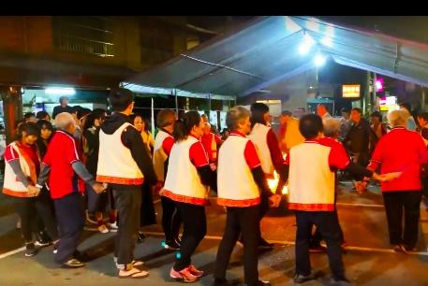 | The Azem Annual Festival is held on November 15th of the lunar calendar. It is a compound ritual, which includes the ancestral rituals, harvest festivals, hunting rituals, and adult rites. During the day, the tribe will hold the "grab the flag" and "knocking fire dragon" that symbolize the rite of adulthood. In the competition, the night people will go to the square in front of the Niumian Community Activity Center to hold a "Dowing the Field" ceremony (left) [8].  The tribes hold hands around the fire, lead the marching rhythm by tapping, and sing along with the tribes. With the song "Aiyén", after dinner, the tribes will talk around the fire and listen to the elders and old people sharing taboos, legends and historical stories... and so on.
Kaxabu’s Traditional Weaving（Mutuun） | 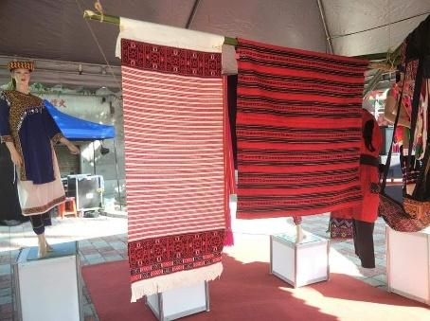 | The main feature is based on the ramie material, with red, white, navy or black weaving threads, with different totems intertwined by the above three colors. The texture changes on the clothing can be divided into three or four different system patterns, and the plain weave structure is composed of geometric and spaced lines.
Niumian Presbyterian church | 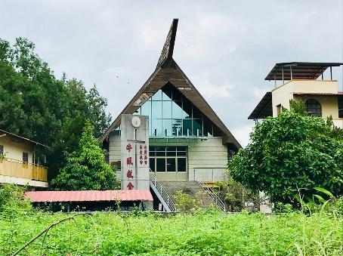 | The Niumian Presbyterian Church has been in existence for a hundred years since 1873. It has undergone many reconstructions due to the earthquake. The current model follows the traditional houses of the Kaxabu tribe. It looks like a ship-shaped building. There is a wooden raft at the entrance of the church. The tribes use Kaxabu in the language. The Bible poems are engraved on the top; in addition to the open accommodation space inside the church, it is also the Kaxabu Heritage Museum.  In the past, church pastors and elders recorded the historical footprints of the church and the Kaxabu tribe through ethnic languages and scripts, and established a Kaxabu tribe fellowship to teach the tribal children to learn English while inheriting the language. In addition to being the guardian bastion of the tribal belief culture, the church is also an important base for the Kaxabu tribe to retain the language.
Traditional Food: Ah-La-Guei  （Tupalis yamadu） | 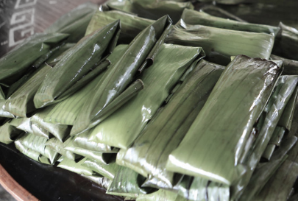 | Kaxabu tribe make "Alajan" to worship the ancestral spirits during the festival, which is one of the most important sacrifices. The "Ala Guei" in Kaxabu is pronounced as "Tupalis yamadu".  The production method is as follows:  The glutinous rice balls mixed with wormwood powder are cut into small pieces, and then the red bean fried ginger or radish silk stuffing is added, and then the two pieces of peach leaves are folded and folded into a square shape, and then steamed in a large pot.
4.2. Reviewing the resurgence of the Kaxabu tribal culture
Although the Kaxabu tribe retains its distinctive cultural characteristics and traditional skills, it is found that less than 30% of the people living in the "Four Villages" know that they are surrounded by the sorcerer's blood. In the language, as the elders faded and the young people's mouth moved outward, the path of inheritance caused a fault, making the preservation and recording work more urgent [9]. In view of the above, in recent years, the "Kaxabu Culture and Education Association" has begun to call the elders and elders to follow the early memories, try to say the words in the impression, put together and compile, and record the language (mouth record) by means of image recording, and establish data. In the library, in collaboration with the poems of the Niumian Church, Mr. Pan Yongli wrote and recorded in the Roman alphabet, completed some Kaxabu textbooks, so-called "The Kaxabu 's Words", and used these materials to regularly set up a language class in the Niumian Church. In the past three years, the Kaxabu have also found more than a hundred pieces of fabric relics belonging to the Kaxabu tribe. Although they are worn out, the weaves and totems are still clearly visible, after passing through the old craftsmanship and weaving technologists. After the exchange and analysis, these woven craft cultures have also been reworked in the near future. The Kaxabu is not only reviving the ethnic language, but also hopes to start from the weaving culture, so that the skills and culture of the Kaxabu can be reproduced.

- Conclusion
In addition to the above-mentioned cultural activities in the Kaxabu tribe, Kaxabu has also handled many summer camps and workshops in the past, attracting outside visitors to participate in and understanding the Kaxabu culture, and has good results and experience feedback. If we can continue this form of experience workshop, and then integrate the elements of ethnic language culture, weaving culture and design culture into its work simulation project, that is, the activities of “Multicultural Design Camp” and let the people and youth design team Participate in tribal people and increase the experience of cultural exchanges in tribal communities, so that participants have the opportunity to jointly design and create designs for tribal cultures [10], and to experience the process and experience of designing cultural innovations, starting with the concept of cultural training. Practice and learn from each other to achieve the effect of awakening inward culture and transmitting culture outward.

Acknowledgments
This research was supported in part by the Ministry of Science and Technology of Taiwan(R.O.C.), under contract numbers MOST 108-2410-H-224-022-

- References
[1] Lin R Z 2013 The Puyuma HuaHuan Tribal School - Cultivates Cultural Seeds and Carries Forward the Tribal Spirit. Aboriginal Quarterly, 4, (23-25).
[2] Pan Z H 2016. The Pingpu language is gone. The 921 earthquake has shaken out the indigenous peoples who have lived well in this group of languages. Retrieved: May 28, 2019. From: https://www.matataiwan.com/2016/12/04/921-earthquake-kaxabu-pepo-indigenous/
[3] Li S H 2010 Discussion on community training and sustainable development in Kaohsiung City. Seminar on Urban Development, 10, (26-27).
[4] Huang Yaorong 2012 The old community in rural areas realized the feasibility of “home aging” residential renovation and participatory design operations. City and Planning, 39(4), (435-438).
[5] Qiu J J 2012 Field Investigation Method Analysis. Group of Heaven and Earth, 9, 241
[6] Huang G Y 2000 Participated in Observational Research Participant Observation: Education Dictionary.
[7] Chen S H, Peng L H 2015 An Investigation into the Feasibility of Incorporating Creative Photography Pedagogy in General Education, The Journal of Design Research, No.11, (01-06).
[8] Shao Y T 2018 Danced with nature, and the kaxabu witches found their original look. Retrieved: May 29, 2019. From: http://bankofculture.com/archives/3884
[9] Lin J H 2013 The Knowledgeable Elder Rescue Fund Needs Support. Retrieved: June 1, 2019. From: http://kaxabu.weebly.com/221342170424043354862448925391.html
[10] Peng L H, Lin H Y 2014, A new Bunun aborigines’ Educational Aspect of Cultural Identity Design in Taiwan, Procedia - Social and Behavioral Sciences, Vol.112, (365-372).

