**On the relative run-out distance of submarine slide: numerical and experimental simulation**

**Zainul Faizien Haza1, Dewi Sulistyorini1 , and M Afif Shulhan1**

1Universitas Sarjanawiyata Tamansiswa, Jl Kusumanegara 157 Yogyakarta, Indonesia

E-mail: zainul@ustjogja.ac.id

**Abstract**. Submarine slide event has been approached using ″the underwater flow“ model. It is performed by flowing the slurry, which is made from mixture of kaolin clay and water, in rectangular channel with water ambient. It is considered to be the basic model of submarine slide simulation. The slurry flow subsequently undergoes energy change from potential energy due to kinetic energy in moving stage. Potential energy was affecting slurry to flow in range about 0.5 m to 1.0 m of run-out distance. After passing that distance, the flow will be related to kinetic energy and stagnant pressure due to velocity. Furthermore, in dealing with velocity generated by moving mass, the Boussinesq approximation is applied to inspect that hydroplaning phenomena was not occurred in this experiment. The CFD software package, FLUENT, has been employed to assess numerically laboratory work. In particular, this research has examined the basic model of submarine slide simulation by adopting the rheological properties of slurry from laboratory work. This numerical approach results some appropriate technical aspects of movement pattern including velocity and run-out distance related to flowing time. However, there was disagreement in mass flow formation between FLUENT and laboratory experiment. This perhaps due to the imperfect initial condition and some physical effects those were not numerically modelled. In general, two methods of laboratory and numerical have conformity each other in submarine slide simulation using gravity flow approach with lock-exchange system.

1. **Introduction**

The technical term of submarine landslides has denotation of failures within the sloping seafloor that cause the displacement of seabed sediments. It represents the predominant processes of sediment transport from shallow water shelf into deep seabed. The distance that sediment reached during move is known as the run-out distance and is reported having hundreds of miles from the original location. Furthermore, about 10 percent of 434 slides have run-out distances more than 100 km with the mean run-out distance is about 41 km [1]. Submarine slides have become a serious and complex problem in the marine field. This is because submarine slide causes damage to the seabed environment in general and to the seabed facility constructed by humans as a means of sea based activities in the field of business, industry, and maintenance of the environment itself. The extensive affected particular site was very variable and continuing development of natural resources [2]. The approach to assessing the hazards, the type of data acquisition and interpretation required must be consequently adapted to fit the site. The features of approach are defined from their topographical expression, performing a large scale, and swathe bathymetry survey [3].

Submarine debris flows are commonly thought to be laminar flows moving down slope as an agglomeration of particles held together by a thick sediment matrix composed mainly of silt, clay, and water (cohesive material) [4]. Compacted and unconsolidated clay are seabed sediment deposits that became the main material in the event of submarine slides and debris flows. These events are relatively common (in geological time scale) occurred in many areas around the continental margin. Once the sediment deposits collapsed, it is released and transformed into a finely communized mixture of clay and water.

Based on the problems mentioned above, then experimental studies of the respective problem on submarine slide are designed by performing mudflow in water ambient using long rectangular channel. It is also conducted simultaneously with exploiting numerical approaches as the complementary simulations. The objective of the research is to obtain the specific velocity preformed by mudflow as well as to record run-out distance reached by respective velocity.

1. **Literature Review**

About 10 percent of 434 slides have run-out distances more than 100 km with the mean run-out distance is about 41 km [1]. Submarine clastic deposits along the continental margins was evealed the remnants of holocenic or older debris flows with run-out distances up to hundreds of kilometres [6]. Individual debris lobes along the Norwegian-Barents Sea margin are elongate bodies consisting of 1-50 km3 of sediment with 2-10 km in width, 10-50 m in height, and have run-out distances up to 200 km [4]. For example, submarine slide data was reported by Zakeri et. al. [7] for two events of submarine slides those were evolved into debris flow and turbidity current along the path, and was estimated based on the communication cable breaks. The gigantic submarine slide events that occurred on slope less than 2° was Storegga Slide [8].

In year 1999, Mohrig et al. [9] performed a laboratory simulation on relative mobility of muddy subaqueous and subaerial debris flows using a mixture of materials consisting of water, kaolin, silt and sand in certain percentage. Laboratory experiment also used to estimate the impact forces exerted by a submarine debris flow on a pipeline [7]. The experiment concluded the measured drag forces on the suspended pipe were about 20% to 30% higher than those measured for the pipe on the flume bed. In similar setting, some implemented experiments were mentioned as gravity flow or gravity current. Investigation of the instantaneous release of two dimensional, heavy, particle-driven gravity currents has been conducted by Hallworth et al. [10] and Amy et al. [11] in a perspex channel with a lock gate. They addressed results of abrupt transitions between high viscosity fluids with the less one. A different scheme of gravity flows experiment was conducted by Mok et al. [12] that generated a high viscosity fluid flow by releasing the fluid continuously flowing to the less viscous fluid. Jiang [13] proposed a model for three different rheologies of the submarine sediments: a viscous fluid, a Bingham-plastic fluid, and a Coulomb frictional material. This research inferred that the slide dynamics were dominated by the rheology aspect of the sediment.

Other research of incorporating the model of the Bingham, Herschel–Bulkley, and bilinear rheologies of viscoplastic fluids was performed by Imran et al. in 1-D numerical model [14]. Moreover, Wright et al. fitted numerical modeling into hydroplaning observation and proposed a block model for submarine slide simulation [15]. The impact of submarine debris flow on pipelines was modeled by Zakeri et al. using computational fluid dynamic that delivered result of drag coefficient Cd for design purpose, related to the value of Reynold number Re [16]. Numerical method also used in observing gravity flow modeling. Cheong et al. investigated numerically gravity currents flowing down the slope using the Boussinesq approximation [17], whereas Mehdizadeh et al. used the accuracy of Reynolds Averaged Navier-Stokes (RANS) turbulence model to predict the currents behavior of 2-D model [18].

1. **Experimental Design**

At the recent time, literature and references that provide the basic methods and conceptual procedure are still very limited, especially the method for elaborating the characteristic of a submarine slide movements based on properties of material factors of sliding mass itself. Furthermore, only a few studies have been devoted to a quantitative understanding of the frontal dynamics of submarine debris flows [19]. Therefore, experiments laboratory were carried out to model the basis of submarine slides.

This paper reports the implementation of laboratory experiment of submarine slide simulation. The main objective is to complement the theories about the modelling of submarine slide events by understanding the behaviour of mass movements along an inclined channel. Therefore, investigation is concerned in the formation of mass flow at a certain time and distance. The constant variable to be used is rheology properties (i.e. density and viscosity) of slurry that made from mixture of kaolin clay and water in certain proportions. Scaling analysis is then utilized to estimate the mechanism of deformable debris flow. The commercial software of computational fluid dynamic (CFD) of FLUENT 6.2 is employed to execute a back calculation in order to verify numerically the laboratory results. Results described in this paper is directed towards development a resource of elaboration of submarine slide simulation in aspect velocity, run-out distance, and the form of moving mass referred to the nature of material rheology properties.

The mechanic of this movement cannot be adequately explained by soil mechanics principles alone, therefore applying fluid mechanics principles is necessary [2]. In a similar design concept, Lowe et al. stated that despite the simplicity implementation, the experiment gave results a wide variety of flow phenomena, some of which disregarded to theoretical that serve as prototypes for geophysical flow [20]. Experiment was performed in a rectangular channel of 8.53 m length, 0.25 width, and height of 0.7 m and 1.30 m at beginning and end respectively. Overall, channel was made of clear glass, including the base. It has a adjustable horizontal position for setting the sloping base purpose. The base declivity was obtained by lifting the beginning edge of channel until reaching the expected slope. Figure 2 shows the laboratory test equipment. In this experiment, the slope angle used was 3°, referring to Hance [1] that the highest frequency density distribution of the average angle of the slope at failure for the seafloor slope failures was 3° to 4°.

The basis of the experiment is simulating a lump of mud (i.e. slurry) sliding into a pool of water then flows over the surface of channel base. The slurry has density of *f* whereas water has density of *w*, where *f* > *w*. The section of 1 m along the base from side wall until the gate was occupied by the slurry, and then the water occupied the remaining section from gate until the end.

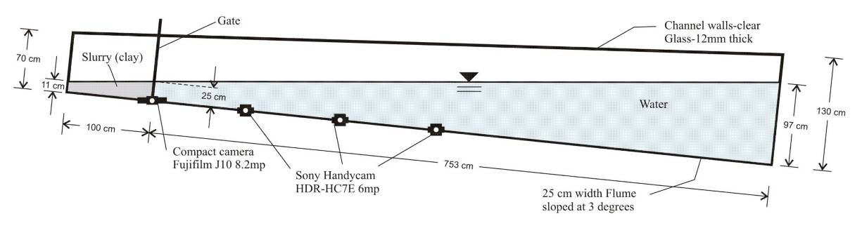

**Figure 1**. Laboratory experiment setup

Materials used in this experiment were slurry made from a mixture of kaolin clay and water with percentage variation as 10% to 35% (increasing every 5%). The specific gravity (Gs) value of the kaolin clay is about 2.6. Kaolinite has a low shrink-swell capacity and a low cation exchange capacity (1-15 meq/100g.) and it is a soft and earthy. Each experiment used a fixed volume of 45 liters of slurry. Mixing kaolin with water was done based on the weight of each and according to the percentage of kaolin in the slurry model. The density of kaolin used in mix design was 2.63 g/cm3, while water 1 g/cm3. Table 1 below lists the slurry mix design that to produce slurry of 45 liters approximately. Rheology test, including viscosity and density, was carried out using Fann Model 35 Viscometer and Mud Balance Model 140. The instruments and test kits were designed to conform to the testing standards established by the American Petroleum Institute (API) and published in API SPEC 10, API RP 10B-2, API SPEC 13A, API RP 13B-1, 13B-2, 13D, 13I, 13J, and 13K, and they were suitable for field and laboratory use.

**Table 1.** Slurry mix design.

|  |  |  |  |  |  |
| --- | --- | --- | --- | --- | --- |
| Slurry model  (% kaolin clay) | Kaolin | | Water | | Slurry (liters) |
| Weight (kg) | Volume (liters) | Weight (kg) | Volume (liters) |
| 10  15  20  25  30  35 | 5  8  11  14  17  21 | 1.9  3.1  4.2  5.3  6.5  8 | 45  45.3  44  42  39.7  39 | 45  45.3  44  42  39.7  39 | 46.9  48.4  48.2  47.3  46.2  47 |

Zakeri et al. extended the issue of time-dependency had to be carefully monitored as the slurries turned out to be rheopectic [7]. In order to complete and verify the rheology test results, slurry was re-tested using Brookfield Digital Viscometer DV-I+ equipment, according to ASTM D2196 [21].

1. **Result and Discussion**

Focusing on initial movement of slurry flow, observation was limited to a range of distance between the gate and a point of 3.5 m. This experiment was tracking the movement of slurry flow by applying timeline feature (t), velocity (v), and run-out distance (l). Observation was made by referring to gravity flow concepts that explain the phenomena of stratified fluids when a denser fluid body spreads under a less dense body of fluid [12]. In this case, slurry was the denser fluid that spreads under the water. Slurry flow performed lobes, billows and mixing region as well as dense fluid intruded into less dense fluid. Various percentage of kaolin clay content addressed a significant difference of head formation; higher percentage formed the thinner head (i.e. decreased value of H).

|  |  |  |
| --- | --- | --- |
| 10_3_1_1_2 | 15_3_1_1_2 | 20_3_1_1_2 |
| 10% kaolin clay | 15% kaolin clay | 20% kaolin clay |
| 25_3_1_1_2 | 30_3_1_1_2 | 35_3_1_1_2 |
| 25% kaolin clay | 30% kaolin clay | 35% kaolin clay |

**Figure 2.** Image capturing at distance of 2.5 m of 10% to 30% kaolin clay content; and 35% kaolin clay content at 1.7 m

With reference to recorded movement data, the head velocities were figured as graph of function of time versus run-out distance. Figure 3 shows the propagation of head velocity during flow, starting from gate point until distance of 3.5 m.

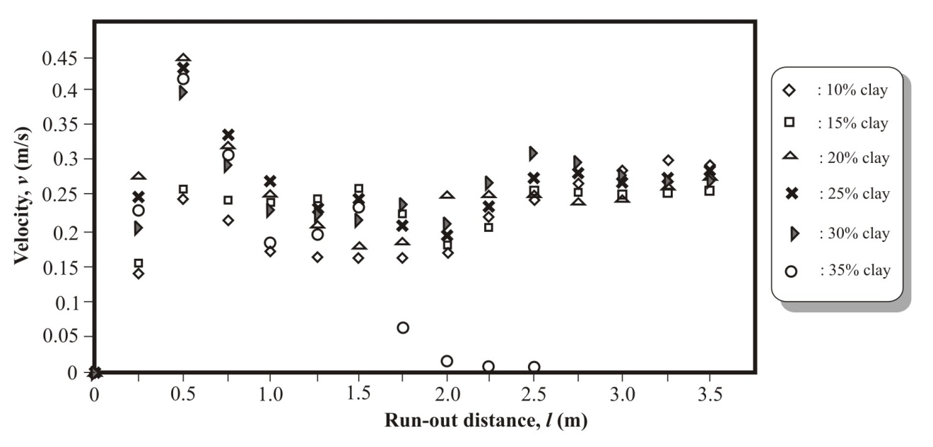

**Figure 3.** Head velocities at distance range of 0 to 3.5 m

FLUENT simulation is also made by using the same method as it is done for laboratory result. Figure 4 shows the propagation of head slurry velocities.

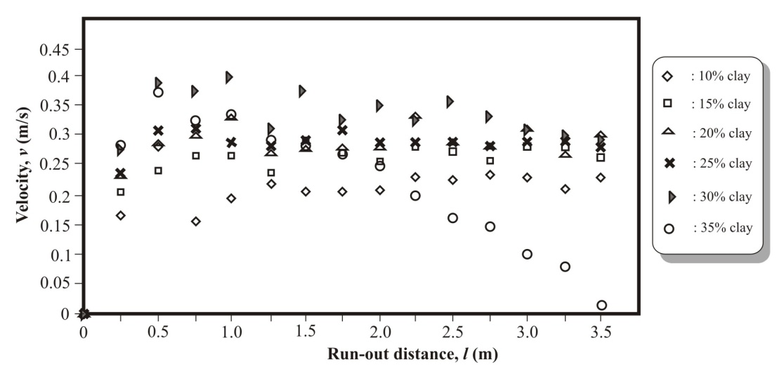

**Figure 4.** The slurry velocities in FLUENT simulation

1. **Concluding Remark**

In particular, this research has examined the basic model of submarine slide simulation by adopting the rheological properties of slurry from laboratory work. This numerical approach results some appropriate technical aspects of movement pattern including velocity and run-out distance related to flowing time. However, there was disagreement in mass flow formation between FLUENT and laboratory experiment. This perhaps due to the imperfect initial condition and some physical effects those were not numerically modelled.

In general, two methods of laboratory and numerical have conformity each other in submarine slide simulation using gravity flow approach with lock-exchange system. Even though, further research is needed to elaborate more engineering aspects related to laboratory equipments and features of the software.

1. **References**

[1] J. J. Hance, "Development of a Database and Assessment of Seafloor Slope Stability based on Published Literature," Master of Science in Engineering, Faculty of the Graduate School, The University of Texas, Austin, 2003.

[2] J. Locat and H. J. Lee, "Submarine Landslides: Advances and Challenges," presented at the The 8th International Symposium on Landslides, Cardiff, U.K, 2000.

[3] G. A. Wood and I. W. Hamilton, "Current Geohazard Problems and Their Geophysical Interpretation- An International Overview," presented at the Offshore Technology Conference 2002, Houston, Texas U.S.A., 2002.

[4] A. Elverhoi*, et al.*, "On the dynamics of subaqueous debris flows," *Oceanography,* vol. 13, pp. 109-117, 2000.

[5] R. J. Lowe*, et al.*, "The non-Boussinesq lock-exchange problem. Part1. Theory and experiments," *Journal Fluid Mechanics,* vol. 537, pp. 101-124, 2005.

[6] F. V. D. Blasio*, et al.*, "Hydroplaning and submarine debris flows," *Journal of Geophysical Research,* vol. 109, pp. 1-15, 2004.

[7] A. Zakeri*, et al.*, "Submarine debris flow impact on pipelines — Part I: Experimental investigation," *Coastal Engineering,* vol. 55, pp. 1209 - 1218, 2008.

[8] P. Bryn*, et al.*, "Explaining the Storegga Slide," *Marine and Petroleum Geology,* vol. 22, pp. 11-19, 2005.

[9] D. Mohrig*, et al.*, "Experiments on the relative mobility of muddy subaqueous and subaerial debris flows, and their capacity to remobilize antecedent deposits," *Marine Geology,* vol. 154, pp. 117-129, 1999.

[10] M. A. Hallworth and H. E. Huppert, "Abrupt transitions in high-concentration, particle-driven gravity currents," *Physics Of Fluids,* vol. 10, pp. 1083-1087, 1998.

[11] L. A. Amy*, et al.*, "Abrupt transitions in gravity currents," *Journal of Geophysical Research,* vol. 110, pp. 1-19, 2005.

[12] K. M. Mok*, et al.*, "Experimental Observations of The Flow Structures at Gravity Current Fronts," presented at the International Conference on Estuaries and Coasts, Hangzhou, China, 2003.

[13] L. Jiang, "Numerical Modeling of Submarine Landslides and Surface Water Waves which They Generate," Doctor of Philosophy, The Faculty of Graduate Studies Department of Oceanography, The University of British Columbia, Vancouver, 1993.

[14] J. Imran*, et al.*, "A numerical model of submarine debris flow with graphical user interface," *Computers & Geosciences,* vol. 27, pp. 717-729, 2001.

[15] S. G. Wright and H. Hu, "Risk Assessment for Submarine Slope Stability - Hydroplaning," Minerals Management Service, Austin, US, Final Project Report 1435-01-04-CA-35515, February 2007.

[16] A. Zakeri*, et al.*, "Submarine debris flow impact on pipelines — Part II: Numerical analysis," *Coastal Engineering,* vol. 56, pp. 1-10, 2009.

[17] H. B. Cheong and Y. H. Han, "Numerical Study of Two-Dimensional Gravity Currents on a Slope," *Journal of Oceanography,* vol. 53, pp. 179-192, 1997.

[18] A. Mehdizadeh and B. Firoozabadi, "Simulation of a Density Current Turbulent Flow Employing Different RANS Models: A Comparison Study," *Scientia Iranica,* vol. 16, pp. 53-63, 2009.

[19] T. Ilstad*, et al.*, "On the frontal dynamics and morphology of submarine debris flows," *Marine Geology* vol. 213 pp. 481-497, 2004.

[20] R. J. Lowe*, et al.*, "The non-Boussinesq lock-exchange problem. Part 1. Theory and experiments," *Journal Fluid Mechanics,* vol. 537, pp. 101-124, 2005.

[21] Standards, "ASTM D1092-05 Standard Test Methods for Rheological Properties of Non-Newtonian Materials by Rotational (Brookfield type) Viscometer.," ed: ASTM International, 2005b.