**Personality Test Social Application System Construction -The Influence of Community Platform On Personality Trait Extroversion, Real and Virtual Interpersonal Relationship**

**Shu-Chen YANG1 and Chun-Wei HSU2**

1 Department of Information Management, National University of Kaohsiung. No. 700, Gaoxiongdaxue Rd., Nanzi Dist., Kaohsiung City 811, Taiwan (R.O.C.)

E-mail: henryyang819@gmail.com. a1033354@mail.nuk.edu.tw

**Abstract.** The rapid change of the times. A smartphone is a part of socialization. Social is a product of the collective society. Different from the social model of the past. The popularity of social software in recent years has also brought about tremendous changes. A social application such as Facebook, Twitter, Whatsapp, etc. All bring a new definition of social style to human society. Since different social software has the same mode of making friends, the face of friends is in appearance or interest. Do we think that dating mode can make changes? There are differences in "people". Differences create different individuality, personalities, and traits. Therefore, we use personality traits as the theme to design a mobile-oriented mobile application that allows users to complete the personality test. The topic, whether or not it does not meet its personality traits, has a standard existence. We use the user personality test to test the user's nine personality scale and can chat and interact with other users through personality matching. Different from general social software, this paper will explore the application value of social software user personality traits, and will have the opportunity to change the interaction mode of today's social software with different dating experiences, so that the social experience generated by users can be further improved.

Keyword－Personality, Information System, Social Software, Creativity, UX/UI Design

1. **Introduction**
   1. *Research background and motivation*

The popularity of smart mobile devices and the explosive development of electronic applications have made interaction between people more zero-distance. From many software, the two functions of social and immediacy can not only influence the current social software. The situation is also the modernization trend of the Internet. The emergence of social software is endless, and the elimination rate is very fast. The development and sustainability of social software have an absolute relationship with market share and market satisfaction. In addition to application development, it is creative and practical and provides users with good user experience. This is a way to survive in a huge social market.  
 This thesis observes that there are various types of personality tests in the market, but these applications are the software of a single personality psychological test, which can provide the type of personality the user belongs to. Furthermore, the sense of belonging is the key to the collective society. Empowerment, similar data, personality, constellation or traits, produce similar or complementary attraction. This paper also observes that communication between people in communication software also plays an important role. Communication can be used to reduce the unfamiliar conflict of users. Therefore, this thesis combines the four characteristics of "personality traits", "social", "communication" and "starry sky" to develop a very unique social software on the market, allowing users to understand their personality traits. It is possible to interact with different users through innovative application services to achieve good social experience and create another wave of trends.

* 1. *Research purposes*

*1.2.1.* There are many personality tests or social communication software in the App Store, but at the same time to combine "personality traits", "social", "communication" and "starry sky" are hardly in the market [1].

*1.2.2.* An in-depth collection of literature on personality traits and other literature, and then develop a set of high-accuracy personality test questions without encroaching on intellectual property rights and copyrights, to integrate new technologies or ideas applied to the software plan [2].

*1.2.3.* The research on the personality traits of social software users can indirectly understand the distribution of user personality traits through test questions, and have corresponding help and research needs for design experience development in the future.

*1.2.4.* Analysis of the use of demand analysis, in addition to the user through the personality test questions, can promote the user's motivation to develop the application.

1. **Literature Review**
   1. *Social applications*

In today's society, due to the popularity of the Internet and the universality of mobile devices, people can receive messages in a timely manner. People use this feature for different applications. According to a survey conducted by the Taiwan Network Information Center (TWNIC), 89.8% of the 2,809 respondents used online community or instant messaging software (TWNIC, 2016). This shows that online dating has a great demand for users. Because online dating software is often used to make friends and match photos, articles. Providing different ways of making friends, and having a new look to the public users is also the focus of this paper [3].

* 1. *Nine personality test*

Based on the ancient system of Nine Personality, you will be introduced to the nine basic personality types inherent in human nature. It will help you to enjoy a more satisfying and fulfilling relationship in all aspects of life. This knowledge will help you better understand how others think and why they do it and enhance your understanding of your personality. (Helen Palmer, 1991).In the future, I will refer to Wikipedia, papers on various online platforms, and books in the library to develop a set of questions based on nine personality types and methods of identification [4].

* 1. *Game fun*

By playing games, humans can develop their personal life skills. According to this paper show that playing games are the best way to understand themselves (Wang Weicong, Wang Jianqiao, 2011). Develop games and personality tests to combine to produce new sparks. To develop personality through games, and to develop games with personality [5].

* 1. *The impact of community platforms on "personality trait extroversion" and "real and virtual interpersonal relationships"*

In real life, people have limited time to get along with each other. So it may be more active to use the social platform to maintain and close the distance between them. Extend the long-term face-to-face conversation, and maintain "real" interpersonal relationships. Stabilizing the feelings between friends or family members. The virtual community platform gives us the opportunity to recognize strangers. To understand people who can't meet in real life. To expand virtual interpersonal relationships through the interactive mode of two-way communication of the community platform, and to lay the foundation for real interpersonal relationships [6][7].

1. **Research Methodology**

I use qualitative research on interview types and develop and filter interviewees. Beside Opinion survey, I use questionnaires for statistical analysis to design a dating software that is different from the software market. The user data can be analyzed this research to analyze changes in future dating patterns and business models.

In the design of the needs analysis of the APP of this plan, the user needs were understood through interviews, and the total number of respondents was about a hundred people. The following are interview results that are categorized and integrated based on the respondents' responses.

*3.1.* *1. Will you use dating software to get to know strangers?*

Thirty-one respondents did not use dating software to meet strangers. The reason for not using it is mainly because there is no such demand. There are ten respondents who think that the existing dating software has too many users for the purpose of sex. Those respondent does not like this kind of atmosphere and therefore does not use it. Seventy respondents used dating software to meet strangers. There are two main reasons for using it. In order to expand the circle of friends, you can meet different types of people. If you want to pass the time, you can find someone to chat. More specifically, five of the respondents mostly use foreign software. I hope to learn the language with each other. Twenty respondents are businessmen and hope to find new customers through software.

*3.2.* *2. How often do you use dating software?*

Fifty-one respondents used the same time each time. Using 30 to 60 minutes each time. Forty-nine respondents used one or two times a week on average, and two respondents used it frequently during their spare time.

*3.3.*  *Is the personality trait obtained from a psychological test or personality test similar to yourself?*

Sixty-five people felt that they were ordinary in the psychological test. Twenty people felt that they were not allowed. Fifteen people felt close. Forty-one people felt ordinary and sixty-two felt very close.

According to the interview, the respondents will do psychological tests because the questions or results of the psychological test are very interesting. The personality test is mainly done by the school and will not take the initiative. A hundred respondents only fifteen people will take the initiative to do personality tests because the respondents want to know more about themselves.

*3.4*. *Will the test results be shared with friends?*

There are twenty people in the personality test who will not share the results. Nine people will only share it with close friends. They think that the result is privacy and they don't want others to know. Forty people will decide whether to share according to the accuracy of the results. The three will share it anyway. In addition, many respondents will want to know the test results of others and want to know each other and reduce conflicts.

*3.5. How do you want to communicate and communicate when you know strangers through software?*

A total of sixty-seven people in the interviews preferred a text message. Of which fifteen were accepted for the voice record message; twenty-three were preferred for voice calls or video. Respondents who prefer text think that it is easy to be embarrassed and feel strange to communicate with strangers by talking or video for the first time. Because they don't know each other's voice and looks. They can have a fantasy space and have a mysterious feeling.

Respondents who prefer voice or video believe that textual narratives tend to cause semantic distortions and take a longer time. Voice calls and video can be understood through conversations, sound characteristics, or fluency of sentences. The other party and communication are more convenient.

1. **Program Architecture**

Users only need to use client-side to click on the mobile device to reach the connection with the server. The server-side compiles the Java language through Android Studio, Python cv2 to process the image and link with the PHP-supported MySQL database.

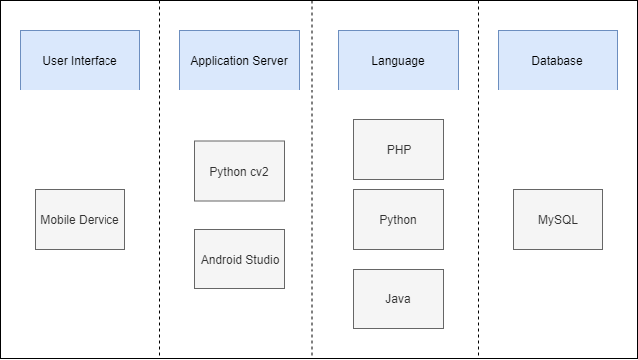

**Figure 1.** Program architecture diagram

1. **System Architecture**
   1. Pairing function

The highlights of this app are "Pairing function". At present, the selection fields of the system configuration are "work", "love" and "coexistence". We analyze the simulation algorithms according to the major types of nine types of book academic research and select the three most suitable pairing user. The relationship between each personality has a suitable and unsuitable relationship. For example, the first type of personality is more suitable for the second, third and fifth types in the work. Using academic research and reference books, the personality trait analysis of this APP is more inclined to reality, not just reference [8].

* 1. Message

When the pairing is completed, a message chat can be performed. The message on this page can be used to know the "good feeling time" message and the message sent by the successful pairing friend [9].

* 1. Star posting

One of this app highlight is "Star posting". Users can publish posts three times a day. Users can see the stars of their posts on this feature page and they can also reply to other users' posts. This action is called "Star picking". The daily star picking is limited to five times. Users can see the post records that they have published and the post records that have been replied by other users. In addition, they can also see that they have responded to others and selected as the best solution. We use the post users and the reply users as a distinction between this feature [9].

* 1. Personality test

This app is based on the establishment of “personality traits” and the interaction of friends. On the test topics, I mainly develop test questions through research books and personality academic references tested by nine-person personality (George Gurdjieff, Oscar Ichazo, 1915, 1960). Each type of topic will have 60 questions, a total of 540 questions. The user can answer three questions according to the online login system every day. The user can also click the test to answer six questions (up to 9 questions a day) to answer more questions to confirm which personality that I belong to. Through the daily three-question test, the personality data of the database is more and more complete. The pairing function mechanism will be more accurate and reliable.

* 1. Introduction and personality analysis

About the feature of the introduction, there are nicknames, genders, birthdays, emotional states, interests and recent troubles. The above information users can edit them themselves. Editing the above information will make the other users understand the status when pairing, and then generate the chat topic. This feature page also allows you to find a description of each personality type. Data about the user's personal personality traits will also be fully presented.

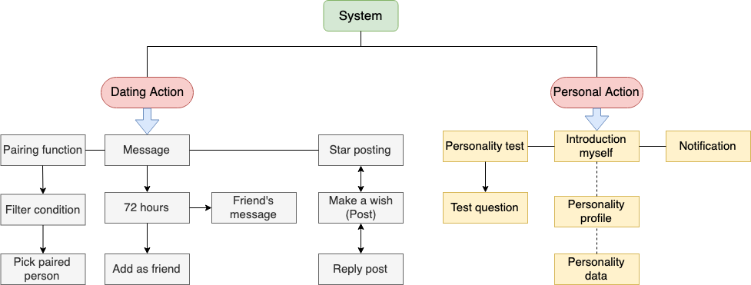

**Figure 2.** System architecture diagram

1. **System Software and Hardware Requirements**

The operating system used by this app is Linux ubuntu. Since only the backhaul data of the database needs to be stored, so the text interface is the most important consideration. The graphics interface system will take up too much CPU resources. The development software uses android studio and python cv2. The development software has a good folder classification and readability. The Adobe XD is designed as a front-end system on the user interface. Since this app mainly supports by android, the programming language uses Java as the development language.

**Table 1. System software and hardware requirements**

|  |  |
| --- | --- |
| Operating System | Linux Ubuntu 16.04 |
| Database | MySQL |
| Development software | Android Studio (program development), Python cv2 (modeling). |
| Program language | Java (program development), PHP (link database), Python (image  processing) |
| Apps installation requirements | Application for Android system software, the minimum Android SDK requirements for API Level 23 (Android 6.0), the main development of the Android SDK for API Level 26 (Android 8.0), because the Android system can support the API down, as long as the Android SDK has no major changes, API Level higher than 23 can be used. |

1. **Conclusion**

The project is expected to develop a set of personality traits that allow users to use social software to understand more interesting people through personality tests. Through the personality test, I can know that I am similar to what kind of personality traits. I can understand myself through the test. The function of wishing and picking stars is also expected to make it easier and clearer for users to express their opinions. You can make a wishing post and then get responses from other users to add overall interactivity and fun. Users can know more about other users thinking and feeling. To understand more people's thoughts and opinions, so that friends are no longer randomly matched or simply reply to the message. The program also hopes that users can share with friends to increase the fun and mutual feelings of the app. In addition, the program system strongly hopes to be different from the previous social, quiz or reply to the application software. The program integrates social and personality tests and the design of wishing post and pick stars, so that users have a new look for a social application and the impression, as well as the design of the added personality test, can also attract users of different ages to apply this application software.

**Acknowledgments**

* 2019 National Inspiring Student Creative Competition Information Application, Group 2nd Place
* 2019 National Micro Entrepreneurship Innovation Competition, The 1st Place

1. **References**

[1] Santos, R. P. D., Esteves, M. G. P., Freitas, G. D. S., & Souza, J. M. D., et al 2014. *Journal of Social Networking***3(2)** 108-118

[2] Toda, M., Ezoe, S., Mure, K., & Takeshita, T., et al 2016. *Open Journal of Preventive Medicine* **6(10)** 215-221

[3] Taiwan Network Information Center (2018). 2018 Taiwan Broadband Network Usage Survey Report. https://www.twnic.net.tw/doc/twrp/201812e.pdf

[4] Suzuki Hideko 2017 *Nine-type Personality workplace literacy: from recognizing yourself to reading others, letting you communicate more effectively, ability to be appreciated* Taiwan:Inspiration

[5] Tsai, T.W., Shen,Y.S., et al 2016. *Journal of Design Science* 19:1 81-102

[6] Allport, G. W., & Odbert, H. S. (1936). Trait-Names A Psycho-lexical Study. *Psychological Monographs* **47(1)** 1-171

[7] Wang Y、Dalian University of Technology（2017）*Charming China* **2017(47)** 49-52。

[8] Ting Ya G, et al 2014. *Journal of Commercial Modernization***7:3** 31-48

[9] Teng, S.Y, Wen, C.Y., (2017) *Forensic Science Journal* **16:1** 1-11

[10] Ting Ya G, Yi Eeng W, et al 2011. *Journal of Commercial Modernization* **6:2** 29-42