**Analysis of SAP Implementation in Accounting Division Using Information System Success Model in Banking Sector (Case Study: PT. Bank Mandiri)**

**Dahlia Raitana1, R. Wahjoe Witjaksono2, Muhardi Saputra3, and Anik Hanifatul Azizah4**

1234School of Industrial Engineering, Telkom University, Bandung (Indonesia)

1[draitana7@gmail.com](mailto:draitana7@gmail.com), 2[witjaksonowahjoe@gmail.com](mailto:witjaksonowahjoe@gmail.com), 3[muhardi@telkomuniversity.ac.id](mailto:muhardi@telkomuniversity.ac.id), 4[anikhanifazizah@gmail.com](mailto:anikhanifazizah@gmail.com)

**Abstract.** PT. Bank Mandiri Tbk.’s accounting division runs the main activities in the company. SAP system helps PT. Bank Mandiri managing every information which supports module and integrating them to the other divisions in PT. Bank Mandiri to simplify the work. The information runs in real-time so that it can reduce human-error mistakes, e.g. data duplication dan inaccuracy. Therefore the system needs research to evaluate SAP in the accounting division, to measure the system performance using the Information System Success Model. Information System Success Model consists of 6 variables, such as system quality, information quality, service quality, use, user satisfaction, and net benefits. Data accumulation uses questionnaires that are distributed to the accounting division and gains 40 responds. There are 9 hypotheses examined using Structural Equation Modelling (SEM), 7 hypotheses are accepted, whereas the other 2 are declined.

1. **Introduction**

PT. Bank Mandiri, Tbk, is one of the first companies, which has implemented an SAP application, which makes PT. Bank Mandiri uses around 10 years. The main reason the company decided to adopt SAP over the other system because of the support provided by consultants and guaranteed data protection in the system database so that the company does not need to be afraid of losing the company’s existing data. If something happens that causes data loss, the consultant will be fully responsible for restoring the lost data and the other existing data structure to the SAP application. At present, Bank Mandiri implements several major SAP modules, which are SAP Human Resource (HR), SAP Financial and Controlling (FICO), and SAP Customer Relationship Management (CRM).

In the accounting division, the headquarters of PT Bank Mandiri conducts the main activities, such as making policy and accounting standards, compiling financial statements for both management and regulators, posting journals from the headquarters, monitoring wide open posts and GNC, and manage the taxation in the company. SAP helps PT. Bank Mandiri manages all information that supports these activities. The SAP system integrates modules inside and integrates with other divisions within the company. The information runs in real-time to reduce human errors, such as data duplication and inaccuracy.

Bank Mandiri continues to conduct a routine evaluation of SAP that implemented, but PT Bank Mandiri Tbk does not have a valuation standard or indicator, which can state that the implementation of SAP at PT Bank Mandiri has succeeded, especially the one used by the accounting division.

Based on the case, the analysis in implementing the SAP system in the accounting division was tested using the Information Systems Success model by Delone and Mclean which has 6 variables, such as system quality, information quality, service quality, use, user satisfaction, and net benefit[3]. The research aims to evaluate SAP software and knowing the factors needed by the company to optimize the successful implementation of SAP. The result of this research is to provide recommendations and guidance in improving or optimizing the functioning of the SAP system in the accounting division.

1. **Basic Theory**

*2.1 Systems Application and Programs in Data Processing (SAP)*

SAP stands for Systems Applications and Programs in Data Processing. SAP is one of the ERP software that is widely used. SAP used to manage the organization's resources, management, and operational control. SAP consists of various modules that integrate all functionalities in each department from product planning, purchasing, inventory control, product sales, and distribution, plant maintenance, quality control, human resources, finance and controlling and many other functions in the company [5].

SAP used by more than 500 companies around the world as a solution for processing operational data and making real-time reports so that it can help management levels to make good decisions appropriately and enable them to manage company business processes effectively and efficiently [7].

There are several advantages for companies from implementing SAP as follow: (1) Reducing paper usage; (2) Expenses in printing and printing by 33%, decreasing the need for human resources by 2.5%, making it easier to manage data; (3) Accelerating data transfer; (4) Improving work output and improving work procedures; (5) Increase the speed of the transaction process; (6) Increase in the level of user satisfaction; (7) Facilitate employees in getting information between different sectors because it uses a single database [6].

*2.2 Information System Model by Delone and Mclean*

In 1992, Delone and Mclean developed a research model, namely information systems success model and then in 2003, Delone and Mclean released "The DeLone and McLean Model of Information Systems Success: A Ten-Year Update" which was an updated Information System Success model [2,3] The revised Information System Success Model has added service quality variables, intention to use as alternative uses and combined individual and organizational impact into net benefits.

The variable of the revised model of information systems success is system quality, information quality, service quality, use, user satisfaction, and net benefit. According to [4] the variables in the model are as follows:

1. System Quality refers to the desired characteristics of system performance, such as user convenience, system flexibility, ease of use of the system, and ease of learning, as well as system features such as intuitive, sophistication, flexibility, and response time.
2. Information Quality refers to the characteristics of the desired system expenditure, such as reporting management and web pages.
3. Service Quality refers to services received by users. According to DeLone and McLean, there three components that affect the quality of service, namely the quality assurance provided by the system, empathy or concern for the system to the user, and the quality of the system's response to user actions.
4. Use refers to how often the user uses the system, examples of measurement are the amount of use, frequency of use, nature of use, the suitability of use, level of use, and intend to use.
5. User Satisfaction refers to the response from the user of the system, such as a support system, website and many more.
6. Net Benefit refers to the extent to which the existing system contributes to the success of individuals, groups, organizations, industries, and nations.

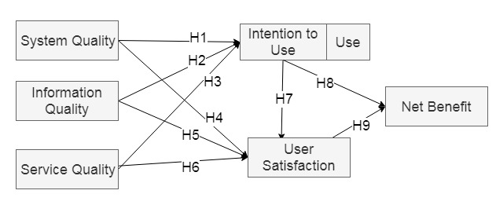

**Figure 1.** Information System Model [3].

|  |  |  |
| --- | --- | --- |
| H1 | : | System Quality has a positive on Use |
| H2 | : | Information Quality has a positive impact on Use |
| H3 | : | Service Quality has a positive impact on Use |
| H4 | : | System Quality has a positive impact on User Satisfaction |
| H5 | : | Information Quality has a positive impact on User Satisfaction |
| H6 | : | Service Quality has a positive impact on User Satisfaction |
| H7 | : | Use has a positive impact on User Satisfaction |
| H8 | : | Use has a positive impact on Net Benefit |
| H9 | : | User Satisfaction has a positive impact on Net Benefit |

Based on DeLone and Mclean's information system success model in Figure 1, the researcher developed the research hypothesis as follows:

1. **Pengumpulan Data**

Every data and information needed and used will be collected using literature studies and field studies. The literature study is a method of collecting data by examining the book. The field study conducted by interviewing PT. Bank Mandiri, Tbk and distributing questionnaires to SAP application users in the accounting division at PT Bank Mandiri headquarters. The questionnaire was distributed using a Likert scale which was used to measure attitudes and opinions [9].

1. **Data Analysis**

The data collected in this study were processed using SmartPLS software, and the IBM SPSS (Statistical Product and Service Solution) Statistics. The data were analyzed and tested using SEM (Structural Equation Model), an approach to get information by combining psychometrics with statistics into an analysis system [1].

In this study, SEM analysis carried out with several tests, such as the coefficient determination test, path coefficients test, and partial test.

Coefficient determination test is a technique to measure the influence of independent variables in explaining the dependent variable. This test is done by looking at the coefficient of determination (R2), what is the value between lift 0 to 1 [9].

Partial tests conducted to determine whether the independent variable has an influence on the dependent variable or does not have an influence on the dependent variable. This test is done by comparing the value of T Count with T Table which has a degree of error of 5% ( $a$ = 0.05), T Count must be greater than T Table [9]. Figure 2 shows the structure of the Information System Success Model that has been tested using the path coefficients test with the SmartPLS program.

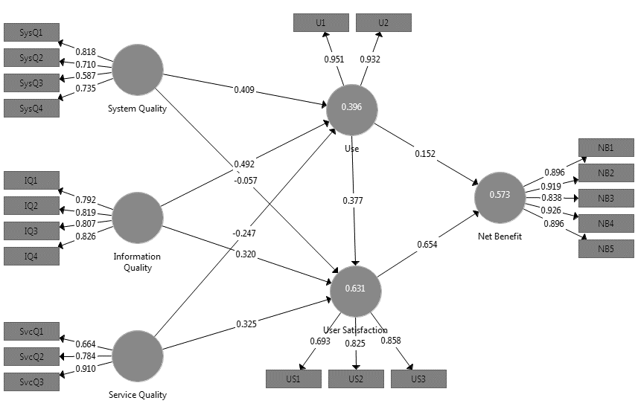

**Figure 2.** The Result of Path Coefficient Test.

Based on the results of SEM analysis conducted with the path coefficient test, coefficient determinant test and partial test that have been done can obtain the significance of the relationship between the variables to assess whether the hypothesis made is accepted or rejected.

**Table 1.** The Result of SEM Test.

|  |  |  |  |  |  |
| --- | --- | --- | --- | --- | --- |
| Hypothesis | Path | β | T Count | R2 | Accepted |
| H1 | System Quality 🡪 Use | 0.409 | 4.698 | 0.346 | Yes |
| H2 | Information Quality 🡪 Use | 0.492 | 1.512 | Yes |
| H3 | Service Quality 🡪 Use | -0.247 | 2.615 | No |
| H4 | System Quality 🡪 User Satisfaction | -0.057 | 2.098 | 0.589 | No |
| H5 | Information Quality 🡪 User Satisfaction | 0.320 | 0.98 | Yes |
| H6 | Service Quality 🡪 User Satisfaction | 0.325 | 0.399 | Yes |
| H7 | Use 🡪 User Satisfaction | 0.377 | 2.363 | Yes |
| H8 | Use 🡪 Net Benefit | 0.152 | 1.267 | 0.550 | Yes |
| H9 | User Satisfaction 🡪 Net Benefit | 0.654 | 2.85 | Yes |

Based on the test results listed in Table 1, the following describes the results of the hypothesis test:

1. H1: System Quality has a positive impact on Use

The system quality variable on use has a path coefficient of 0.409 and a statistical T value of 4.698, where the T statistic is greater than t table which is 2.024. Thus, the quality of the system has a positive impact on use and the variables are significantly interrelated. The higher the quality of the SAP system, the higher the frequency of use of the SAP system for users in the accounting division.

1. H2: Information Quality has a positive impact on Use

The information quality variable on use has a path coefficient of 0.492 and the value of T Count 1.512, where T Count's value is less than T Table with a value of 2,024. Therefore, information quality has a positive impact on use even though the variables are not significantly connected. This means that the quality of the information displayed and generated by SAP increases the frequency of using the SAP system in the accounting division.

1. H3: Service Quality has a positive impact on Use

The service quality variable on use has a path coefficient of -0.246 and the value of T Count 2.615, where T Count’s value more than T Table with value 2.024. Therefore, service quality does not have a positive impact on use and significantly connected.

This is because there are services provided by the SAP system that is implemented not in accordance with the business processes contained in the accounting division so the company must use other applications, as a result, user satisfaction with the quality of service is not good.

1. H4: System Quality has a positive impact on User Satisfaction

The system quality variable on user satisfaction has a path coefficient of -0.057 and the value of T Count 2,098, where T Count’s value more than T Table with value 2.024. Therefore, service quality does not have a positive impact on user satisfaction and significantly connected.

This is because of the complexity of SAP software that makes it difficult for users in the accounting division to operate SAP applications in their daily work, so they experience difficulties and find errors when using it.

1. H5: Information Quality has a positive impact on User Satisfaction

The information quality variable on user satisfaction has a path coefficient of 0.320 and the value of T Count 0.98, where T Count’s value less than T Table with value 2.024. Therefore, information quality has a positive impact on user satisfaction but the variables are not significantly connected. This means that the quality of the information displayed and generated by SAP makes accounting division employees increase the good responses regarding the implementation of the SAP system.

1. H6: Service Quality has a positive impact on User Satisfaction

The service quality variable on user satisfaction has a path coefficient of 0.325 and the value of T Count 0.399, where T Count’s value less than T Table with value 2.024. Therefore, service quality has a positive impact on user satisfaction but the variables are not significantly connected. This means the services provided by the SAP system increase the good responses from accounting division employees.

1. H7: Use has a positive impact on User Satisfaction

The use variable on user satisfaction has a path coefficient of 0.325 and the value of T Count 2.363, where T Count’s value more than T Table with value 2.024. Therefore, use has a positive impact on user satisfaction and significantly connected. This means the frequency of using the SAP system in the accounting division increases good responses from accounting division employees.

1. H8: Use has a positive impact on Net Benefit

The use variable on net benefit has a path coefficient of 0,152 and the value of T Count 1,267, where T Count’s value less than T Table with value 2.024. Therefore, use has a positive impact on user satisfaction but the variables are not significantly connected. This means the frequency of using the SAP system in the accounting division increases the expected net benefits received from implementing SAP in the accounting division.

1. H9: User Satisfaction has a positive impact on Net Benefit

The user satisfaction variable on net benefit has a path coefficient of 0,654 and the value of T Count 2,85, where T Count’s value less than T Table with value 2.024. Therefore, user satisfaction has a positive impact on user satisfaction and significantly connected. This means the good responses from accounting division employees increase the expected net benefits received from implementing SAP in the accounting division.

1. **Conclusion**

Based on the results of research for analysis of SAP implementation in the accounting division at PT. Bank Mandiri, Tbk, using the Information System Success model that has been done, it was proven that from the 9 hypotheses tested using the Structural Equation Modelling (SEM) model, 7 hypotheses proved to be accepted and 2 hypotheses proved to be rejected.

It can be concluded that the variables which increase the Net Benefit of SAP implementation, namely increasing the use and user satisfaction felt by users in using the system can increase the net benefit felt by the company, accounting division, and employees, but the frequency of using the SAP by user does not have a significant effect.

Second, improving User Satisfaction felt by the user by increasing the Use, the quality of the SAP system (System Quality) and the quality of information (Information System), but the quality of information (Information Quality) and service quality (Service Quality) has no significant effect. Finally, increasing the use of users can be done by increasing service quality and information quality on SAP, but the information quality obtained from the SAP has no significant effect on user satisfaction.

**5**. **References**

|  |  |
| --- | --- |
| [1] | Abdillah 2017 *Metode Penelitian Terpadu Sistem Informasi* (Yogyakarta: Andi Publisher). |
| [2] | DeLone and McLean 1992 *Information Systems Success: The Quest for the Dependent Variable* (Inf. Syst. Res) vol. 3 p 60-95. |
| [3] | DeLone and McLean 2003 *The DeLone and McLean Model of Information Systems Success: A Ten-Year Update* (J. Manag. Inf. Syst') Vol.19 p 9-30. |
| [4] | Iivari 2005 *An Empirical Test of the Model of Information System Success* (The DATA BASE for Advances in Information Systems) Vol. 36 p 8–27. |
| [5] | Junnarkarm, Atul and Verma 2017 *Study on System Application Product (SAP)- An Important Enterprise Resource Planning Tool For Achievement of Organizational Vision, Mission and Operational Performance* (International Research Journal of Engineering and Technology) Vol. 4 p 2064. |
| [6] | Khoualdi, K and Basahel 2014 *The Impact of Implementing SAP System on Human Resource Management: Application to Saudi Electricity Company* (International Journal of Business and Management) Vol. 9 p 28-32. |
| [7] | Okungbowa 2015 *SAP ERP Financial Accounting and Controlling – Configuration and Use Management* (New York : Appress). |
| [8] | Riduwan and Kuncoro 2014 *Analisis Jalur* (Bandung: Alfabeta). |
| [9] | Sugiyono. 2017 *Metode Penelitian Kuantitatif, Kualitatif, dan R&D* (Bandung: Alfabeta) |