ORCHESTRA LEARNING BASED ON STUDENT CENTERED LEARNING - COMPREHENSIVE MUSICIANSHIP THROUGH PERFORMANCE

¹Fu’adi, ²Agustianto, ³Yunike Juniarti Fitria
Faculty of Language and Art, Yogyakarta State University
email: fuadi@uny.ac.id, agustianto@uny.ac.id, yunikejuniarti@uny.ac.id

Abstract
This study aims to describe orchestral learning based on Student Centered Learning - Comprehensive Musicianship through Performance (SCL-CMP) in the Department of Music Education, Faculty of Language and Art, Yogyakarta State University. The specific target of this study was to find excellence, barriers, potential application of student centered learning in orchestral learning.This research is a qualitative research with researchers as the main research instrument (participant observer). Data collection techniques by observation, interviews, and documentation. Validity of data by triangulation. data analysis through stages of data reduction, categorization, and conclusion. The results of the study are 1) Application of SCL-CMP in orchestral learning, and 2) Evaluation of Orchestra Learning, Through SCL-CMP students and lecturers can develop their competencies with discussions according to their musical instrument groups. Students are more active in discussing with lecturers and lecturers also easier to monitor the development of student abilities. Technical and non-technical problems can be solved in discussions, so that SCL-CMP model-based learning can be applied in orchestral learning.
Keywords: orchestra, student centered learning, comprehensive musicianship through performance

INTRODUCTION
Orchestral learning as a compulsory course in the Department of Music Education is a course of practice in which student musical competence is developed through mastery of orchestral standard material. Standard material for orchestral courses is drawn from works by world composers such as W.A. Mozart, L.V. Beethoven, G. Bizet, Tchaikowsky and others. Spitzer in Sadie (2001: 530) explained the term orchestra in ancient Greece and Rome refers to a basic level of an open stage, which was used again during the Renaissance to show the place in front of the stage. In its development, in the seventeenth century there were several inter-related orchestral features, including a) Orchestra based on string instruments namely violin, viola (alto violin) and double bass, b) Stringed instrument group playing the same tone, c) Wind instruments and percussion perform with different amounts according to the times, d) The orchestra is coordinated by a main player of the violin (concertmaster) or keyboard player, then led by a conductor.
Orchestra learning has been using lecture and demonstration methods. The learning process is still centered on lecturers in providing materials, instructions, assignments and so on. In this case students are in a passive position by accepting and carrying out instructions. The centralization of the learning process by lecturers has an impact on student dependence in an effort to develop orchestral music competencies. With this reality, the creativity of students, the development of insights and skills of students is not fully developed.. A learning model is needed that can guide students more actively in participating in orchestral music learning. Student activity is very influential on the development of competencies.
One learning model that is expected to encourage student activity is the SCL learning model (Student Centered Learning) Comprehensive Through Performance. In this learning model orchestra learning is no longer centered on lecturers, but students are more active in following the learning process. The lecturers are in the position of facilitators. Students are directed to be more active in mastering the material both in theory, practice, and everything related to learning materials by group discussions with lecturers as facilitators.
Student Centered Learning is a learning strategy that places students as students (participants) active and independent, with psychological conditions as adult students who are fully responsible for their learning, and able to learn outside the classroom. On the other hand the teachers switch functions from teaching to learning partners as well as facilitators including as learning partners, no longer as the main knowledge source (Harsono, 2008). Brown (2008: 30) there are two learning models in student-centered learning that can be applied in music learning, namely Comprehensive Musicianship through Performance (CMP) and PROPEL Art.
This study examines the application of the Student Centered Learning method in Orchestra lectures with the model used, namely CMP (Comprehensive Musicianship through Performance). In accordance with what Brown explained, the CMP learning model, namely by choosing repertoire / music works then students must actively find out everything related to the music work so that it can add knowledge to both students and lecturers. Sindberg (2012) explained CMP learning models can be used in modern bands, orchestras, and choir classes. In relation to this research orchestra lecturers designed orchestral learning and monitored learning, as facilitators in student groups and prepared cases or problems for students to solve in groups, in this case orchestral learning material namely overture Coriolan by L.V. Beethoven. The students discuss and conclude the problem or task given in groups, in this study discussing, practicing, and presenting the results by demonstrating the overture of Coriolan Beethoven in accordance with their respective musical instruments.
Many studies have been conducted on Student Centered Learning-based learning including Reza Rindy Antika (2013) entitled "Student Centered Learning Based Learning Process (Descriptive Study at Baitul 'Izzah, Nganjuk Islamic Middle School)" . The results of this study are (1) Aktive Learning, learning oriented to student activities, (2) Contextual Learning, learning strategies with real life students. In addition there are also obstacles both inside and outside. The internal obstacle is the existence of students who are passive and not all subject matter can prioritize the activity of students, especially the basic formula material. External barriers are lack of facilities, lack of attention from the government and lack of knowledge of student guardians on the actual learning process. Other research by Sugiyo entitled "The Effectiveness of the Student Centered Learning Method Based on Fun Chemistry to Improve Student Chemistry Learning Outcomes". The results of the study show that learning using the Student Centered Learning method based on Fun chemistry effectively improves student learning outcomes. The relevance of the two studies above with the research that will be conducted lies in learning based on Student Centered Learning. The difference lies in the subject, target and urgency of the study.

METHOD
This research is a qualitative research with researchers acting as the main instrument of research. Moleong (2005: 5) qualitative research is research that uses natural settings, with the intention of interpreting phenomena that occur and are carried out by involving various methods commonly used, namely interviews, observations, and document utilization. The process of qualitative research involves a variety of important efforts, including asking questions and procedures, collecting specific data from participants, analyzing data inductively from specific themes to general themes, and interpreting the meaning of data (Creswell, 2016: 4-5).Triangulation is done by matching the data obtained from observations, interviews and documentation. If the data has not found a match then it is checked again with the data source until the data is truly valid. Observations were made in orchestral learning classes, including the learning process, the methods used, the results achieved by students, the ease in understanding and mastering orchestral learning material. Interviews with orchestral learning students are intended to find out the extent to which the material can be mastered, the effectiveness of the learning process, freedom of asking and giving opinions. Documentation is the act of collecting all document data both audio and visual and written about orchestral learning and its results. Through these three things the researcher obtained data which would then be used to describe orchestral music learning models based on Student Centered Learning - Comprehensive Musicianship through Performance at the FBS UNY Music Arts Education Department. Participant observers were chosen because the researchers took part and were directly involved in the orchestral learning process. This research was conducted at the FBS UNY Music Arts Education Department, Karangmalang, Yogyakarta.

RESULTS AND DISCUSSION
SCL-CMP-based orchestral learning is implemented by dividing the class according to the type of instrument, namely friction, blowing and percussion instruments. With these groupings students as centers play an active role in learning. Learning of inflatable instruments and percussion is carried out in the ensemble room C.30.101 and string instruments on LMT 402. The material of Coriolan Overture is the object of discussion where the time allocation is divided into three sessions, namely the first session at 13.20-13.40 WIB lectures are opened by lecturers with apperception on Coriolan material, the second session at 13.40 - 15.40 WIB was a discussion between students, and the third session at 15.40-16-40 WIB was a discussion between students and lecturers.
SCL-CMP model learning is interesting for students because students have more time to explore everything about orchestral learning material. With the formation of group discussions of string instruments, inflatable instruments and percussion instruments, students are more free to express their opinions, questions and share with their friends. Courage to ask lecturers was also apparent in group discussions, because when asking questions they felt more comfortable with fewer participants. Another interesting thing about learning the SCL model is that students become clearer about the Coriolan material they play. Discussion in detail so as to minimize the game from which to read. This is reflected in the interview on October 3, 2016 "Interesting, because it can discuss material more, not from reading, dynamic, etc." SCL-CMP based orchestral learning puts forward a discussion in peeling Coriolan Overture material. Through sexual time to discuss it can be done optimally. In the case of inflatable sex, the problem lies in the saxophone instrument where it is difficult to read the F key because saxophone uses the G key. Thus a solution is needed by reading a lot with the F key and writing with a new key or transphose it into the G key Another problem with the flute instrument is the difficulty of playing high notes in the Coriolan song. This can be overcome by practicing the Major Ice scales three octaves. This is in accordance with the interview on October 3, 2016 namely "Time can be used well, because it can discuss difficult parts".

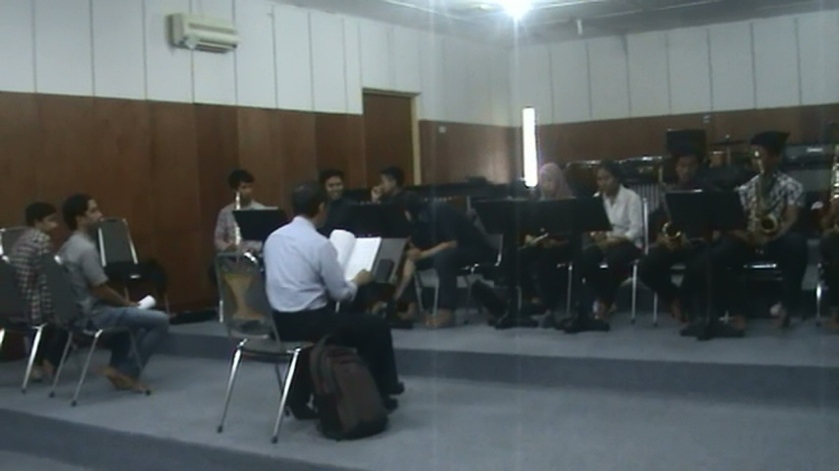
Figure 1. Discussion of Student Centered Learning-Comprehensive Through Performance
(Source: Fu’adi Documentation)

SCL-CMP in orchestral learning can provide a role, among others, through discussions to explore orchestral learning material more clearly so that it is easily understood by students. Problems with intonation, articulation, and others can be solved. In addition to technical problems, group discussions encourage students to be more active in asking lecturers. Through sexual if there is an instrument that is problematic, it will soon be known quickly, so that coping efforts become more effective. Understanding the character of each musical instrument is easier with the SCL-CMP model compared to the combined learning modeled on TCL. The obstacle in applying SCL-CMP is that not all students can actively engage in discussion and exploration. The habit of lazing and being passive is not easy to eliminate. Thus only certain students can join the SCL-CMP properly. In this group of instruments, which were quite a lot, only a few students were active. Awareness to continue to improve competence is still lacking.
BIBLIOGRAPHY
Antika, Reza Rindy. 2013, Departemen Antropologi, FISIP, Unair Surabaya. Penelitian yang berjudul Proses Pembelajaran Berbasis Student Centered Learning (Studi Deskriptif di Sekolah Menengah Pertama Islam Baitul ‘Izzah, Nganjuk. Retrieved from journal.unair.ac.id.
Brown, J. K. (2008). Student-Centered Instruction: Involving Students in Their Own Education. Music Educators Journal, 94( 5).

Harsono.(2008). Student-Centered Learning di PerguruanTinggi. Jurnal Pendidikan Kedokteran dan Profesi Kesehatan Indonesia. Volume 3, No. 1.

Moleong, Lexy J. Metodologi Penelitian Kualitatif, Edisi Revisi. 2005. Bandung: PT. Remaja Rosdakarya, cetakan ke 21.

Shinberg. L. K. 2012. Just Good Teaching. Latham MD; Rowman & Liilefield Education.
Spitzer, John. 2001. Orchestra, dalam Stanley Sadie ed., The New Grove Dictionary of Music and Musician, London: Macmillan Publishers Limited.
Sugiyo, Warlan. Ersanghono Kusuma, dan Purnami Tri Wahyuni. 2009, FMIPA UNES Semarang. Penelitian yang berjudul Efektifitas Metode Student Centered Learning yang Berbasis Fun Chemistry Untuk Meningkatkan Hasil Belajar Kimia Siswa. Retrieved from journal unnes.ac.id

