Translation and Reproduction of the Fishing Culture in the City of Taichung
Li-Hsun PENG¹ and Hsing-Chuan WU² and Indarti³

^{1, 2} Department of Creative Design, National Yunlin University of Science and Technology. University Road, Section 3, Douliou, Yunlin 64002. (Taiwan)
³ Department of Home Economic, Faculty of Engineering, Universitas Negeri Yogyakarta. (Indonesia) & Doctoral Program, Graduate School of Design, National Yunlin University of Science and Technology. University Road, Section 3, Douliou, Yunlin 64002. (Taiwan)
E-mail: literature71548@gmail.com
Abstract. Taichung WuQi was once an important port administrative center during the Japanese Era. With the stagnation caused by the Second World War and the transfer of the political center after the National Government came to Taiwan, WuQi was turned from a prosperous moment to depression. The gap between the rich and the poor, population migration, landscape change, and cultural loss are the problems that WuQi is facing [1]. In recent years, the government's implementation of the exhibition industry and land policies in the land planning has become an important subject to deal with the local people. This makes the habitat on the above-mentioned existing problems, and faces new population problems, which in turn affects the changes in the inner culture of the habitat. This study focuses on the increase of the elderly population in WuQi, the topic of aging in the land, and the cultural characteristics of the scorpion fishing as the main axis, and the understanding and participation of the local and foreign residents, injecting culture into the local area. It is hoped that the old people and the new residents of WuQi will be able to resonate and reflect on the issues related to the aging of the land, and take further action.
Keyword－Population Ageing, Fishing Culture, Taichung, Creativity, Translation and Reproduction.
- Introduction
1.1. Research background and motivation
With the development of science and technology, many fishing-related jobs are mostly based on machines and fishing boats. Because Taichung has already entered the aging society, the fishing skills that have been circulated in ancient times can only rely on the memories of the past. It is not easy to spread and pass on, but it has gradually been forgotten by the public. To save its memory and skills as the main axis of this social and cultural issue, the local residents and new residents understand the importance of cultural heritage [2].
1.2. Research purposes
The fishery story light is used as the design for the translation of the Taichung fishing culture in Taichung. The constituent elements are the six local fishing techniques: tie, fish, abalone, rattle, twist, and brake.
The purpose of this study is the following two points:
(1) Let the public know the six fishing skills of Taichung in the easier and direct way.
(2) Innovation in green design with local art and lighting products, and activating culture.
1.2. Research purposes
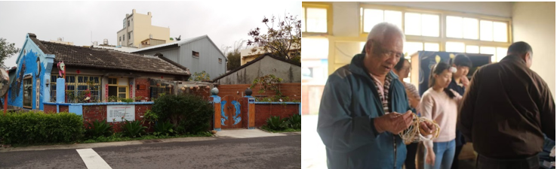
Figure 1. Traditional Fishman’s House Figure 2. Retired Fish men Discuss with Students
- Literature Review
2.1. Population Ageing area’s official Population Ratio
Table 1. Age-specific Population Ratio from 2000 to 2018 in WuQi area, Taichung, Taiwan

There is a tendency for the population to enter the ageing society in Taiwan in 2000, the population of 0-29 years old in the WuQi area accounted for 51.83% of the total population.
In 2018, the proportion of young people gradually decreased. On the other hand, the proportion of elders over the age of 60 has risen year by year. In 2000, the elderly over 60 years old in the squatting area accounted for 9.37% of the total population, and the proportion of young people gradually decreased.
2.2. Research on Local Fishing Techniques
Using the tidal principle, the bamboo and fishing nets are inserted one by one on the shore. When the tide is high, the fish will swim into the net, and then pull the fishing net around and pull the fish down.
A not twisted (AhBuDoNin阿不倒擰)
Tied bamboo rafts and ropes along the coast, and the grass under the ropes increased the friction and buried them. When the tide of the sea comes, the net will fall, the tide will recede, and the net will stand up. When the tide recedes, the catch will be obtained.
Put the screw (BangNingAh放擰仔)
It is characterized by the implementation of this technique before sunset and dawn. A buoy is tied to the top of the net, and a lead block is tied to the bottom of the net. Take the bamboo rafters and wait for them to take the buoy as the target. The bamboo rafts will slide back to the distance and come back. Wait until the time is available.
Fish farming (KanHiZai牽魚栽)
It is characterized by time-based and seasonal, and the use of homemade "hand fork net" will pick up the fry again.
Swing the Clock (YaoZhong搖鐘)
Relying on tidal range and fish and shrimp foraging habit fishing, the fisherman will shake the bamboo poles around because of the process of collecting the net, so it is called the bell.
2.3. Discussion on Cultural Translation Process
It has been an important port administrative centre and has a rich fishing culture [3]. From the local culture, it takes six kinds of ancient’s fishing methods as concepts, and translates them into the present life, so that the local culture can be continued and transmitted. In addition, the elderly can participate in it and develop their strengths. The subject matter is renewable, interactive, smuggling, readable, inheritable, and disseminated. The fishery lamp group--DIY fishery lamp combination bag, the main body of the lamp is the ancient fishing image of layered stacking, which can assemble the favourite table lamp by replacing and blending different ancient fishing methods.

- Research Methodology
3.1. This article attempts to highlight the following topics
1. The importance of aging in the land
2. Exchange and resumption of local skills
3. The possibility between aging and skill
The research method is mainly based on field investigation, oral interview, and literature collection, and is divided into two parts:
1. Life level (for the elderly: education, music block) old people worry-free
2. Cultural level (for the elderly: transmission, family) aging culture [4]
In an aging society, the family population has decreased, and the proportion of the dependency ratio has increased. As a result, some families have been unable to fully bear the care and care responsibilities of the elderly as in the past, and the support of the social care system is urgently needed. Course requirements are also increasingly eager.
Yuxi has a rich fishing and fishing culture, which is aimed at ancient fishing, dependence on the ocean and admiration, as well as local materials: clam shells, fishing nets, bamboo art and other elements, but now it has been lost due to a number of factors, only the rest Some of the old people have their relevant knowledge and try their best to preserve and inherit.
Between the "aging" and "culture" overlaps, the impact of an aging society is a situation that is facing the most suitable self-confidence and dignity for the elderly [5]. Life is rich and practical, and the years passed by the elders, such as the wave of cultural and artistic stories piled up in layers, enriching the enriched but concealed "aging culture", and scented with the elderly and local residents, and spread to various places.

- Design Analysis & Outcomes
When we are facing the issues of aging population, industrial changes, and deal with the gap between the rich and the poor. To deal with the loss of traditional culture in WuQi [6] is an important challenge for the researchers and designers to conquer. The research group has come out with transforming the “aging” issue of the inhabitant’s image into creative design works. By using the nature elements from the environment such as the waves, dolphins, sands, moonlight……, under the topic of revival with "cultural" issue of the environment [7].
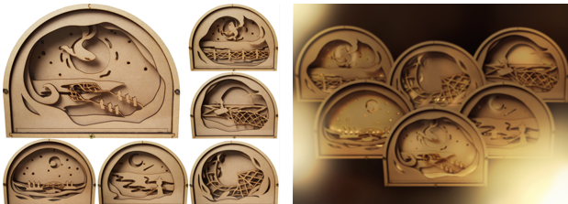
Figure 03. Creative Works with Nature elements. Figure 04. Creative Works with lighting system.
However, after creating works in respond to the research questions, our research units are still facing the following issues: How to make the issue of the "aging culture" of popularizing the local society to be taken seriously, so that the habitat is more suitable for the elderly. This group expects to go deep into the base research, discussion and presentation from the perspective of the third party. Let local and foreign residents see the hustle and bustle, and know more about their own hometown. What kind of difficulties and opportunities are there? [8]
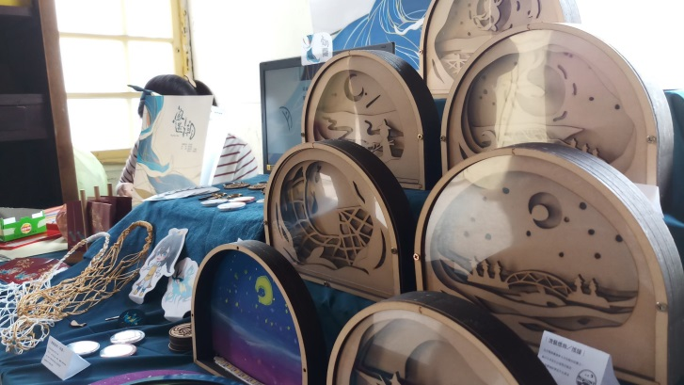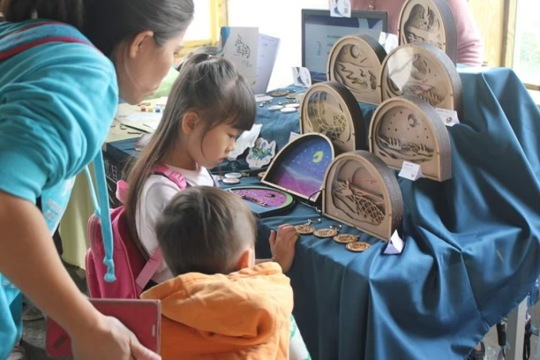
Figure 05. Creative works in Display. Figure 06. Creative works with Audiences.
- Conclusion
The ageing of the population [10] will be the most important political, social and economic change factor in the next 40 years. Due to the rapid development of technology and economy, the culture is gradually losing. It is foreseeable that the age-related services in Taiwan will be provided through commercial market services and self-reliance of the people, and then has the concept of orange service and orange design. In Taichung, the related orange services have been in full swing. For example, government policies and care for elders, care and support at the living level [9], etc., a series of planning and implementation for "aging", but "culture" But it still gradually disappears with the years.
The study hopes to shift “culture” and “aging” from the perspective of cultural and creative industries, Through regular exhibitions and events so that orange culture design can inject new ideas, new vitality and communication into the local community.


Figure 07. The fishery lamp. Figure 08. Usage scenario.

References
[1] XiaLiao Community Development Association 2019 "Yuchai Tsinghai" - Taichung City WuQi District. XiaLiao Community Exhibition Association published Retrieved: June 1, 2019. From: http://digitalculture.tw/exhibition/yuliao/index.html
[2] Lee, H. H.; Peng, L. H. 2018 Research on Green Sustainable Design and Entrepreneurial Strategy of Social Enterprises in Taiwan, 4th International Conference on Applied System Innovation 2018 (ICASI 2018 ), 2018/04/13-17, ICASI 2018, Chiba, (1-4).
[3] Marshall, Joan. 2008. Tides of Change on Grand Manan Island : Culture and Belonging in a Fishing Community. Montreal: MQUP.
[4] Chen, M. 2004 The Influence of Population Aging on Taiwan's Overall Economy and Its Response, Taiwan Economic Research Monthly, 27:11 (21-29).
[5] Fisheries Department 2019 Farmers' Economic Survey Annual Report - Fisheries Statistics 86-106
[6] Taichung City WuQi District Office 2016 The Year 105 of WuQi District Statistical Annual Report, Retrieved: May 15, 2019. From: https://www.wuqi.taichung.gov.tw/media/157454/762914203671.pdf
[7] The Chief Executive Office of the Executive Yuan 2019 Retrieved: June 15, 2019. From: https://www.dgbas.gov.tw/mp.asp?mp=1
[8] Peng, L. H., Pan, C. Y. 2015 The Practice of Cultural Industry and Business Model of Alola Foundation in East Timor, 2015 Global Entrepreneurship and Innovation in Management (GEIM) Conference, 2015/07/29-31, National Chung Hsing University, Taichung, Taiwan.
[9] Sung, C. H., Peng, L. H. 2013, Educational Research and Experience Design of Taiwanese Traditional Pickles’ Visualization, International Conference on Education & Educational Psychology 2013 (ICEEPSY 2013), 2013/10/02-05, British Psychological Society, Antakya,190.
[10] Population Aging : Is Latin America Ready?, edited by Daniel Cotlear, World Bank Publications, 2010..

