Using Traffic Signs in Children's Shoes and Metalworking Design
Li-Hsun PENG¹ and Rong-Rong YU² and Indarti³

^{1, 2} Department of Creative Design, National Yunlin University of Science and Technology. University Road, Section 3, Douliou, Yunlin 64002. (Taiwan)
³ Department of Home Economic, Faculty of Engineering, Universitas Negeri Yogyakarta. (Indonesia) & Doctoral Program, Graduate School of Design, National Yunlin University of Science and Technology. University Road, Section 3, Douliou, Yunlin 64002. (Taiwan)
E-mail: penglh@gemail.yuntech.edu.tw
Abstract. According to research, the current situation of declining of children’s birth rate is becoming a serious social issue in Taiwan. Therefore, most parents are willing to give their children the best care, and the trend of children's goods is refined and more creative. It can be seen that modern people are not afraid of expensive but pay more attention to quality and creativity. This study takes the common traffic signs as design target. Modern children's living environment is becoming more scientific and less exposed to outdoor activities. The preschool children's vision is not broad enough to judge the meaning of the traffic sign. Therefore, in the news reports, people often see cases of children misunderstanding the road, leading to tragedy. Parents play an important role in the child's growth and must teach children to identify relevant signs at the right time. This study hopes to teach children the correct concept of transportation through relevant designs. Although the elements of traffic signs are very simple, the more complex the environment, the more streamlined it is to achieve simplicity and order. The ultimate goal of this study is to make children curious about the goods and teach the correct concept of transportation.
Keyword－Traffic Signs, Metalworking, Children's Shoes, Creativity, Customization
- Introduction
1.1. Research background and motivation
Nowadays, social technology is more and more developed. When we were young, we grew up in a more natural environment. There are not many technology products in life. Sports and leisure are also an important part of life, but now children are exposed to TV, computer and 3C products. Etc., so that children are less exposed to the outdoors or have been attached to electronic products, because the long-term and gradually affect the development of the child's limbs, the reason is the environment given by the outside world, and fewer people actually perform assistance or realize in life. Young children who lack the common sense of traffic safety often make dangerous behaviours such as running and running on the road, even suddenly rushing to the road, and ignoring children’s awareness of traffic signs and safety, so they face child traffic safety. In recent years, it has become a topic of global concern, in order to make more people understand the importance of traffic safety to children.
1.2. Research purposes
Designed with traffic signs as the imagination, the elements are simple, but in more complex environments, the more order is needed, the bright and saturated colour matching and the various styles of the symbols can attract children and parents’ attention in children's shoes and metalworking accessories. In the sales, the importance of transportation and safety can be further explored between parents and children. It also enables the parents of preschool children to have a monetary attitude and a perception of the concept of transportation. However, there are thousands of changes in the common plaques in life. The world of colour makes people feel vivid and interesting, creating the imagination of shoes and accessories that are different from the past. Therefore, the elements of the traffic sign are creative in the life market, making traffic safety environments and products that are suitable for children. The purpose of this study is the following points:
(1) Exploring the monetary attitudes of parents toward preschool children and their perception of traffic concepts.
(2) Design creativity and research on children's shoes and metal products.
(3) The combination of traffic signs for the actual function application design of children's shoes.
(4) Promote parent-child relationship in children's traffic safety.
- Literature Review
This chapter is mainly exploring the design of children's shoes and metalworking, and introduce the correct concept of transportation to teach children and promote parents' ideas and research related to this research.
2.1 Metalworking concept 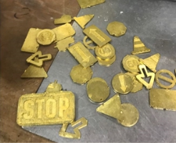 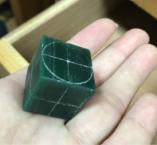
Figure 1. Gold crafts Figure 2. Wax carving technique
The production of the necessary supplies for human beings has begun in a rather primitive era. In the early days of human life, various tools, utensils, clothing, and equipment were used. Tools include hunting tools for hunting, farming tools for farming, and the like. From the initial development of the process to meet the needs of life [1], it was later added to the aesthetic needs of the ornamentation and styling. Nowadays, the subject and object of production and demand have been interchanged. The production of metalworking is not from the necessity of life [2], but mostly becomes the spiritual level. Need. Looking at the development process of Taiwan's metalworking art, it shows that the craft not only improves people's real life, but also reflects the ethnic culture, and fully presents the cultural imagery and life trajectory of each era. Even with the evolution of the times, there are changes or replacements. There is a place to reproduce the value of civilization [3].
The gold crafts are divided into (gold, silver, copper), and the texture is different from the result of mass production. We also use wax carving techniques and 3D printing as a production method. The process must think about how to present the ideas and feelings that we wanted to convey. When the works show the original appearance and texture of the materials, we think differently and choose different ways of conception. Creative works add to the completeness of the techniques, from the understanding of the presentation of the results, the effect of the effect of electroplating in addition to improving the texture and color techniques to make the original appearance of Metalworking faithful and creative [4].
2.2. Investigating Children's shoes
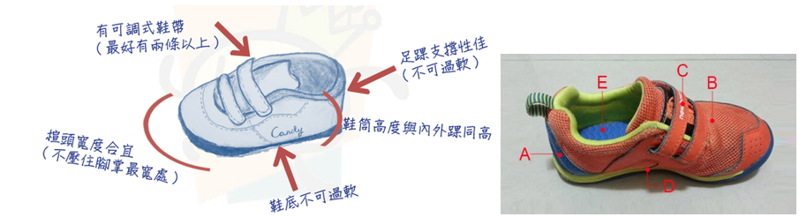
Figure 3. Shoe analysis & Sketches Figure 4. Children's shoes note
A. The foot support is good: The rear half of the shoes should be hard enough to effectively support the child's heel, and it is not easy to be skewed due to running and jumping activities.
B. The front end of the shoe should be wide enough (the same width as the widest part of the child's foot): the shoes should not be too soft, but the place on the instep should be soft and elastic, and can be bent moderately to help the child to run forward smoothly [5].
C. Have adjustable shoelaces (preferably more than two): the shoes are tight to help the child's arch support.
D. The sole should not be too soft: the sole should be hard enough to support the child's weight, especially when chasing the running and jumping activities, it can also have the effect of shock absorption, and the arch is not easy to collapse.
E. The inner pad of the shoe should be breathable and moderately soft and soft: because of the relationship between the fat pad of the foot, the child's foot and the shoe will have a large contact area, so there is no need to give extra shock absorption or excessive support. It can release the pressure generated when walking, and provide comfortable wear.
Divided into: basic principles, size selection, and shoe change frequency.
Children's shoes are too small to squeeze in the shoes, there will be pressure points, causing broken skin or bruises. If not properly taken care of, it will cause bacterial infection, which will affect the development of the child's feet and the arrangement of the bones of the feet. The shoes cannot provide appropriate Stability, resulting in lower limb muscles must spend excess strength to maintain the stability of the lower limbs. It will be easy to get tired and fall easily, so you can't buy too much double and it will make your child's muscle development unbalanced.
- Research Methodology
3.1. Investigating the Traffic Lights in LED
Traffic Light, is a colour light signal that is alternately replaced at a specified time. It is usually placed at a fork or other place where traffic control is required to assign road access rights to vehicle driving. People and pedestrians, control traffic control facilities that pass, stop and turn. Traffic control facilities operating with electricity as an energy source, with red, yellow and green lights or supplemented with sound signals, indicate that vehicles and pedestrians stop, pay attention and travel. There are different indications depending on the colour, usually red, blue, white, and yellow. The traffic sign plays an important role in road safety [6]. Today, the LED itself has a considerable improvement in the angle of illumination and brightness. However, the size of the LED light-emitting chip is small, which can be regarded as a tiny point source. In the dark environment, the pupil is enlarged. When the number of lights is changed, the light emitted is not evenly treated, which is likely to cause danger to passers-by on the road. In the study, high-brightness LEDs [7], Fresnel lens and lampshades were used as the basic units and these basic units were recombined to form a high-uniformity lamp, which is indispensable in life and an important indicator for maintaining order and Problem-Based Learning.
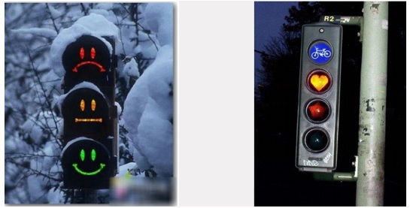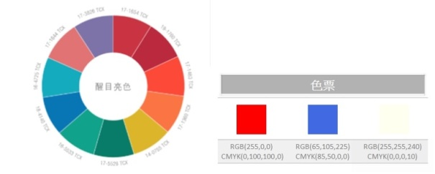
Figure 5. Special traffic lights Figure 6. Creative LEDs

Figure 7. The color of the traffic sign is mainly based on simple and bright colors.
3.2 Colour ticket analysis related to WGSN traffic number
- Design Analysis & Outcomes
  - Structural Analysis
This research analysis is divided into two major parts:
The first part, metalworking and children's shoes products, the meaning of modelling, colour matching and materials, can make a closer understanding of the texture and value of children's shoes and metalworking related works in the market.
The second part collects and analyses the process of making children's shoes and metalworking. The research production project consists of four categories: "Material", "Colour Match", "Structure" and "Identity". The research method will be carried out in conjunction with the literature creation and the combination of jewellery creation. In the literature research, the meanings of metalworking, children's shoes and traffic signs are collected on the products for the purpose of traffic safety, so as to understand the meaning of the works. Among them, the material of the children's shoes is applied with the colour matching of the vivid colour, the fabric is the microfiber skin, the laces use the fluorescent and replaceable LED shoelaces [8]. The key totems of the version of the cut-off number are: arrows, prohibitions, beware of children's shoes, and the direction of customization can be creative, so that they can use red copper and electroplating to create techniques and dyeing techniques for metalworking jewellery. To make the jewellery more developmental. Understand the differences in material orientation, colour styling and pattern cutting during the production process. The significance of the use is to promote the child safety and parent-child relationship. It has been advocating outdoor activities and environmental issues, using the elements of traffic signs to make children and parents pay more attention to the safety of the topic, and using the design of goods to teach children the correct concept, increase the emotional interaction between parents and children, traffic signs As a children's shoe and a combination of metalworking products concept.
4.2 Consumer and age group analysis of purchasing children's goods

Figure 8. Age Chart
Nowadays the younger generation of parents are more willing to buy quality and safe shoes for their children. They don't care about the high price but the value is not worth buying.
Brand positioning: lively, pure, quality
Market positioning: department stores, and urban markets, high-end consumption
Pricing: 1000~2000 yuan
Target group positioning: 0~6 years’ old children, their parents, relatives and friends who pursue fashion, quality and progress.
- Conclusion
This research is based on metalworking design and children's shoes design. The traffic sign [9] is a thought, and the children are taught the correct concept of transportation through relevant design. The age of children's shoes, the characteristics of children and the analysis of the status quo of children's products, the necessity of describing children's products and advocating the design of correct concepts were studied. On the basis of the design concept of metalworking and children's shoes, it puts forward the innocence, liveliness and quality of children's products. At the same time, through the use of color saturation signs in the design of children's products, it presents the style of street hip-hop, combining metalworking with children's shoes to attract consumption and increase the desire to buy. Since the current lack of children, we must create more innovations, not just the appearance, but really care about health and comfort, quality and brand, shoe style, traffic safety, price and children can wear and take off, in the design appearance It can replace a variety of different logo totems, to achieve the benefits of customization and the addition of hand-painted metalwork on children's shoes to add fun. Expanding the design results different from the previous ones, and the hue uses red, white, blue and bright fluorescent colours and can be replaced with LED light shoelaces, which makes children's shoes more eye-catching and increases and promotes the traffic safety.
References
[1] Chen, G. T. 2009 the Origin of Metals Used by Humans, Taiwan Archaeological, Historical, and Cultural Assets Seminar.
[2] Zheng, Y. H. 2007 Artisan and Design of Traditional Taiwanese Goldsmiths, Design Institute of Chaoyang University of Science and Technology.
[3] Fang, B. X. 2009 Su Q S, Su Jian'an Religious Gold and Silver Craftsmanship, National Taiwan Institute of Taiwanese Culture Research
[4] Song, J. W.; Huang, P. F. 2017 The architectural elements used in Taiwan during the Japanese occupation period are used in jewelry design - taking Tainan District Court and Lin Department Store as an example, D3-8.
[5] Liao, J. J. 2003 Discussion on the Loyalty of Children's Sports Goods in Kaohsiung City Primary School--Taking Sports Shoes as an Example, Research Paper of National Taiwan Sports Institute, p 84
[6] ePaper 2010 Knowing the Road, Fengjia University Student Paper, Figure 1.2
[7] Li, Y. H. 2003 Research on Optical Design of Total Reflection LED Traffic Signal Lights, Yuanzhi University Research Institute
[8] Child Welfare Alliance, 2019 Investigation Report on the Fertility Desire and Parenting Status of Taiwanese Women in 2019. From https://www.children.org.tw/research/detail/71/1508
[9] Johansen, J. D.; Larsen, S. E. 2002. Signs in Use: An Introduction to Semiotics. Florence: Routledge. Accessed September 23, 2019. ProQuest Ebook Central.

