Good Earthworm-Kitchen Waste Decomposition Device
Li-Hsun PENG¹ and Pei-Yin ZHENG² and Ibnu Siswanto³

^{1, 2}Department of Creative Design, National Yunlin University of Science and Technology. University Road, Section 3, Douliou, Yunlin 64002. Taiwan.
³ Automotive Engineering Education Department, Faculty of Engineering, Universitas Negeri Yogyakarta.
E-mail: penglh@gemail.yuntech.edu.tw, kwai860417@gmail.com, ibnusiswanto@uny.ac.id
Abstract. Modern people's lives pay more attention to the quality of life, but the waste of food and the improper recycling of food waste have caused energy and environmental problems. We use the advantages of decomposing food to solve the problem of raw kitchen waste and make organic fertilizer for planting.The household kitchen waste disintegration device that we tried to design we used the drum type proposal and put it indoors to solve the problem of raw kitchen waste. There is a cover to switching to reduce the odor and cause the mosquitoes to approach. After entering the raw kitchen, turn the drum, stir the soil and raw kitchen, easy to operate and simple, and improve the quality of life.After a period of time, the organic fertilizer is collected after the worm-eating the raw from the kitchen. The mesh can be replaced by a hole. When turning, the soil will fall into the larger box below, and the culture water will flow into the lowermost box, and the sputum will remain in the drum. In the next, continue the next breeding.
Keyword:Food Waste, Earthworm, Waste Decomposition Device, Participatory Design, Creativity
- Introduction
1.1. Research background and motivation
In the beginning, we hope to solve the problem that the general garbage bins in the family are difficult to classify and have odors. Therefore, we analyze the contents of the general trash cans and find that the proportion of kitchen waste is very high. The kitchen waste is caused by the garbage odor. The reason for the mess, so we have a deeper analysis of the kitchen waste. It is found that most of the kitchen waste is raw kitchen waste, but the raw kitchen waste is the most reusable value.
According to the data of the Environmental Protection Agency, it is conservatively estimated that the average kitchen waste per person in Taiwan is about 96 kilograms a year, which is parallel with Europe and the United States. It is a waste of big countries, an average of 20% more than that of China, Japan and South Korea, and 8.7 times that of South Asia and Southeast Asia. 16 times that of Africa. On the island of Taiwan, the daily cooking capacity is about 6,100 tons, which can be loaded into about 300 trucks [1].
This shows that the waste of food and improper recycling of food waste have caused economic and environmental problems.

1.2. Research purposes
We tried to design a household kitchen waste disintegration device, which can solve the problem of raw kitchen waste by utilizing the advantages of raw food and organic fertilizer produced by us. However, many breeding boxes have been sold in the market, most of which are too large, and the shape is not beautiful. It is not suitable for the general family, and there are a few well-looking breeding boxes, but there is still room for improvement in structural design, participatory design and with the green design aspect.
Therefore, our design goal is to design an earthworm breeding box that is more convenient for home use and can solve the problem of raw kitchen waste in the general household.

- Literature Review
2.1. Collection and analysis of existing products
This chapter mainly analyzes the relevant product design related materials and analyzes the use in the environment.
Existing product collection and analysis:
1.Indoor small beautiful breeding box.(shown in Figure 1 and Figure 2.)
The appearance is elegant, which makes the public accept more, and can be used by ordinary families. The advantages and disadvantages are as follows:
(1) Advantages: Beautiful, indoors are not unobtrusive, can make more consumers accept
(2) Disadvantages: Small capacity, unable to put too much food waste.
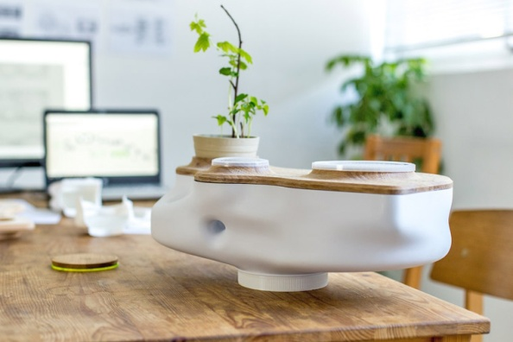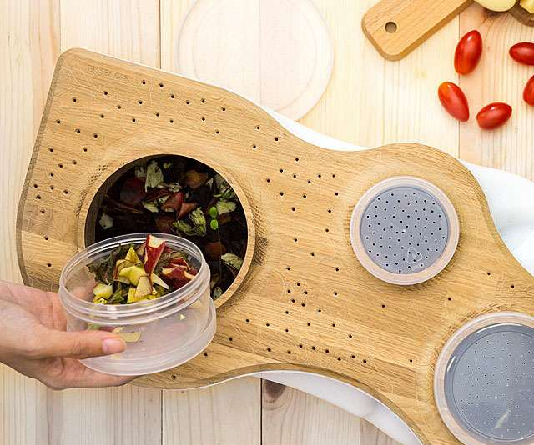
Figure 1. Interior small-scale beautiful breeding box appearance.
Figure 2. indoor small beautiful breeding box top view.
2.Large breeding box(shown in Figure 3 and Figure 4.)
It is usually used by professional farmers, and the volume and capacity are large and convenient for breeding[2]. The advantages and disadvantages are as follows.
The advantages and disadvantages are as follows:
(1) Advantages: Can breed more cockroaches and make more organic fertilizers.
(2) Disadvantages: Not beautiful, need to be placed outdoors, not suitable for ordinary families.
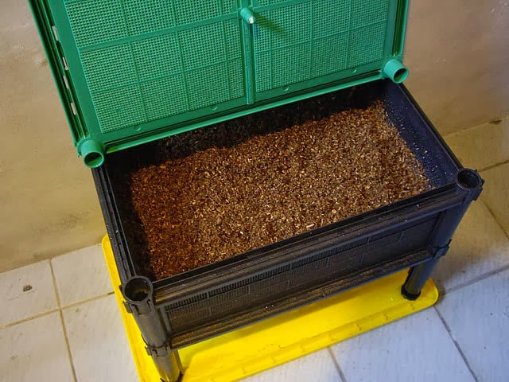
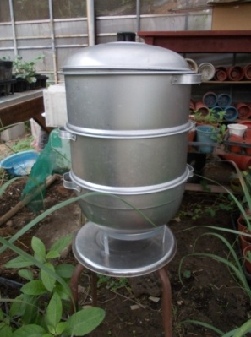
Figure 3.large breeding box.
Figure 4.large breeding box.
2.2. Operational analysis
Through the above analysis of the two main types of breeding boxes sold in the market, it is found that different breeding boxes also have different modes of operation, but all need to meet the standards of "with breathing holes" and "convenient switches".

2.3. Environment analysis
2.3.1. Public environment.
This product is for families, so the size is small, and feeding is not everyone's compliance and understanding of the precautions, so it is not suitable for public places, but if this design concept is highly accepted by the public, it can be extended to make large-scale breeding boxes.

2.3.2.Family environment.
Family farming, difficult to choose buildings, but in a limited space, you can find a suitable location. In general, it is best to choose a small balcony with sunlight. There is space for planting on the window sill, which can be directly supplied after collecting the organic fertilizer produced by the earthworm. Plants can coordinate the environment. Because the flowers have beautiful colors, wonderful shapes and beautiful postures, they can make people pleasing to the eye, and the flowers are full of fragrance, which makes people feel relaxed and happy. The green leaves of the blue leaves can eliminate the fatigue of the nerves of the eyes and relax the central nervous system, making people relaxed and happy[3]. In addition, although you don't interact with people, it is a small creature. In the process of breeding, you can get a sense of accomplishment and forget the temporary troubles.
In short, farming is not too difficult, it can solve the problem of raw kitchen and make the plant in the home healthier and more comfortable.

- Research Methodology
3.1. Field Research
We use field visits and literature to understand the lifestyle of the cockroach and design a device to solve the problem of the raw kitchen.
Through the literature discussion and Field visits, we need to actually go to the studio that studies the symbiosis of cultured carp and fish carp, understand the culture process and the ecosystem of cockroaches, and ask about the problems that may occur in the design of the culture tank, which will help us to design ideas later.
Unified interview results and literature collection results.
(1) Earthworm composting characteristics[4]
It is a multi-functional fertilizer combining organic matter, beneficial microorganisms and growth factors. It can not only improve the fertilizer utilization rate but also activate the soil and decompose the accumulated N, P and K in the soil and activate various growth factors in the soil [5]. Balanced growth of crops.
(2) Awkward diet
In line with the three principles of fine, wet, soft, etc. (citrus or taste is not irritating), feeding with uncooked raw kitchen, the survival of the cockroach can be more stable.
(3) The living environment of the village
Temperature about 10-30 degrees C, humidity 60-85%, pH 6.5-7.5
(4) Precautions for breeding
Adding water to the bottom of the box prevents ants from invading and may attract mosquitoes and flies due to sourness[6].

- Analysis
4.1. Analyze the Users ethnic groups
Through the above research, the following points can be compiled:
Applicable ethnic groups: small families in general.
1. Problem point analysis
According to product data analysis, the current problems of existing products are as follows:
(1) Difficulty in appearance and function
(2) The use of the product is too cumbersome
2. Design guidelines:
(1) Easy to use operation with a simple mechanism
(2) Strengthen the design of the appearance, can be placed indoors, beautiful and not conflict
(3) The raw kitchen and soil are well stirred.
(4) Cover design reduces taste and mosquito problems.

4.2. Good Earthworm-Kitchen Waste Decomposition Device
Design a different breeding box (shown in Figure 5) that is different from the market. The shape is simple and the size(shown in Figure 6) will not occupy too much space. After pouring into the raw kitchen, turn the drum, stir the soil and raw kitchen, and collect it after a period of time[7]. Earthworm after eating the raw kitchen, the organic fertilizer is produced[8]. The mesh can be replaced by a hole. When turning, the soil will fall into the larger box below, and the culture water will flow into the lowermost box, and the sputum will remain in the drum and continue. Secondary breeding.

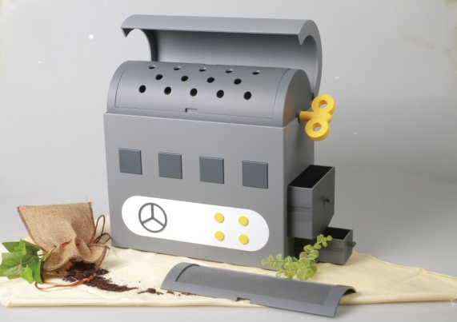
Figure 5.Earthworm breeding box
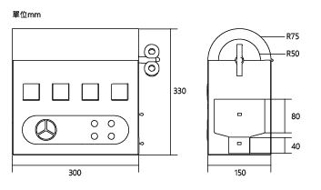
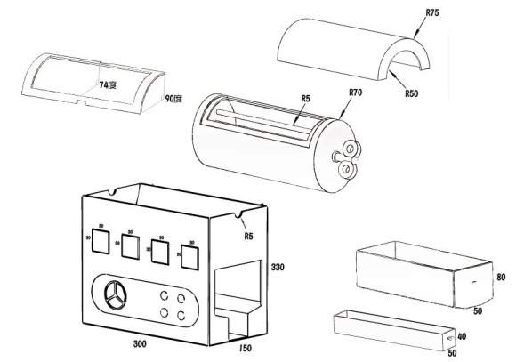
Figure 6.Earthworm breeding box size
This design has the purpose of achieving the original design - solving the problem of raw kitchen waste, using the most natural way, without consuming energy to solve the raw kitchen waste, in this process can reach a cycle (shown in Figure 7), we eat vegetables to produce food waste Then convert the raw kitchen waste into organic fertilizer [9]for us to plant.
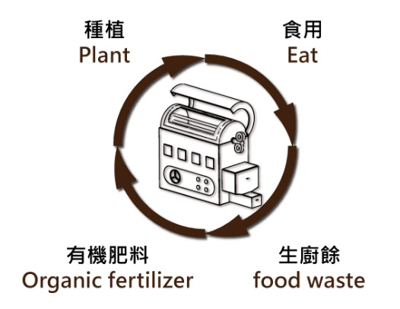
Figure 7. Recycling Diagram

- Conclusion
As mentioned above, this research proposes "Good earthworm" product design. It is easier for younger users to use it through simpler and clearer operations, In addition to understanding the ecology, the process of converting raw kitchen waste into organic fertilizer can also be seen to reduce food waste[10].
Look forward to this kitchen waste decomposition device design can as a reference for future related companies and designer to practice this design[11].

Acknowledgments
This research was supported in part by the Ministry of Science and Technology of Taiwan(R.O.C.), under contract numbers MOST 108-2410-H-224-022-

- References
[1] The News Lens 2017 Taiwan’s annual kitchen waste officially surpasses Japan and South Korea, and is a waste of power in Asia. Retrieved: May 30, 2019. From: https://www.thenewslens.com/article/78631.
[2] Zhao, K. Z. 2015 Earthworm Breeding Retrieved: June 15, 2019. From: https://harmonic1012.pixnet.net/blog/post/434135396%E8%9A%AF%E8%9A%93%E9%A4%8A%E6%AE%96
[3] Emma Chang 2018 Tea Art - Environment of tea tasting
[4] Plytycz, Barbara, Homa, Joanna, and Aziz, Azwady nor. 2008. Earthworms for Monitoring Metal Contamination. New York: Nova Science Publishers, Incorporated. Accessed September 23, 2019. ProQuest Ebook Central.
[5] Chen, Baoling 2017 Strategies of leftover food treatment process in Taiwan.
[6] Cai, Cing-Fen 2011Studies on the growth of earthworm and the qualities of vermicompost affected by the different proportions of organic wastes.
[7] Chang, ChiaJui2019 Study of the Three Common Vermicomposting Species on Cyclical Utilization of Swine Manure.
[8] Blouin, M.; Hodson, M.E.; Delgado, E. A., Baker, G., Brussaard, L., Butt, K.R., Dai, J., Dendooven, L, Peres, G, Tondoh, J.E, Cluzeau, D., Brun, J.-J., 2013, “A review of earthworm impact on soil function and ecosystem services”, European Journal of Soil Science, vol. 64, Issue 2, pp.161-182.
[9] Coleman, D. C.; Crossley, D. A. Jr.; Hendrix, P. F. 2004. Fundamentals of Soil Ecology. London: Elsevier Science & Technology. Accessed September 23, 2019. ProQuest Ebook Central.
[10] Truong, Ha Duy2016 Effects of vermicompost application on the growth of organic seedling and organic production of two tomato varieties (small honey and graces).
[11] Niaounakis, Michael. 2013. Biopolymers : Reuse, Recycling, and Disposal. Saint Louis: Elsevier Science & Technology Books. Accessed September 23, 2019. ProQuest Ebook Central.

