Development Of Accreditation Information System (AIS) for Vocational Higher Education with NAAHE Standard
(Case Study At Astra Manufacturing Polytechnic)

Rida Indah Fariani¹ and Ayudiah Damayanti²

^{1,2}Department of Information System, Astra Manufacturing Polytechnic
Jl. Gaya Motor Raya No. 8 Sunter II Jakarta, Indonesia

E-mail: rida.i.fariani@polman.astra.ac.id
Abstract. Higher Education Accreditation is an activity that must be implemented by every college for every 5 years where this activity becomes a benchmark for college sustainability. This accreditation must be in line with the National Accreditation Agency for Higher Education (NAAHE) standards. Astra Manufacturing Polytechnic (Polman Astra) as one of the vocational higher education also conducts the accreditation. In compiling the accreditation instrument Polman Astra has a problem such as the inaccuracy of accreditation data between one department and another and the difficulty of coordinating among departments in providing data accreditation compilation. This problem may cause the late of accreditation according to a predetermined time. Due to this problem, an information system was built, namely Accreditation Information System (AIS). It is a web-based information system and designed according to NAAHE standard. AIS is built using the .NET framework and SQL Server DBMS with prototyping methodology. After implementation, AIS was able to integrate the needs of data accreditation by providing data requirements and eliminates delaying data preparation by the related department since it was directly generated from the Polman Astra database. AIS is also able to manage the accreditation data table dynamically and transparently, eliminates paper printing costs into zero and prevent delays in the preparation of accreditation instruments so that the accreditation can be completed according to a predetermined time

- Introduction

Higher education plays a fundamental role in preparing human resources to gain global competitiveness and enhance the nation. One of higher education quality is affected by the quality of education. The Indonesia government has set standards that can maintain the quality of education by establishing the National Standard of Higher Education (NSHE) and the standards set by each college [1]. NSHE must be applied by each higher education. Therefore the government conducts accreditation to see whether the higher education has implemented NSHE in its governance. Accreditation is the recognition of educational Institutions given by the competent authority after being assessed that the Institution meets certain criteria requirements [2]. This accreditation is carried out by the National Accreditation Agency for Higher Education (NAAHE) [3] and the result is the recognition that the institution or study program has met the established standards.
Astra Manufacturing Polytechnic (Polman Astra) is a formal educational institution with a Diploma III program that focuses on creating human resources that are ready to use in the industry. Supporting government regulations regarding higher education accreditation, Polman Astra organizes accreditation carried out by NAAHE with established standards. There are 7 standards that must be met, namely: (1) Vision, mission, goals, objectives and strategies foNAAHEr achievement, (2) Governance, leadership, management systems and quality assurance; (3) Students and graduates; (4) Human Resources; (5) Curriculum, learning, and academic atmosphere; (6) Financing, facilities & infrastructure and Information Systems; and (7) Research, community service, and collaboration [4].
In the accreditation process, Polman Astra makes accreditation instruments for both institution and program study in accordance with the NAAHE standards. It is found that when making the accreditation instrument, there are several problems experienced, namely: (1) Data inaccuracies between one department and another, because the existing data between department related to accreditation has not been integrated; (2) Difficulty in coordinating among team accreditation which lead to delaying of accreditation instrument preparation ; and (3) Delay in returning table data by the related department for over fifteen days by average.
To solve these problems, Polman Astra conducts a business process improvement for the accreditation process by developing an information system that can accelerate the process of preparing accreditation instruments. The system is called the Accreditation Information System (AIS). Therefore the purpose of this research is to build AIS which has the ability to: (1) Integrate data and information for the purposes of compiling accreditation instruments; (2) Making data and information on accreditation instruments to be transparent and can be managed easily by all related departments; (3) Reducing operational costs such as paper printing costs for drafting accreditation instruments; and (4) Prevent delays in the preparation of accreditation instruments so that the preparation of accreditation instruments is completed on time.

- Related Work

Some issues in the accreditation field have been addressed. In research on the implementation of accreditation preparations at higher education [4] found obstacles such as lack of coordination between accreditation teams, not centralized supporting data, poor database and nonstandard format. The solution taken is to design a cloud computing-based university accreditation information system that will facilitate communication between universities and assessors from NAAHE in the data processing. Unfortunately, the implementation system has not yet been discussed.
Another research at the University of Technology of Mara, Malaysia suggests that it is difficult to manage traditional file systems or manual processes, specifically for the document search to support the accreditation process [5]. In other research, the focus is not on the preparation of accreditation data but on the process of accreditation assessment that is still manual and high human error risk [6], so a system for accreditation assessment can be built that can be used as a self-assessment before the actual assessment by the NAHEE team.
Research conducted by Sukamto, et al [7] automates the accreditation process, where NAAHE is a user to reduce the hard copy documents sent to NAAHE. This automation is the web-based study program accreditation information system. Automation related to the accreditation process especially for the education process was also carried out in research at the University of Science and Technology in Jordan [8]. This automation facilitates decision support makers such as instructors and heads of departments to assess the educational process. Other research replaces e-mail-based submissions of data with a web-based information system that provides a central repository of all faculty-related accreditation requirements [9]. A web-based database-driven software system was also developed by Arizona State University to facilitate accreditation process by maintaining course and program objectives/outcome information together with relationships among this descriptive information [10].

- Methodology
This research process was carried out with the stages as follows : (1) Problem identification and formulation; (2) Business Process Improvement; (3) Development of AIS, which is using prototyping method since the user is fully involved from the beginning. The user also wants to see the initial prototype first and then refine it until it becomes a finished prototype that matches their needs. This method consist of several phase : Planning, Analysis, Design and Implementation ; (4) Presentation of research result; and (5) Presentation of research conclusion.
On stage one, problem identification and formulation are obtained by doing an user interview and analyzing the current internal business process. Business process improvement is done by automating or eliminate some inefficient process. On the development stage, the prototyping method is chosen based on several factors, such as short time development, energetic users are involved in the development that leads to the user requirement that still changing [11]. The presence of the prototype being examined by the user prevents many misunderstandings [12]. A prototyping method perform the analysis, design and implementation phases concurrently, and all three phases are performed repeatedly in a cycle until the system is completed [13].

- Result And Discussion

  - Existing Business Process and Improvement
Existing business process can be described as follows : (1) Institution or Program study that requires accreditation process apply accreditation request to QA department; (2) QA Department prepare the preliminary data for instrument accreditation; (3) QA Department then distribute the preliminary data to the related departments to be completed ; (4) The related departments complete the data based on NAAHE standard and sending it back to the QA department; (5) QA Department gather, check, and compile data form departments using standard format and sending it to the accreditation team; (6) Accreditation team then make instruments accreditation based on these data and sending it back to the QA Department when finished; (7) QA Department do final check and legalize these instruments and submit it to the NAAHE. These flows can be seen in Figure 1.
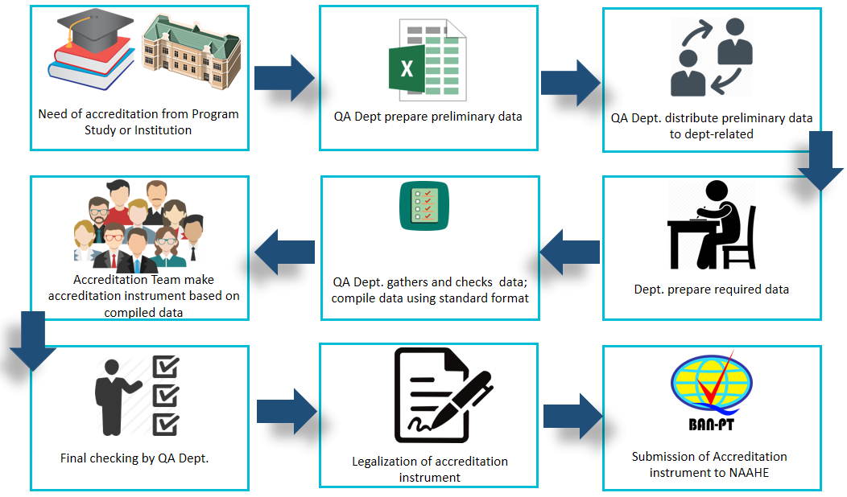
Figure 1. Existing Accreditation Business Process

From the current business processes, improvements are made in the form of (1) process efficiency; and (2) process changes. Efficiency is carried out in the data preparation process, from originally manual data preparation changed into automatically generated from institutional databases. Process changes were made to the data processing (point 2 to 6 in the existing business process). In the improvement process, the department is given the right of access to data through the system so that the process of completing data is simpler and faster. There is no need for the accreditation team specifically because the data has been produced by the department according to needs. The QA Department only needs to do a final check and generate data in accordance with NAAHE standard by the system.

  - Development of AIS
    - Planning. This phase is the fundamental process of understanding why an information system should be built and determining how the project team will go about building it [11]. This phase produces system request, a brief summary of a business requirement and business value. It explains how a system that support the need will create business value. Business requirements can be stated as follows: (1) The system can manage departments related to accreditation; (2) The system can manage accreditation standards; (3) The system can manage accreditation questions bank; (4) The system can manage accreditation tables templates; (5) The system can manage tables for accreditation entries; (6) The system can manage the details of the accreditation table ; (7) The system can generate detailed accreditation tables which data can be supported by Polman Astra's database; (8) The system can manage the accreditation table authorization to the related departments; (9) The system can manage the contents of accreditation tables entries; and (10) The system can export tables of accreditation entries into a spreadsheet format.

    - Analysis. This phase answer the questions of who will use the system, what systems will do, and where and when it will be used [11]. It produces functional requirements and user category. The Functional requirements are Related Department Function, Standardization function, Question Bank Function, Accreditation tables templates function, Accreditation tables function and Entries of Accreditation tables function. User category for AIS can be seen on Table 1.
Table 1. User Category of AIS
User Category | System Grant
Admin | (1) Manage related departments; (2) Manage standardization; (3) Manage bank questions; (4) Manage accreditation tables templates; (5) Manage the accreditation tables; (6) Manage the accreditation tables details; (7) Manage to generate detailed accreditation tables; (8) Manage authorization the accreditation tables detail to the related department; and (9) Exporting the accreditation table
Related Department | Manage accreditation tables entries

    - System Design. This phase decides how the system will operate, in terms of the hardware, software and network infrastructures, the user interface and database that will be needed [11]. AIS uses ASP.NET programming language version 14.1.11170.0 with the development tool Microsoft Visual Studio 2015 version 14.0.25431.01, SQL Server 2012 version 11.0.2100.60 as database and IIS 8 as web servers. AIS uses client-server-three-tier network architecture. Furthermore the operational environment needs to be considered and analyzed to maximized system performance. The recommended operational environment of AIS are presented in the Table 2, meanwhile user interface example presented in the Figure 2.
Table 2. Hardware and Software Specification for AIS Operational
Specification | Client | Application Server | Database Server
Processor | Intel® Core 2 Duo CPU E8400 3.00 GHz | Intel Xeon 3.3 GHz 8 CPU | Intel Xeon 2.27 GHz 8 CPU
Memory | 2 GB | 8 GB | 4 GB
Storage | 80 GB | 300 GB | 100 GB
Operating System | Windows 7 Pro x64 | Windows Server 2012 | Windows Server 2003
Web Browser / Web Server/ DBMS | Google Chrome | IIS 8 | Microsoft SQL Server 2008 R2 x64
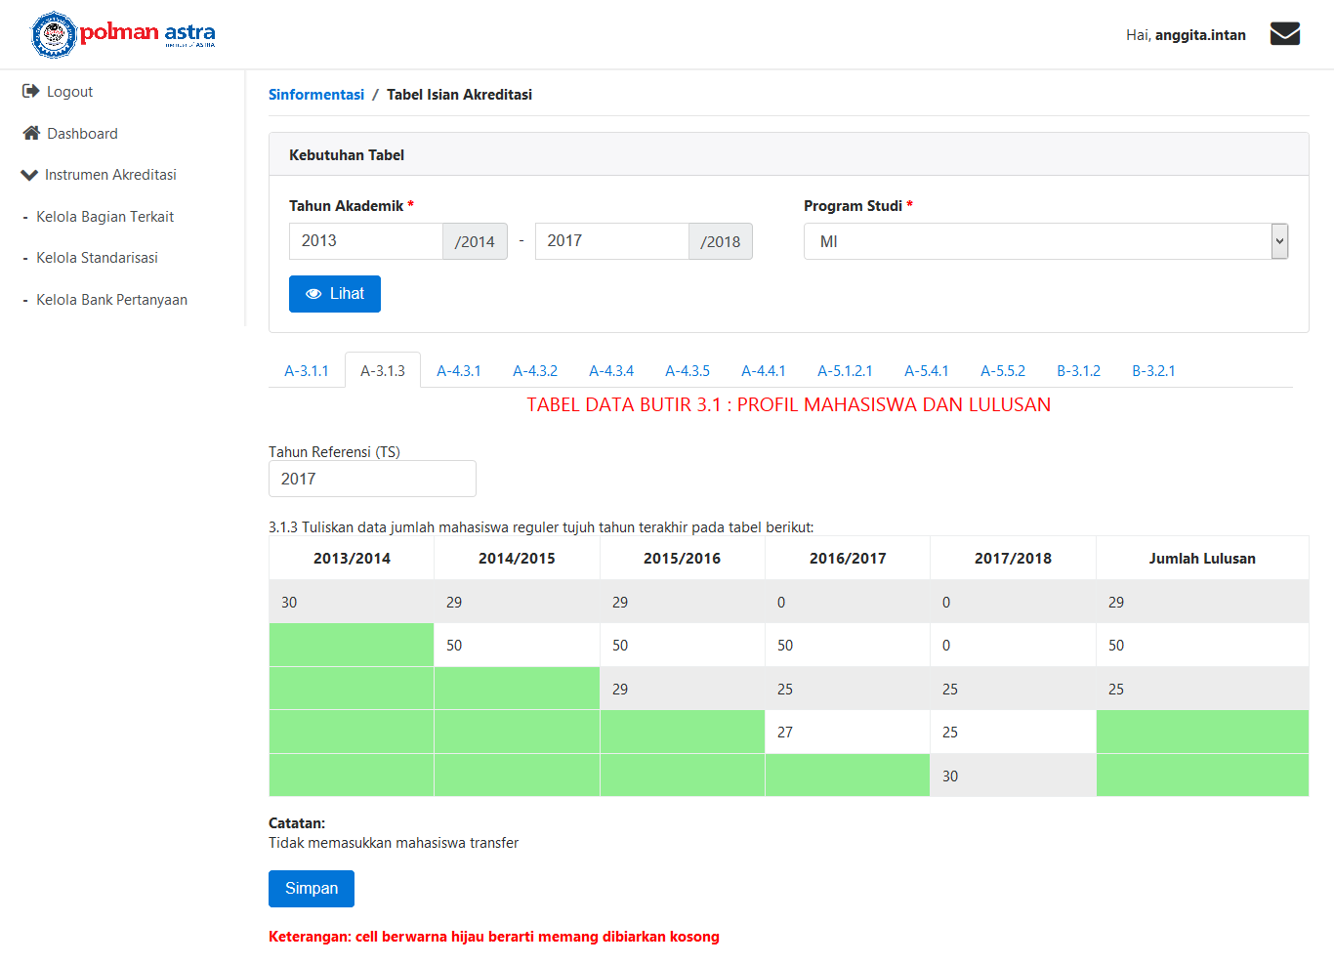
Figure 2. User Interface Example : Generate Detailed Accreditation Table

    - Prototyping History. In its development AIS has gone through three prototypes to become a complete system. The following are the history of the AIS prototype : (1) Prototype 1: produces functions that can manage : related departments, standardization, question banks, accreditation tables, accreditation tables detail, authorization of accreditation tables, accreditation table details entry, exporting accreditation authorization entries; (2) Prototype 2 : adding the functions to manage the accreditation tables template dynamically so that the export function of the table can still be used even though there is a change in the rules of NAAHE; (3) Prototype 3 : Separating the data generate detail table for study programs accreditation and institutions, which previously merged.

  - Test and Implementation

AIS testing is done based on scenarios which in line with its business processes. The testing is conducted by the QA department as a user and uses dummy data that matches the data used in the real case. It is need to ensure the achievement of the objectives, ensure there are no errors, ensure validation runs properly, and ensure easy access to the user. The following results are obtained from the AIS test : (1) Data and information on the accreditation tables can be integrated and can produce its detail directly from the Polman Astra's database. It eliminates the delay of returning data preparation from the related department from fifteen days by average to zero; (2) Data and information on the accreditation table that can be viewed by all related departments and can be managed based on the authorization given; (3) AIS can eliminate the paper printing process when there is an error in filling, because all related departments can view and update the entire contents of the accreditation tables through the system. It eliminates the cost of printing accreditation instruments draft into zero; (4) The risk of delays in the preparation of accreditation instruments can be prevented because there are reminders that will appear at any time when the related departments have not filled the accreditation table.

- Conclusion and Future Work

Based on the implementation and results of the AIS testing, it can be concluded as follows : (1) AIS can integrate accreditation data and information for both the institution and study program accreditation; (2) AIS can make data and information on accreditation instruments to be transparent and can be managed easily by all related departments; (3) All data can be corrected directly through AIS so it can reduce paper printing costs due to data errors from the related departments; and (4) AIS can prevent delays in the preparation of accreditation instruments and can be completed on time. These results ensure that accreditation document can be submitted to NAAHE on time.
AIS is currently being used in QA Department for its use in the accreditation process. Since major function AIS, for now, is for data accreditation preparation, the following functionalities are considered for further developing: (1) Support for producing accreditation document. It is document that has to be delivered to the NAAHE for assessment process; (2) Making an accreditation assessment template; and (3) Making functions for Estimating score of accreditation through self-assessment.

- References

- Regulation Of National Accreditation Agency for Higher Education (NAAHE) No. 2 Year 2107 concerning national accreditation system
- “Indonesia Dictionary,” [Online]. Available at : https://www.kbbi.web.id/akreditasi. [Accessed 06 07 2018]
- Regulation Of National Accreditation Agency for Higher Education (NAAHE) No. 1 Year 2107 concerning NAAHE organization and governance
- Sallu, Sulfikar and Darlispon 2016 Konsep Sistem Informasi Akreditasi Perguruan Tinggi Berbasis Cloudcomputing (Mind Journal ISSN : 2528-0015) Vol.I No.1 p. 19-25
- Rasidah, Mokhtar dkk 2014 Proceeding International Symposium on Technology Management and Emerging Technologies (Bandung) (IEEE Xplore Digital Library) p.102 – 106
- Yudatama, Uki; Widiyanto, Andi and Maimunah 2012 Proceeding Konferensi Nasional Sistem Informasi (Bali) (Bali : STMIK STIKOM)
- Sukamto, Titien et all 2016 Proceeding Seminar Nasional Teknologi Informasi (Jogjakarta) (Jogjakarta : Universitas Islam Indonesia) p. F-34 – F.40
- Najadat, Hassan; Al-Bdarneh, Amer and Qawasmi, Huda 2016 International Conference on Information Technology Based Higher Education and Training (ITHET) (Istanbul, Turkey) (IEEE Xplore Digital Library) .
- Franco, Ross 2015 Proceeding Information Technologies, Databases & Information Systems, Engineering and Electrical Engineering Conference (China) (IEEE Xplore Digital Library) .
- Kumaran, Vidhya and Lindquist, Timothy 2007 37th Annual Frontiers In Education Conference - Global Engineering: Knowledge Without Borders, Opportunities Without Passports (Milwaukee,WI, USA) (IEEE Xplore Digital Library) p. T3E19-T3E24
- Kute, Seema and Thorat, Surabhi 2014 A Review on Various SDLC Models (International Journal of Research in Computer and Communication Technology) Vol. 3 p. 776-781
- Sabale, Rajendra and Dani A.R 2012 Comparative Study of Prototype Model For Software Engineering With System Development Life Cycle (IOSR Journal Of Engineering) Vol.2 p 21-24
- Dennis, Allan 2010 Systems Analysis and Design with UML third Edition (John Wiley & Sons)

