Study of the VR Education and Digitalization in China
Shu-Yu Sun¹ and Li-Hsun PENG²

¹Department of Industrial Design, Musashino Art University. 1-736 Ogawamachi, Kodaira-shi, Tokyo. (Japan)
²Department of Creative Design, National Yunlin University of Science and Technology. University Road, Section 3, Douliou, Yunlin 64002. (Taiwan)

E-mail: sunshuyu505@outlook.com, penglh@gemail.yuntech.edu.tw
Abstract. Human society has entered the era of information digitization. The rise and spread of electronic technology, digital media, the Internet, blockchain, Augmented Reality/Virtual and Reality, etc. affect all aspects of human society. At the end of the 20th century, the development and achievements of information technology constituted an important background for the existence of education, and promoted the development of online teaching, network examination, and other aspects, which made a big difference.
However, digital technology has not been applied in primary education and secondary education. The existing teaching method is still taught in the form of textbooks and manual drawings.
This research focuses on the application of digital technology in primary, secondary and advanced teaching in the digital age. This study conducts research and analysis on local schools and students through observation, experimental and comparative research methods, and compares the differences between ordinary teaching and digital teaching.Taking virtual reality technology as an example, breaking the impression that traditional teaching gives people can effectively implement diversified learning, cultivate students' practical ability and innovative ability, also can improve their independent learning ability.
Keyword－Chinese education、Learning ability、Virtual and reality(VR)
- Introduction
1.1. Research background and motivation
1.1.1. The meaning of education
Education itself has two responsibilities from the macroscopic and microscopic perspectives. One is to transport different types of talents from engineering to art for various industries in society, so that society can develop continuously on the material and spiritual level; the second is to make people as a single individual to achieve better self-development, including the "correct" of ethical values, the ability to think, and so on, to the health of the body, the extension of life span.[1]

1.1.2. Chinese education
When you hear about Chinese education, what you are most familiar with is exam-oriented education. Test-oriented education, as the name suggests, teaches for the exam. The way most schools teach is cramming. The advantage of cramming is that the foundation of the students is very solid, but it does not make students interested in learning. Even some people will be reluctant to the school.

International comparison of education levels: China's average education level is low.
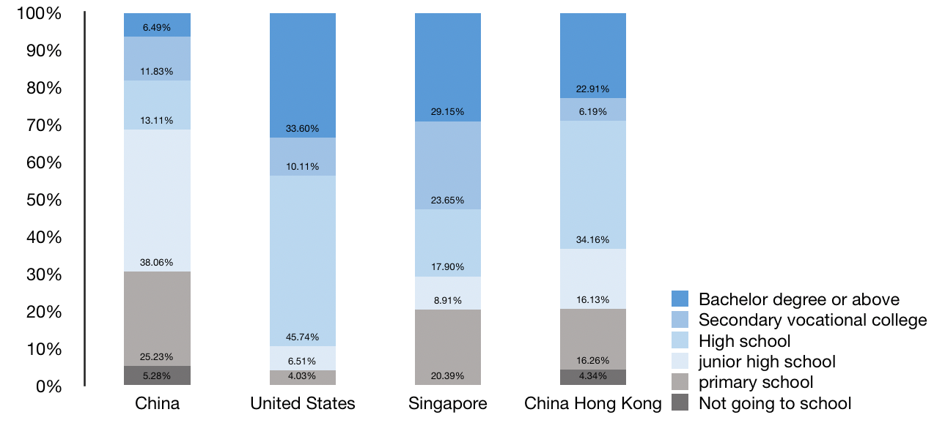
Source: National Bureau of Statistics，UNESCO，CCEF research.

Comparison of the average education level between big cities and the whole country.
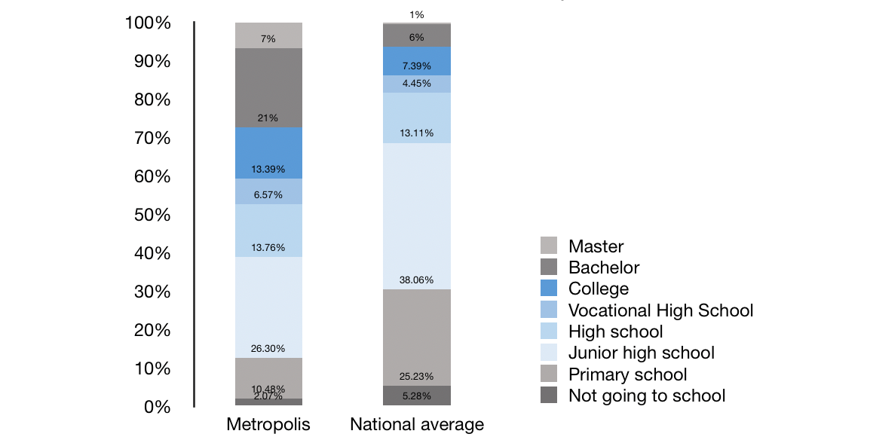
Source: National Bureau of Statistics，UNESCO，CCEF research.

1.1.3. Family Education
When it comes to Chinese education, it is indispensable for family education. When I go out of school, I spend most of my time with my parents. Then Chinese-style family education has become a stumbling block on the road to education.

1.1.4. Art education
It must be said that China's art education is relatively backward compared with developed countries. The Chinese people's aesthetic appreciation of art stays in the ‘real’ fast, the ‘true’ image of the painting, and the ‘real’ singing. Because art does not have such clear learning leads and evaluation criteria. The study of art is invisible or even internalized by the inner aesthetic ability and cognitive ability that cannot be evaluated by the only standard. The art education in the middle and senior college entrance examinations is also lack of art education. Most art candidates repeatedly copy and write portraits in order to cope with the college entrance examination, but how much is their basic art knowledge? How high is their appreciation level? Among the art candidates, it is conservatively estimated that at least two-thirds of the students do not know the most basic Western art history and Chinese art history; at least half of the students cannot fully appreciate a famous painting; at least one third of the classmates did not have a clear understanding of the face structure of the portraits they painted.

1.1.5. Application of digital technology
In the book Digital Survival, Negroponte fully demonstrates the impact of digital technology on our lives, work, education and entertainment. As a result, the word "digital" has become an important symbol in the information age. "Digital technology" refers to many software and hardware technologies that convert information objects into digital signals, which are stored and processed by computers and transmitted by computer networks. Among them, virtual reality technology, intelligent technology, large database systems and computer networks play a huge role in the initial design of design process, optimization and management of design solutions. However, digital technology has not been applied in teaching.

1.1.6. The impact of technology and electronic products on society
In the process of human development, it is inseparable from the support of science and technology. The continuous innovation of science and technology has brought convenience to social life, but at the same time it has brought adverse effects to the environment. As a member of modern society, it is obliged to protect our mother earth to achieve ecological balance. On the one hand, science and technology are changing the living environment of people, improving the way of transportation, communication, etc., and promoting the development of the whole society towards high-tech; on the other hand, the rise of the ability of science and technology has also affected the social environment. It has led to ecological imbalances in some areas, and the phenomenon of animals and plants is on the verge of extinction. A large part of these phenomena are due to the emergence of science and technology. Therefore, it requires humans to make rational use of science and technology, and also recognizes that science and technology are Favorable and adverse effects, in order to protect the environment and improve our life.

1.2. Research purposes
This study takes traditional Chinese teaching method as the leading factor, combines foreign educational models and digital products to improve and promote Chinese education, optimize China's overall learning atmosphere, improve the ability of solidified thinking, and enhance people's awareness and understanding of art education as much as possible. At the same time, develop digital products that can help education (for example VR teaching equipment).

1.3. Research Questions
Through observation, experimental, and comparative research methods, we conduct research and analysis on the existing materials of Chinese education, and then use educational and design thinking to produce digital products which can explore the following issues:
①The current situation of Chinese education?
②What is the aim of education?
③Students are not interested in the content of teaching? How to develop course ware that is more meaningful and interesting?
④Is art education important?
⑤Can digital products improve the quality of teaching?

- Literature Discussion
2.1. Examination-oriented education
Examination-oriented education (also known as cramming education) (which is the essence of China's current education system) is generally regarded as an educational system that focuses on improving students' test-taking ability and is highly valued in test scores, memorizing and solving problems. Meanwhile, quality education is not the corresponding concepts. This kind of education system is the only popular education system in the Middle Ages and modern East Asia and Europe. Because it can be trained and mastered by the masters, a large number of technical talents can be cultivated. However, under capitalist reform, the demand for pioneering generalists has increased greatly. After that, it gradually changed to "quality education", while East Asian countries still adhere to the test-taking system. This kind of education is a part of cramming education, which instills knowledge into students. It is like a duck-filling. In the process of duck feeding, ducks are stuffed with ducks with high sugar content to make them quickly gain fat. Others, such as the ability of ducks to survive, will not be the focus of attention.[2]

2.2. Art exhibition
The art exhibition is the product of the development of social culture at a certain stage. It is a special communication method between artists and the public. Artworks can be presented through exhibitions for public reading and appreciation. They are collected by collectors, reviewed by art critics, and gradually form an art display system integrating art creation, art communication, art marketing, and art appreciation. In the formation of this system, the planning of art exhibitions plays a pivotal role. A successful exhibition planning can not only provide a smooth communication platform for art exhibitions, but also the value brought by it is unimaginable. Besides, the success of the art exhibition will also promote regional development to a certain extent.[3]

2.3. Educational electronics（VR, etc.）
VR virtual reality technology uses computer simulation to generate a three-dimensional virtual world, providing users with simulations of visual, auditory, tactile and other senses, allowing users to observe the three-dimensional space in a timely and unrestricted manner. It can be said that VR virtual reality, the scenes, and characters that can be seen are all fake, it is to put people's consciousness into a virtual world. So, how does VR teaching create a new educational environment？
VR teaching uses powerful virtual reality technology and other means, it is widely believed that VR teaching will make qualitative changes in 21st-century education. The reason why VR teaching will undergo qualitative changes is that the virtual education environment has an unparalleled advantage in the real education and training environment. The so-called virtual education environment refers to a kind of artificial environment suitable for virtual education generated by virtual reality technology. It can be the real realization of the foundation or facilities of the real world. It can be a virtual world.[4]

- Research theory and method
3.1. Observation
Observation method refers to a method in which researchers use their senses and auxiliary tools to directly observe the object to be studied according to a certain research purpose, research outline or observation table. Scientific observations are purposeful, planned, systematic, and reproducible. In scientific experiments and investigations, observations have the following effects: 1 to expand people's perceptual knowledge. 2 inspire people's thinking. 3 leads to discoveries.
Through the process of learning students in the classroom, this study found that students' enthusiasm for learning is not high, and the learning status, learning mood, and learning ability is very low. However, as soon as the painting class and the music class were taken, the enthusiasm was generally improved.

3.2. Experimental Method
The experimental method is a scientific research method that discovers and determines the causal connection between things through the main change and control of the research object. Its main features are: first, initiative transformation. Observations and investigations are based on the premise of not interfering with the research object, and the problems are identified. However, experiments require active manipulation of experimental conditions, artificially changing how objects exist and changing processes, so that they are subject to the needs of scientific understanding. The second one is controlling. Scientific experiments require that, according to the needs of research, various methods and techniques be used to reduce or eliminate interference of various unrelated factors that may affect science and to understand the research object in a simplified and purified state. Last but not least, causality. An effective tool and necessary way to discover and confirm the causal link between things.
The study was divided into four groups by 10 children with average academic scores and 10 children with better grades. The two groups of children learn in the usual way of teaching. The other two groups of children use digital devices with story scenarios to learn. The experiment found that regardless of the average or better children, after using digital equipment to learn, knowledge acceptance is generally higher than the general education method.

3.3. Comparative research
Comparative research is a method of research and judgment on the similarity or dissimilarity between objects and between people. Comparative research can be understood as a method of examining two or more related things according to certain criteria, looking for similarities and differences, and exploring general laws and special laws.[5][6]
This study applies theory to practice through practical means and transforms knowledge into skills. Using VR teaching enables students to quickly learn and understand in a virtual scene through hands-on experience. Students are more accepting than regular classes. According to the research needs, after the parents' consent, I conducted a follow-up investigation of a middle school student. The student was found to have a good grade in the class, but the class was in good condition and the class was very serious. However, after listening to the lecture, the correct rate of the operation is only 70%-80%, and some operations need to be read through the book to complete. It can be seen that the efficiency is not high.

- Research and Analysis
Under the development trend of VR teaching, in the 21st century, various new types of school education relying on virtual reality technology, such as basic education, art education, and various types of training, may be established. Many students under VR teaching are accepted in the virtual environment. Various educational experiences and training. The VR teaching system will enable people to easily acquire perceptual knowledge and practical experience in a virtual environment. Compared with real education bases or facilities, the virtual education environment of VR teaching has the following characteristics and advantages:
4.1. Simulation
VR teaching allows students to train through virtual facilities, as well as in real-life teaching bases. This is because the virtual environment is virtual but realistic for both the real environment and the imaginary environment. The ideal virtual environment for VR teaching should reach the level that makes it difficult for trainees to distinguish between true and false, even more, true than true.

4.2. Operability
VR students can use the natural skills of human beings to manipulate objects or events in a virtual environment, just like in a real-world environment. Operability is necessary for practical use of the virtual education environment. It enables students to acquire practical knowledge and skills from VR learning which helps to fulfill the distance education.

4.3. Openness
The VR teaching virtual education environment has the potential to provide any trainee with a wide range of training venues at any time, anywhere. In fact, the connotation of virtual education environment is extensive. It is different from the traditional education environment. It has the environment similar to the traditional education project, but its specialty is the kind of realistic environment in which students are placed among the project objects. The virtual environment in which the trainees can learn or master certain knowledge and skills through the operation of related instruments can be attributed to the virtual educational environment.

4.4. Correspondence
VR teaching content closely corresponds to the virtual environment. For example, if students are studying chemical experiments, then the virtual environment is the simulation environment of the chemical laboratory. Besides, virtual reality technology can carry out individualized education in a corresponding manner according to the basis and ability of each student.

4.5. Timeout
The virtual education environment of VR teaching has the characteristics of time and space. It can present objects and events in the past world, the current world, the future world, the micro world, the macro world, the universe, the objective world, the subjective world, the fantasy world, etc. Or organically combined and available to educatees anytime, anywhere. For example, students need to be in an environment that transcends reality and time, so the virtual education environment can provide the historical environment and virtual space.
The new educational environment created by VR teaching can greatly improve the learning efficiency of learners. Rio Tinto's VR teaching starts from practical teaching and creates a panoramic teaching mode that enables students to achieve "immersion learning", which can subvert the bottleneck of the traditional teaching methods that the educated party cannot participate and cannot interact; support the classroom full simulation simulation And interaction, with its own characteristics, combined with technical means to reflect the initiative of students, increase the practicality and realism of teaching, enrich the requirements of teachers and students on 3D stereoscopic display and practical.

- Conclusion
The status quo of traditional Chinese education faces the following facts that the learning burden is heavy and score is the only criteria for evaluating the outcome. Yet, it is almost blank in cultivating children's creative consciousness ability. What’s more, it is still a demand for high quality education resources. Take Beijing as an example, while there are hundreds of thousands of teachers, the number of stunt teachers is less than 1,000 with half of them are already retired. Under such circumstance, the one-teacher-to-many-student education method and endless homework strategy contributes to the exhausted and inefficient status for both teachers and students.
Thus, future education systems should be the combination of artificial intelligence to personalize the learning plan, study, counsel, and teaching contents from teachers. In many cases, the teaching content of excellent teachers will eventually be replaced by artificial intelligence technology.
Take VR as an example, the fundamental value of VR in education is not only stayed in beautification, but it is a radical change to the past learning model. Stanford University's Virtual Reality and Human Interaction Lab (VHIL) used VR to do a series of psychological researches. One of the experiments invited a group of college volunteers to wear VR equipment in order to experience deforestation in the Amazon jungle. After that, a cup of water was overturned in front of the volunteers. As a result, the people who participated in the experiment used less napkins than people not participated in the research to wipe up the desk. It seems that VR experience helped to shape the volunteers with the sense to protect the environment. Scientists have also done a VR experiment on racial discrimination, allowing the subjects to experience the unfair treatment of black people in their daily lives and the effort to pursue the same thing. After the experiment, racist people immediately changed their impression of black people and began to think about the meaning of human rights. The value of VR education is not to let students experience a 3D version of Confucius who are teaching Analects. Its value is to let students become Confucius and experience his great life in person which helps students to conduct conclusions. The great opportunity we see in VR education lies in the revolution of the learning model, subverting the education of teaching + obedience in the past, and replacing it with the education of experience + reflection which faces future.
This study simulates a teaching scene by adopting virtual reality technology. The new educational environment created by VR teaching can greatly improve the learning efficiency. The VR teaching starts from practical teaching and creates a panoramic teaching mode that enables students to achieve an immersive learning experience, which can subvert the bottleneck of the traditional teaching methods that the educated party cannot participate and cannot interact or support the classroom simulation and interaction. With its characteristics, VR teaching combined with technical methods to reflect the initiative of students, increase the practicality and realism of teaching, enrich the needs of teachers and students for 3D stereoscopic display. The content is abundant and realistic, and the virtual scene effectively reduces the security risks in the experiment. It allows a variety of hypothetical scenarios can be practiced repeatedly, breaks the time and space constraints, and reduces costs. There are multiple instructional video animations in each scene, each of which is based on a specific course to help and guide the user through the experience.

- References
[1] Zhihu.com. (2019). [online] Available at: https://www.zhihu.com/question/22500496?sort=created [Accessed 6 Aug. 2019].
[2] Baike.sogou.com. (2019). Examination-oriented education - sogo. [online] Available at: https://baike.sogou.com/v453687.htm?ch=zhihu.topic [Accessed 6 Aug. 2019].
[3] Wu, y., Shu, y. and Ye, j. (n.d.). Yi Shu guan li yu shi chang.
[4] Zhang, G. (1991). Zi ran bian zheng fa gai lun. Dong ying: Shi you da xue chu ban she.
[5] Wu, W. and Yang,H. (n.d.). Bi jiao jiao yu xue. Ren min jiao yu shi: Shui niu.Wenkan Wu.
[6] Na Qu Mi Er Si, Na Qu Mi Er Si, Pan, M., Chen, Z., Frankfort-Nachmias, C. and Nachmias, D. (2001).

