THE INFLUENCE OF DIFFERENT WELDING POWER CURRENT ON
A36 CARBON STEEL TOWARD SHIP EMBROIDERY WITH
HEAT ANNEALING TREATMENT PROCESS
Sri Pramono¹
Universitas Ivet Semarang
Muizzaddin Waaddulloh²
Universitas Ivet Semarang
Monika Retno Gunarti³
Politeknik Pelayaran Surabaya
Didik Dwi Suharso⁴
Politeknik Pelayaran Surabaya
Hendra Purnomo⁵
Politeknik Pelayaran Surabaya
Oktoberty⁶
Universitas Ivet Semarang

Abstract
The welding process can occur in shipbuilding with steel material. The purpose of this study was to determine the effect on welding. this research was conducted welding with different amperes with heat annealing treatment. The welding process used in ASTM A36 steel carbon welding or Shielded Metal Arc Welding (SMAW) with 9 mm thickness. Finally, a test was conducted including A36 carbon steel content test, NDT test, tensile test, and microstructure test.
The result showed that the highest tensile stength value was 559,410 MPa in speciation 1 with 110 amide and the lowest tensile strength value of 556,473 MPa at 60 amperes. The NDT test using chemical substance showed that there was undercut on the welding in speciation 1 with amperage 60 amperes; while, speciation 2 with 110 Volt amperage there is no undercut in the welding area. From the results of the structure test microstructure showed that the pearlite and ferrite grains are formed smaller and tight because there is the influence of heat that is given in welding process, in which the smaller the number the greater the number of hardness of a material.
Keywords: ASTM A36, NDT, Pulling test,Micro structure and SMAW

INTRODUCTION
In the world of shipping industry, the welding process can occur in manufacturing in the field, especially in shipbuilding. Welding technology is one of the techniques that is widely used in the process of joining materials and steel construction. The welding process will usually occur deformation, cracking, or other defects that result in repairs. Deformation that occurs after the welding process, welding cracks and other defects, resulting in changes in the metallurgical arrangement of the material and it cause the decrease of material power.

In this study, welding was carried out 3 times as much as annealing. The reason was to reduce the present tension in the re-welding, and to change the microstructure in a material which gives annealing heat and whether the changes in the granules in the material would change significantly or not after applying heat in the form of annealing.
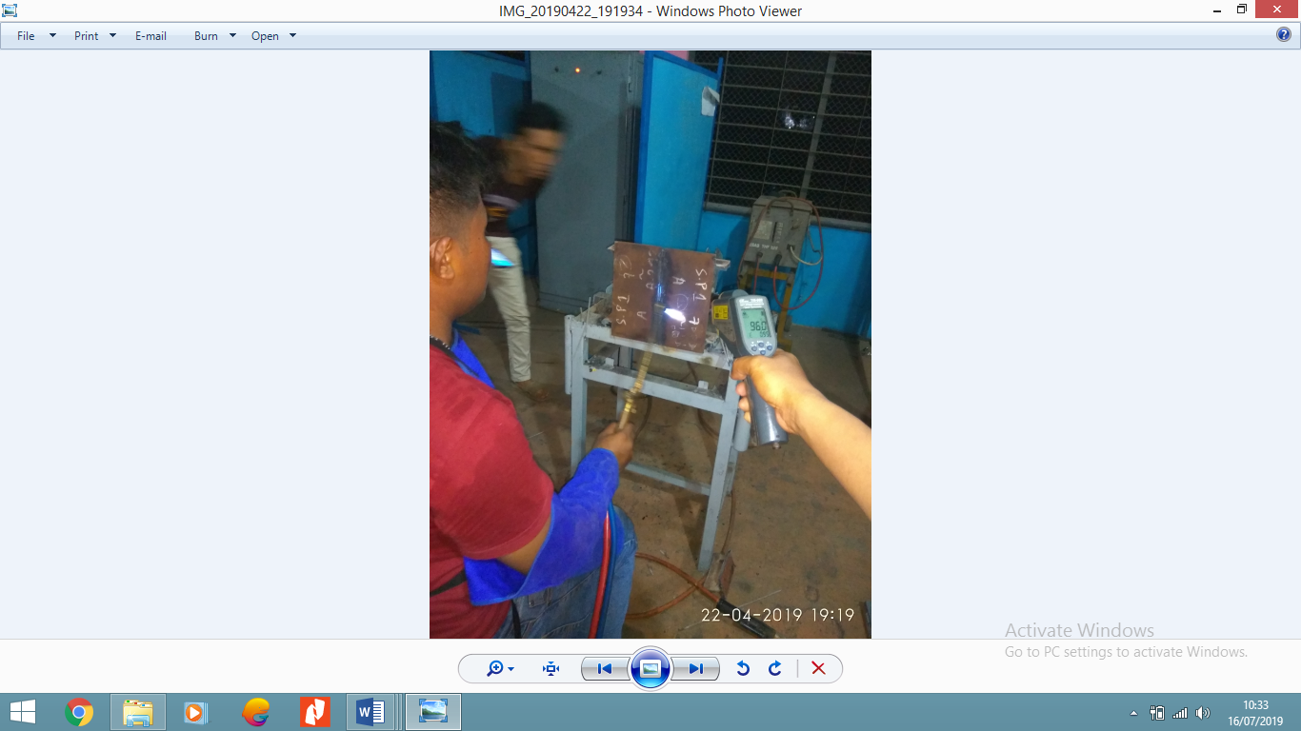
Figure 1.Annealing Process on steel speciation material
Testing method with penetran is one of the non-destructive test methods on a material where the surface is not porous. This penetrant test can be used to detect damage or discontinuity that is open to the surface. The use of penetrant test is very broad, which is used to check weld joints and surfaces on workpieces. This penetrant test method can also be used to detect crack damage that occurs in engine components such as crank shafts, gears, etc. This test is using the capillary properties of liquid objects used are non-viscous liquids and has a small surface tension, which usually in color as penetrant. Test material dyed or sprayed with this liquid, because of its capillary properties, which makes the liquid enters cracks, fissures or pores on the surface of the test material to the deepest part.
PURPOSE OF THE STUDY
The purpose of the study was to find out the effect of re-welding process from annealing system toward A36 steel carbon resulted in welding defects.
METODOLOGY
In this study the authors used a type of experimental research that aims to determine differences in amperes with different specializers with Specialization 1 using 110 amperes and speciation 2 using 60 amperes and given annealing heat treatment with tests such as material composition, microstructure tensile testing, tensile strength values of weld metal regions , HAZ and Base Metal welding SMAW A36 steels with Annealing heat treatment.
RESULT AND DISCUSSION
Preparation of the Material
- Material
Material yang digunakan dalam penelitian ini adalah material baja karbon rendah A36 dengan ukuran 300 x 150 x 9 mm sebanyak 4 buah.
- Electorda
In the test material welding is given on the surface using the SMAW welding process and the welding wire used is E 7016.
- Welding groove
The shape of the welding groove in the material work on this final project can be seen in this following picture

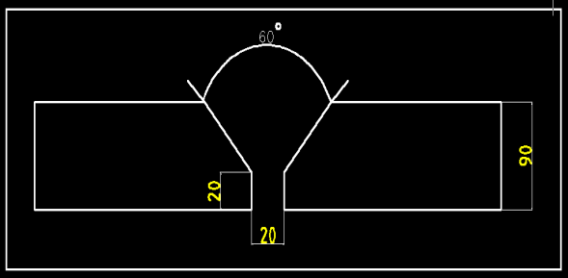
Figure. 2 Groove Weld speciification
In this welding, welding grooves used is a single V type welding groove, with the size according to draw. After the weld groove is finished, the weld groove section needs to be cleaned using a grinding machine first because it leaves dirt and an uneven surface. The process of making welding grooves using a grooving machine.
- Annealing Application on the Material
When steel hardness increases during cold working, ductility decreases and additional cold reduction becomes so difficult that the material must be annealed to restore its tenacity. The annealing between the processing steps is referred to as in-process or just annealing process. This can consist of proper care. But in most cases, subcritical care is sufficient and most inexpensive, and the term "annealing process" is without further qualifications which usually refer to subcritical annealing in the process. Annealing application is carried out by heating in the area of the material to be welded to a heater which has a maximum capacity of 90°C, the test material is heated to a temperature of 90° C according to ASM Handbook - Vol 4 - Heat Treating (2173s).
- Welding process
The welding process used to connect two A36 carbon steels is the Shield Metal Arc Welding (SMAW) welding process. Welding of this process using the E7016 metal filler with the parameters used in this welding are as follows:
Based on the parameters specified above, the following clarification steps are carried out:
1. Preparation stage
a. Straightness check and mounting stopper.
b.Prepare SMAW welding machines
2. Welding phase after the preparatory phase is carried out above, the welding stage is carried out. This welding process stages are as follows:
a. Material given heat treatment by using Annealing.
b. In the coupon 1 test, no welding of specification 1 with 110 amperes was carried out so that three layers were immediately made.
c. In coupon test 2, welding of speciation 1 with 60 amperes was made so that 3 layers were immediately made.
- Material Compostition
Table 1 Chemical composition of ASTM A36 (Source: PT Gunung Raja Paksi plate mill (GRP), 2016
Element | Content
Carbon, C | 0,18
Silikon.Si | 0,33
Manganese, Mn | 0,90
Fosfor,P | 0,016
Sulfur(belerang),S | 0,005
Niobium,Nb | 0,001
Cuprum(Tembaga),Cu | 0,01
Krom.Cr | 0,01
Nikel,Ni | 0,00
Molibden,Mo | 0,00
Vanadium,V | 0,02
Aluminium,Al | 0,04
Titanium,Ti | 0,001
Nitrogen,N | 0,0057
Serium,Ce | 0,33

- Visual DNT Testing (Non Destructive Testing)
material before the NDT test. It could be seen at the welding defects visually to find out what defects are in the welding, from the image data above it is found that the A36 carbon steel plate with specialization 1 with 110 amperes has a lot of welding defects because there are undercut welding defects next to welding material because of the welder factor, and specimen 2 with 60 amperes amperes. the specimen material 2 with 60 amperes of Volts above is found that the A36 carbon steel plate with material has no welding defects due to the amperes of 60 amperes.
- Pulling Test Result
we get the data, that the A36 carbon steel plate with material 1 (110 amperes) has a value (yield stress and max stress of 559,410 Mpa yieldstrength) and 619,916 Mpa (max stress), while the A36 carbon steel plate with material 2 ( 60 amperes) has yield strength and max stress.
The lowest stress is 560,473 N / mm 2 (yield strength) and 622,050 MPa (max stress). It can be seen that from the above data the value of the yield strength max stress decreases but is not too significant. This explains that if the material is often re-welding the material will have a high tensile strength value, but not too significant. From the strain data above we can conclude that Elongation in specimen 1 and specimen 2 has a very significant difference with specimen 1 having a value of 30.459% and speciation 2 having a value of 22,296 it can be concluded that for material that has the highest value of elongation is specimen 1.

- Micro structure analysis result
Micro photos of speciation 1 and speciation 2 can be seen (200x enlarged) base meatl area in Figure 3:
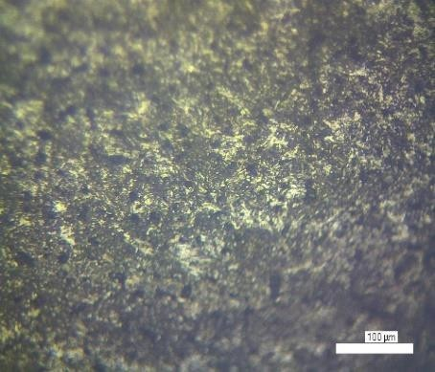

ferrit
Pearlit

Micro photo material 1 and 2 (60 amperes) and (110 amperes) 200x magnification weld metal area:
area in Figure 4:
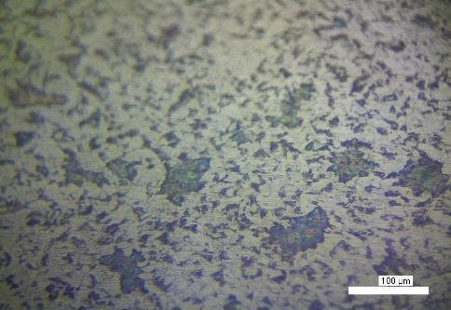

ferrit
pearlit

Micro structure in the form of grains separated by grain boundary from Figure 3 to Figure 4 on the base metal, HAZ and weld metal we can judge for the granules. It shows that the granules consist of ferrite and pearlite, where the stern ferrite is light colored while pearlite is dark colored it is seen that the base metal material area 1 (60 amperes), in material 2 (110 amperes) does not experience significant changes in the microstructure. It is seen that the base metal material area 1 (60 amperes), in material 2 (110ampere), does not experience significant changes in the microstructure.

CONCLUSION
After testing the NDT (Non Destructive Test) and analyzing the test results, the conclusion is obtained: For welding defects that are very prominent in welding with 110 amperes because the amperes are too large and cause welding defects such as undercuts on the material. Whereas, for 60 amperes there are not too many welding defects compared to welding using 60 amperes which did not improve due to the use of amperes that are not large so that there is no damage to the material or welding defects for testing the microstructure in the weldmetal area, Haz and base metal at 110 amperes and 60 amperes due to heat treatment using annealing so that the material does not experience a very significant change.
Suggestion
It is suggested that further experiments can be better and can further refine the experiments that have been carried out in this study by comparison of materials, with one material not being affected by heat compared to material given heat treatment and with different amperes.

DAFTAR PUSTAKA
Academia.(t.thn.).SifatMekanikLogam [Online]. Available:
http://www.academia.edu/6302170/SIFAT_MEKANIK_LOGAM.
Alat Uji. (2016). Charpy Impact Testing. Retrieved Juni 08, 2016, from www.alatuji.com:http://www.alatuji.com/article/detail/388/charpy-impact- testing#V1hZoPl97IU
Ardra. (t.thn.). Pengujian Pengamatan Metalografi [Online]. Available: http://ardra.biz/sain-teknologi/metalurgi/besi-baja-iron-steel/pengujian-pengamatan-metalografi/.
ASM International. (1991). "ASM Metal Handbook Volume 4 Heat Treating".Ohio: ASM International Handbook Committee.
ASM International. (1991). "ASM Metal Handbook Volume 6 Welding, Brazing andSoldering". Ohio: ASM International Handbook Committee.
ASTM A36. (1997). Standart Specification of Carbon Structural Steel. Washington:
American Society for Testing and Material.
AWS D.1.2. (2010). "Structural Welding Code-Steel". Miami: American Welding Society.
AWS. (2000). Inspection Welding Technology. Miami: American Welding Society.
Biro Klasifikasi Indonesia Volume VI. (2009). "Rules For Welding". Jakarta: Biro Klasifikasi Indonesia.
Electric Power Research Institute. (2007). Carbon Steel Hand Book. Palo Alto: California.
Funderburk, R.S. (1987). Welding Innovation Vol.XV No.2-Post Weld Heat Treatment.
Miami: The James F. Lincoln Arc Welding Foundation.
Japan Welding Engineering Society. (2006). Advanced Welding and JoiningTechnologies. Tokyo: Japan Welding Society.

