Numerical Simulation of Fluid Flow Characteristics at Oxygen Gas Tank with Variations Compressibility Values using OpenFOAM
Syamsuri^{1, #}, Hasan Syafik Maulana¹, and Gatot Setyono¹
¹ Department of Mechanical Engineering, Institut Teknologi Adhi Tama Surabaya, Arief Rahman Hakim St., No. 100, Surabaya 60117, Indonesia.
# E-mail: syamsuri@itats.ac.id
Abstract. Oxygen gas tank is one application of the decompression tank, which is filled with oxygen with a certain pressure. Oxygen storage tubes is very vital in the health sector, both at the clinic and at the hospital, because most people who are sick or who will undergo surgery in desperate need of clean oxygen. In this study the decompression tank was analyzed using numerical simulation methods using OpenFOAM software. Three different compressibility values of oxygen gas (6.90e-03, 6.90e-04, and 6.90e-05) varied in this study. This is done to find out the results of the pressure distribution and velocity in the tank. From the results of the study with variations in oxygen gas compressibility values, we can know that each compressibility value has different pressure distribution and velocity characteristics even though with the same time and the smaller the compressibility value, the pressure distribution and velocity produced are wider and faster propagating
- Introduction
In the modern era, the use of decompression tanks in everyday life has grown rapidly. This decompression tank is widely used in the industrial sector, as well as health or medicine sector. Oxygen gas tank is one application of the decompression tank, which in this tank is filled with oxygen with a certain pressure. The use of oxygen storage tank is vitally important to the health of the world, both in the clinic and in the hospital[1]. This oxygen tank is used as a breathing aid when someone is lacking oxygen in the body. The pressure inside the decompression tank, especially oxygen cylinders, can cause corrosion in parts of the outlet when used continuously, and if the pressure is in the decompression tank is too high then the outlet valve or anchoring is not able to withstand the pressure that can cause damage or explosion that is very dangerous when used. In this study a computational fluid dynamics (CFD) is used because of the method has advantages compared to experiments [2] including: time and cost efficient for a new model / design, control experiments that are difficult or very impossible to do then the CFD can be used, to study the system under dangerous conditions experimentally then CFD can do it all. Some studies have used CFD and have been successful, including: [3,4 and 5].
Research on decompression tanks has been carried out by many researchers including research conducted by Lubis Asnawi et.al. [6]. In this study, the strength and volume of expansion of the toroidal tank with an elliptic cross section were analyzed using computational methods with variations in internal pressure. The results of this study indicate that the internal pressure limit is strongly influenced by the ratio of toroidal tank cross sections. Where the limit pressure value will decrease with increasing ratio of toroidal tank cross section. In another study, the character of the pressurized water tank was analyzed by varying the internal pressure using OpenFOAM analyzed by Syamsuri [7]. In this study, the water pressure inside the tank varied with compressibility values 4.54e-06, 4.54e-07, and 4.54e-08. The results of the study show that with increasing compressibility the pressure distribution area produced will be wider and more rapidly spread.
Research on the decompression tank is very dangerous if there is an error when setting the output section, so the research on decompression tank is usually performed by computational methods or numerical simulation. One of the numerical simulation software used is OpenFOAM. The use of OpenFOAM software has many advantages, including that the software is open source status or open to the public so users do not need to buy a license for this software. On the other hand, OpenFOAM is also capable of being used to simulate various turbulence models, simulate multiphase flow and others [8-13]. So that this OpenFOAM software is used in this research.
The aim of this study is to determine the characteristics of the pressure distribution and flow velocity that occur in the tank with variations in compressibility values. In addition, the area around the output pipe is also analyzed to determine the flow and pressure characteristics that occur.

- Research methods
To find out the characteristics of the pressure distribution and flow velocity that occur in the tank and the area around the output pipe, the test is done by varying the value of compressibility of 6.90e-03 s²/m², 6.90e-04 s²/m², dan 6.90e-05 s²/m². The fluid used in this study is oxygen gas with density 1.429 kg/m³ at a pressure of 1 bar, while the dynamic viscosity is 1.95e-05 MPa.s. The boundary conditions in this study are also regulated, as well as the nozzle is set as a pressure outlet which P = 0 and the time of data collection used includes t₁ = 0.005 s, t₂ = 0.0075 s, t₃ = 0.01 s. For the initial conditions in this research set with U = 0 m/s dan P = 100 bar. The domain used in this study is displayed in a 2-dimensional form where the domain consists of a tank that has a small pipeline on one side as an outlet as shown in Figure 1.
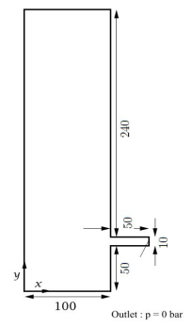
Figure 1. Tank specifications with output pipelines
This research was conducted by numerical simulation method using the Computation Fluid Dynamic (CFD) program, OpenFOAM. OpenFoam itself uses C ++ programming language to operate it and to solve problems that exist in this study, it is done with an approach with the Navier-Stokes equation [14, 15].

- Result and Discussions
3.1. Validation
Before performing deeper analysis on this study, the validation is done in advance so that the results obtained did not stray too far. In this validation, the compressibility value used is 4.54e-07, The value used to be used for comparison with previous studies that research conducted by Syamsuri [7]. In that research an independent grid test with variations in grids of 184, 244, 309, and 344, and the results of the grid test showed that the grid variations did not have a significant difference in pressure values, and this resulted in the resulting contour pressure having similarity with previous research. This is the basis for making of that research as a benchmark problem. Comparison of the results of the present study with research conducted by references [7] shown in Figure 2.
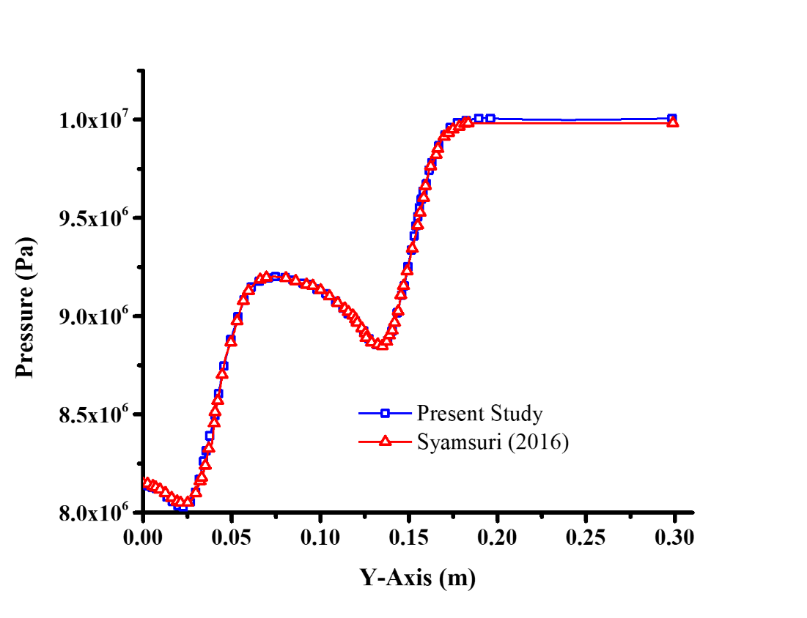
Figure 2. Validation of pressure distribution
In Figure 2, a plot of data is obtained from the pressure distribution along the Y axis on the axis X= 0.075 m. In the figure it can be seen that the highest pressure dominates at the top of the tank, while the lowest pressure dominates at the bottom of the tank. From the Figure data above also formed a pressure distribution pattern along the Y axis on the axis X= 0.075m approaching the same between the current research and the research conducted by Syamsuri. In general, this research has the same results as the research conducted by previous research. Thus the simulations carried out at this time can be declared feasible to carry out simulations with different variations.
3.2. The results of the pressure distribution comparison with variations in compressibility values
The pressure distribution obtained from this study is strongly influenced by the value of the compressibility of the fluid. As shown in figure 3 which in the figure shows the effect of variations in the value of compressibility on the pressure distribution at the time t = 0.005 s, t = 0.0075 s and
t = 0.01 s. In Figure 3a, it can be seen that with the compressibility value of 6.90e-03, the high pressure area dominates the entire area of the tank at all times tested because the distribution of the pressure distribution is very small. High pressure oxygen gas exits through the output pipe due to the pressure difference between the tanks and the pressure at the end of the output pipe. This can be seen clearly at, when t = 0.01 s, at the end of the pipe the output pressure is lower than the pressure in the tank. In experiments with the compressibility value of 6.90e-04 shown in Figure 3b, indicates that there is a change in pressure contour in the tank. At t = 0.005 s the high pressure area dominates 75% of the entire tank area and only the area close to the output pipe has a low pressure. At t = 0.0075 s the high pressure area dominates 60% of the entire tank area. Whereas at t = 0.01 s the high pressure area dominates 40% of the entire tank area. From the third time with a value of compressibility 6.90e-04, the lowest pressure lies in the output pipe of the tank. As is the case with the compressibility value of 6.90e-04, the experiment with the compressibility value of 6.90e-05 indicates that of the three data retrieval times, the lowest pressure lies in the output pipe as shown in figure 3c. But at t = 0.005 s the high pressure area dominates 40% of the entire tank area. Whereas when t = 0.0075 s the high pressure area dominates 35% of the entire tank area. But when t = 0.01 s the high pressure area dominates 30% of the entire tank area.
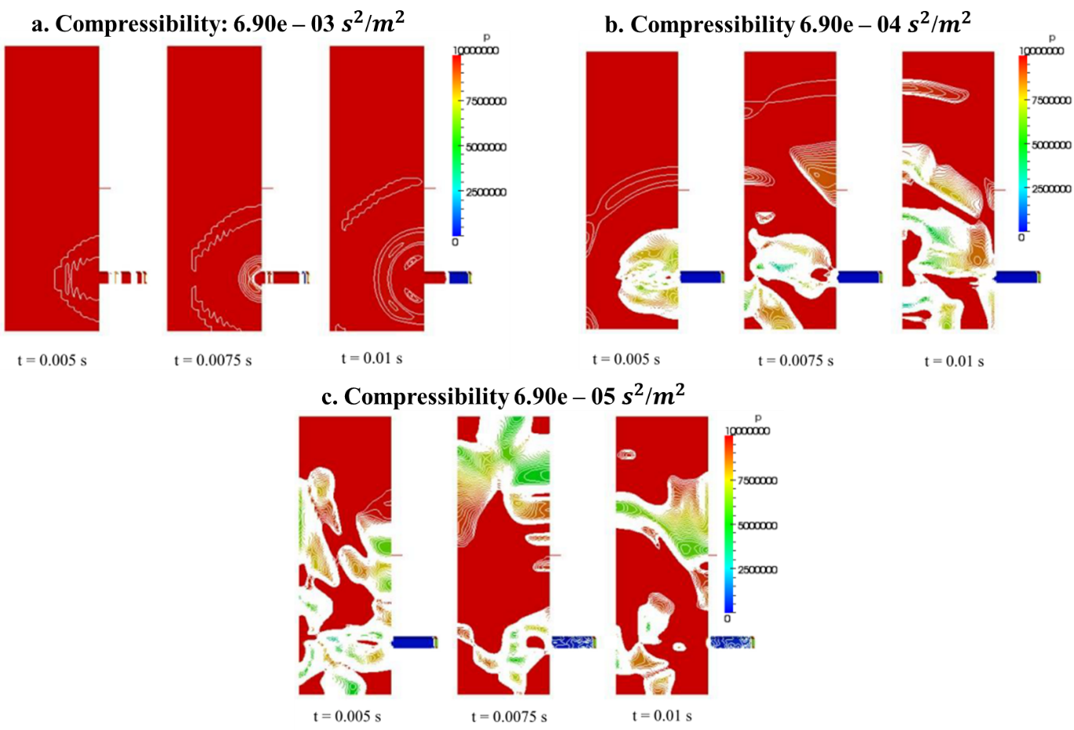
Figure 3. Pressure contours on the decompression tank with variations in the value of compressibility

3.3. Results of comparison of speed distribution with variations in compressibility values
With reference to the Bernoulli equation, which if the pressure increases, the speed will decrease and vice versa as in the results of this study, as shown in Figure 4. The figure shows the effect of variations in the value of compressibility on the speed distribution at time t = 0.005 s, t = 0.0075 s and t = 0.01 s. In the Fsigure 4a shows that the value compressibility 6.90e-03 shows the change in velocity contours, wherein the output end of the pipe when t = 0.01 s highest speed increase compared to any other time. In experiments with the compressibility value of 6.90e-04 shown in figure 4b, shows that from the third time the data collection is the highest speed in the output pipe which in this area has a low pressure. This is indicated by the measurement data, which at time t = 0.005 s shows that the high speed region propagates by 25% from the tank area to the output, then when t = 0.0075 s the high-speed area propagates 40% of the entire tank area, while when t = 0.01 s the high pressure area propagates 70% of the tank area. Similar to the results obtained with the compressibility value of 6.90e-04, the result of the compressibility value of 6.90e-05 shows a similar result, where the highest velocity region is in the output pipe. But with variations in the compressibility value of 6.90e-05, the high velocity area has a wider area of experiment with compressibility values of 6.90e-04. Which at t = 0.005 s the high speed region propagates by 60% of the tank area. For t = 0.0075 s the high-speed area propagates 65% of the entire tank area. For t = 0.01 s the high pressure area propagates 70% of the tank area.
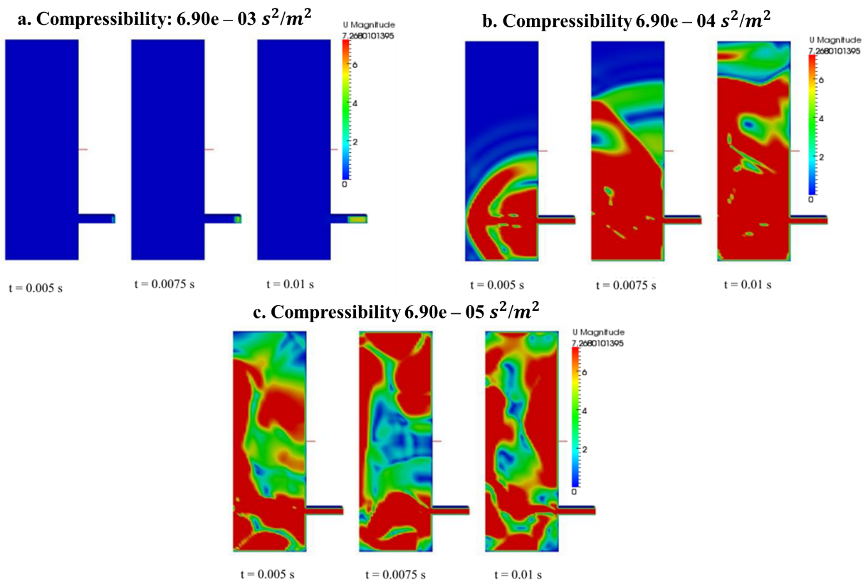
Figure 4. Speed contours on the decompression tank with variations in the value of compressibility

- Conclusions
From the results of data simulations carried out to determine the phenomenon and characteristics of pressure distribution and speed of the decompression tank with Oxygen fluid, it can be concluded that:
- Each compressibility value has different pressure distribution and speed characteristics even at the same time.
- With the compressibility value of 6.90e-05 the pressure distribution and the resulting velocity are wider and faster propagating than the compressibility values of 6.90e-03 and 6.90e-04.
- The highest speed distribution occurs in the output pipe but the distribution of pressure is low at each compressibility value.

Acknowledgments
The authors would like to express their gratitude for the financial support given by ITATS (Independent Research). The authors are grateful to Dr. Nima Vaziri, Prof. Ming Jyh Chern, Prof. Horng for their helpful discussion as well.

- References
[1]. Gupta S, and Jani CB. 2009. "Oxygen cylinders: "life" or "death"?". African health sciences. 9. 1. 57-60.
[2] H K Versteeg, W Malalasekera. 2007. "An Introduction to Computational Fluid Dynamics, The Finite Volume Method", Second Edition, Pearson Edition Limited, Edinburg Gate, England.
[3] Ming Jyh Chern, Syamsuri S.2013."Effect of Corrugated Bed on Hydraulic Jump Characteristic Using SPH Method",J.Hydraul.Eng,139,221-232.
[4] Ming Jyh Chern,Nima Vaziri,Sam Syamsuri,Alistair G.L.,Borthwick. 2012."Pseudospectral solution of three-dimensional nonlinear sloshing in a shallow water rectangular tank", Journal of Fluids and Structures, 35(2012), 160-284.
[5] Syamsuri, Hasan Syafik M, Yudho Putro I. 2017."Study the Effect of Angle of Attack on Flow Characterictics of Racing Bike Helmet Using CFD, MATEC Web of Conferences 204, 06001. IMIEC 2018.
[6]. Lubis A, Akmal J, and Winata MYA. 2014. "Analisis Kekuatan dan Ekspansi Volume Tangki Toroidal Penampang Eliptik dengan Beban Internal Pressure". Jurnal Mechanical. 5. 2.
[7]. Syamsuri. 2016. "Characteristics of Decompression Tank Internally Pressurized with Water Using OpenFOAM". Applied Mechanics and Materials. 836. 3-8.
[8]. Favero JL, Cardozo NSM, Secchi AR, and Jasak H. Simulation of Free Surface Viscoelastic Fluid Flow Using the viscoelasticInterFoam Solver. In: Pierucci S, Ferraris GB, editors. Computer Aided Chemical Engineering. 28: Elsevier; 2010. p. 31-6.
[9]. Furbo E, Harju J, and Nilsson H. Evaluation of turbulence models for prediction of flow separation at a smooth surface. Uppsala Universitet report; 2009.
[10]. Habla F, Marschall H, Hinrichsen O, Dietsche L, Jasak H, and Favero JL. 2011. "Numerical simulation of viscoelastic two-phase flows using openFOAM®". Chemical Engineering Science. 66. 22. 5487-96.
[11]. Harikrishnan GA. CFD simulation of subcooled flow boiling using OpenFOAM2013. 441-7 p.
[12]. Labeaga JI. Two Phase Pipe Flow Simulations with OpenFOAM: Norwegia University of Science and Technology; 2013.
[13]. Weller HG, Tabor G, Jasak H, and Fureby C. 1998. "A tensorial approach to computational continuum mechanics using object-oriented techniques". Computers in Physics. 12. 6. 620-31.
[14]. Adaze E, Al-Sarkhi A, Badr HM, and Elsaadawy E. 2018. "Current status of CFD modeling of liquid loading phenomena in gas wells: a literature review". Journal of Petroleum Exploration and Production Technology.
[15]. Wen C, Cao X, Yang Y, and Zhang J. 2011. "Supersonic swirling characteristics of natural gas in convergent-divergent nozzles". Petroleum Science. 8. 1. 114-9.

